Direct Certification Downloads

These instructions will lead you through the process to download and view weekly and monthly Direct Certification files.

Logging On

- Go to the Direct Certification Login page
- Enter your login name and password, click “LOGIN”
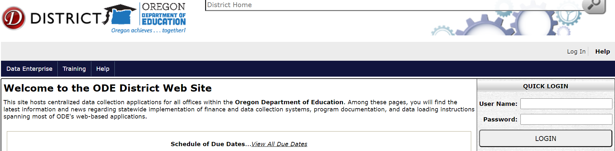

- Click on “Consolidated Collections”

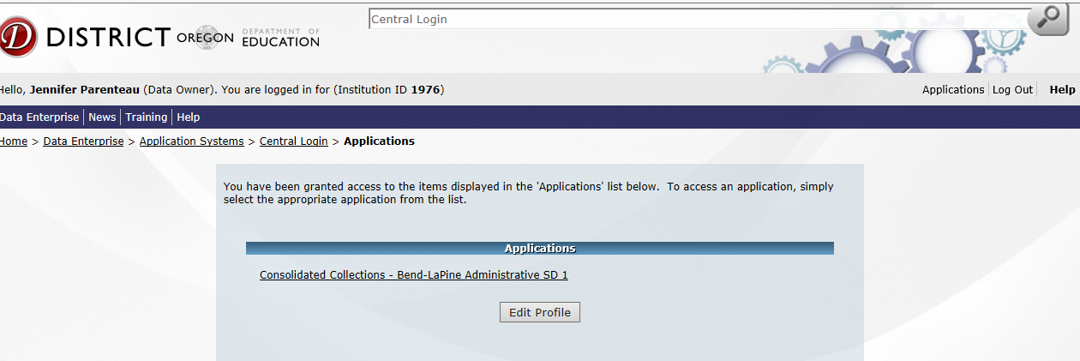

- Click on “Student Collections”
Click on “Child Nutrition - Direct Certification Match (NSLP) –> Direct Certification (SNAP and FOSTER data) ->View and Download Matches”

Direct Certifications since your institutions last download only

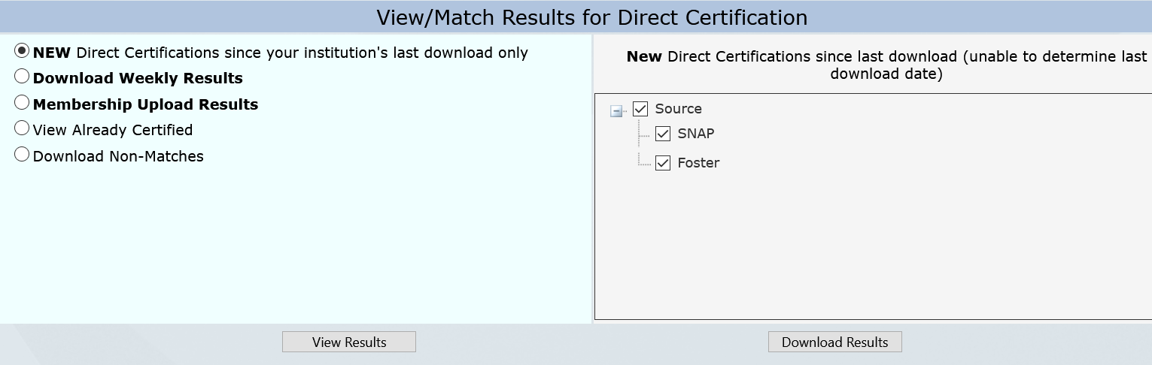
- Select “New Direct Certification since your institutions download only.”
You will receive an automated email weekly if you have new or updated students since your last download.
- Choose your Source; SNAP or Foster or both.
- There are two options to view the results “View Results” or “Download Results”.
- “View Results” will return a list of students displayed individually as a .pdf
- “Download Results” will send a .csv file to the email address on record that can be uploaded into Benefit Issuance software

View and Download Weekly Results
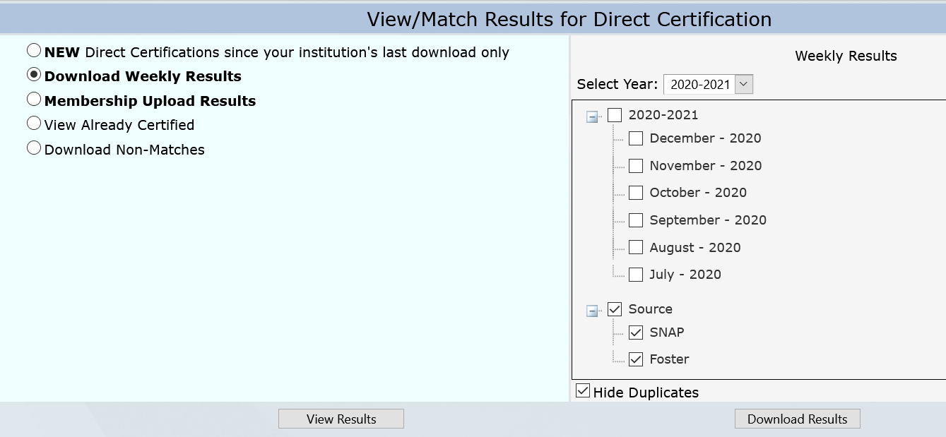

- Select “Download Weekly Results”
- “Select Year”. The system will default to the current school year. Previous years may be chosen from the drop-down.
- Select the individual month. To include all months, check the box to the left of the year.
- Select “Source”
- SNAP
- Foster
- Click “Hide Duplicates” or uncheck to return all entries for the date range(s) chosen.
- There are two options to view the results “View Results” or “Download Results”.
- “View Results” will return a list of students displayed individually as a .pdf
- “Download Results” will send a .csv file to the email address on record that can be uploaded into Benefit Issuance software

Download Non Matches
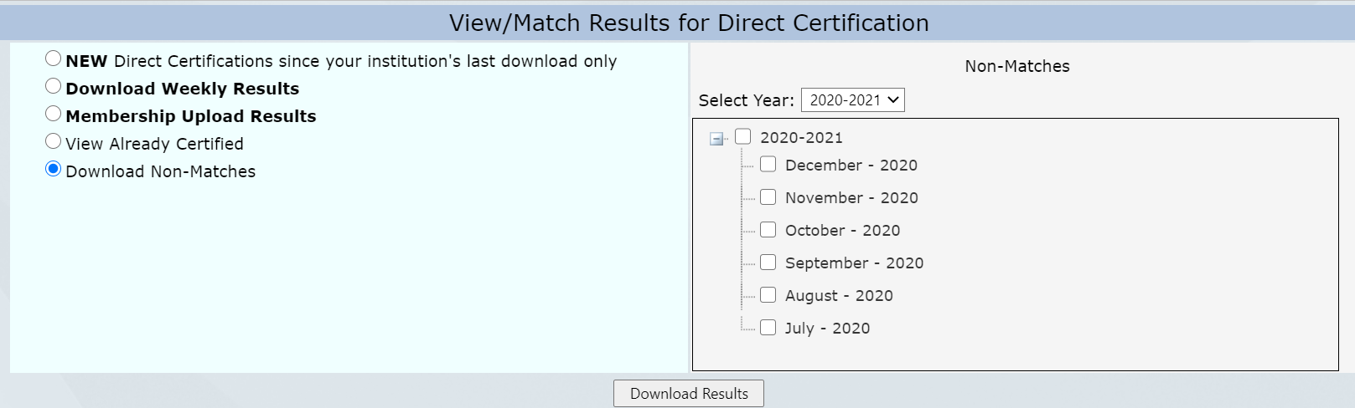

- Select “Download Non-Matches”
- “Select Year”. The system will default to the current school year. Previous years can be chosen from the drop-down.
- Select the individual month. To include all months, check the box to the left of the year.
- Click “Download Results” will send a .csv file to the email address on record that can be uploaded into Benefit Issuance software

Student Search
- Select the “Student Search” tab to find individual students.
- Select Filter options. “Matches” only will return students matched to the school (district) chosen. “Non Matches” will return students on the non-match list throughout the state.
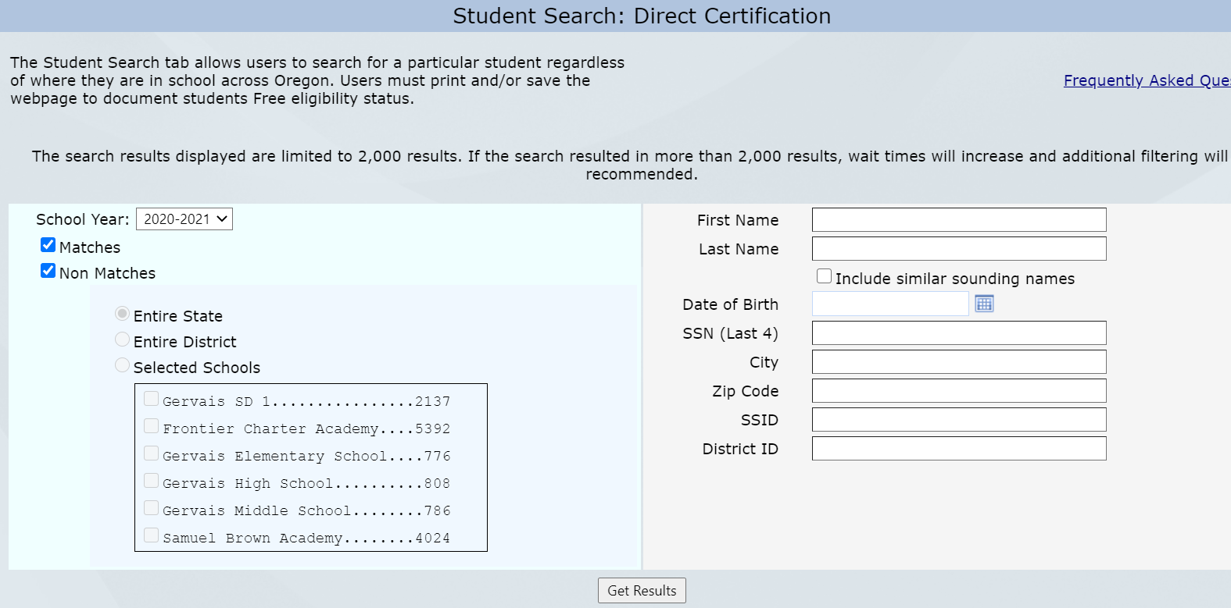
- Search by any available information. More information that is added will provide better results.
- By checking “Include similar sounding names” box all students with similar names will be displayed

- If a student(s) is found, they will be displayed with the option to view available information under the headers by scrolling across the page, or a .pdf can be downloaded and/or saved by clicking on the “PDF Export”. There may be multiple students listed depending on the search criteria that was provided. If a student is off of the “Non Match” list, there will not be any data for the “Match Source”, “Match Code”, or “Institution Information”.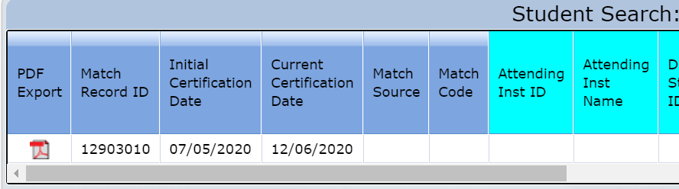

- To determine how a student was matched, look at the match code on the results dialog box, or the.pdf file, and look for the code on the “Match Code Legend”
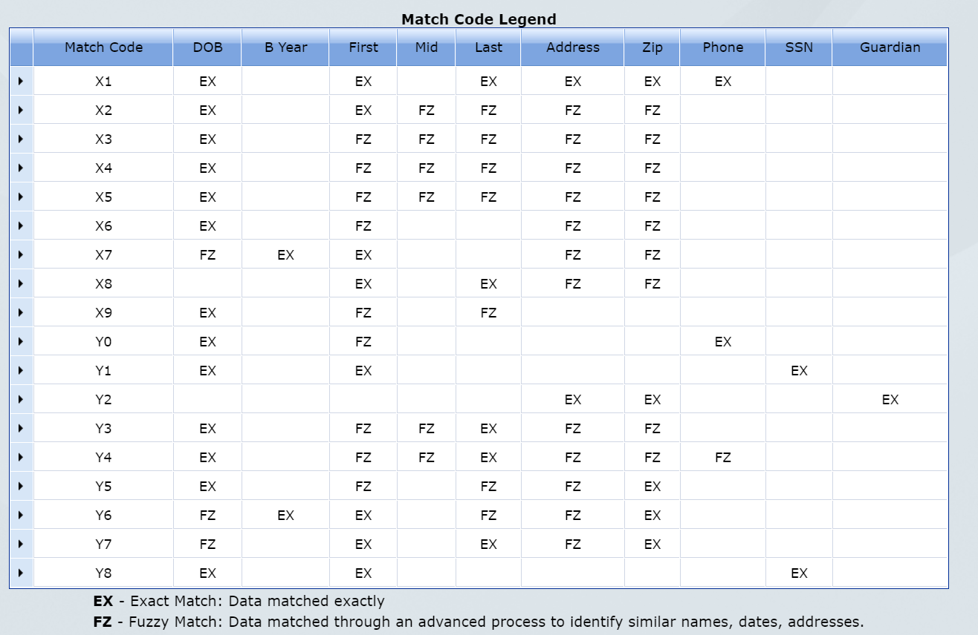

Retrieve the Downloaded File
- A dialog box appears that states, “The file you requested is being generated.”
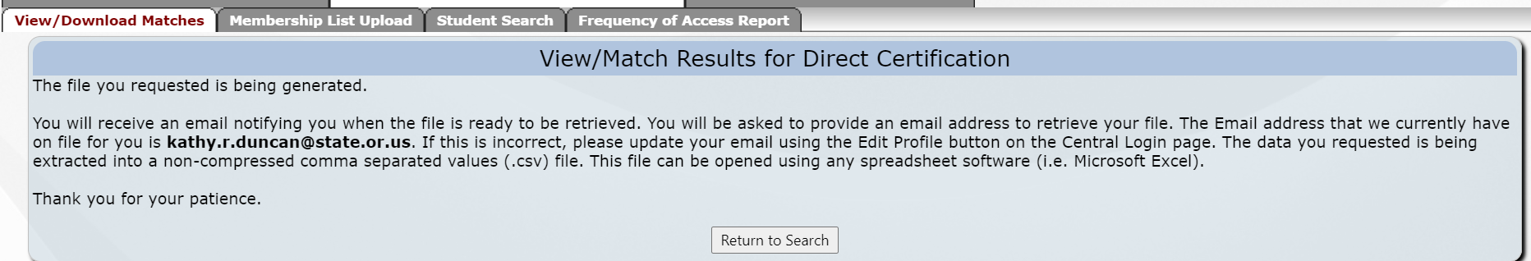

- Go to your email Inbox and open the email from the ODE Helpdesk.
(The subject line is “Direct Certification File Transfer” see the circled area).

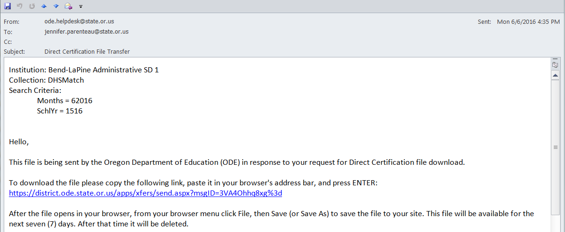

- Click on the blue underlined web address as shown in the email or copy and paste the address in the email into your web browser

- Type in your email address exactly as it is on file for the student collections, and click on the “Submit Email Address”

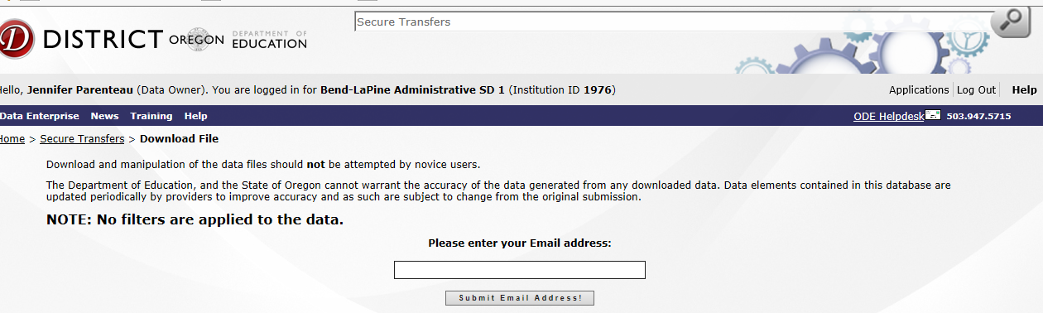

- Click on “Download”. 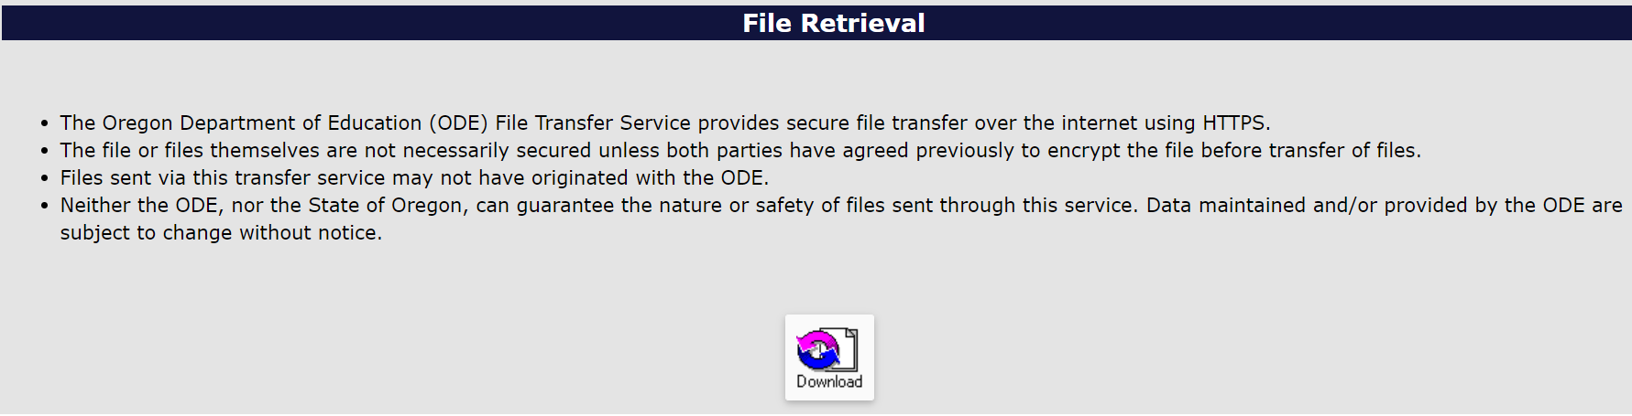
- A dialog box will appear that gives the option to “open” or “save (as)”.

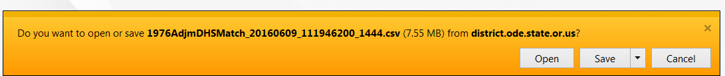

NOTE: If you use an eligibility software program, importing the file is vendor specific. Contact your software vendor for details or assistance.

- Direct Cert File Format

