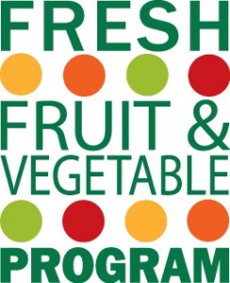
Allowable / Unallowable Items
According to the USDA Fresh Fruit and Vegetable Program (FFVP) is intended to introduce “elementary school children to a variety of produce that they otherwise might not have the opportunity to sample.”
In an effort to honor the intention of the Program, ODE considers certain fruits and vegetables “standard fare”, thus distinguishing them as ineligible for reimbursement under the FFVP in most circumstances. These varieties are outlined below:
- Yellow bananas (standard size)
- Navel oranges
- Baby orange carrots, or standard orange carrots sticks (carrots served with tops left on are allowable)
- Some common apple varieties
  - Gala
  - Granny Smith
  - Red Delicious (this includes “blush”)
  - Golden Delicious
Other, less widely consumed varieties of oranges, apples, bananas and carrots are allowable – including, but not limited to, valencia oranges, cosmic apples, red bananas, rainbow carrots, etc.
If you are claiming extraordinary varieties of bananas, carrots, oranges or apples, please be sure you have included in your claim the variety of the item whose type alone may be considered standard to avoid the removal of the item from your claim; i.e. “apples, cosmic”, “oranges, valencia”, “carrots, rainbow” or “bananas, baby.”
In unavoidable circumstances, for example if a distributor uses a Standard Fare item as a replacement in an order, ODE will allow an exception and the items may be claimed. In a case such as this, please provide an explanation in the body of the email with the claim.
FFVP Resources

