Please Note: You will need a Google account to save the templates. Follow the steps below
- Sign into your Google account and then click on the form links to start saving them one at a time.

- After opening the Google form, click on the blue “Make a copy” button
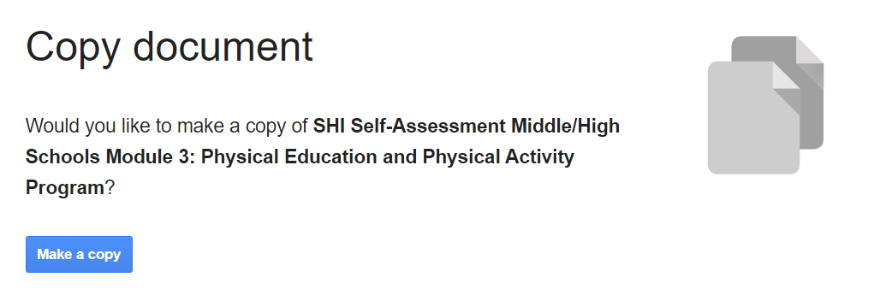

- At the top of the form, click on the “Responses” tab and then the three dot menu.
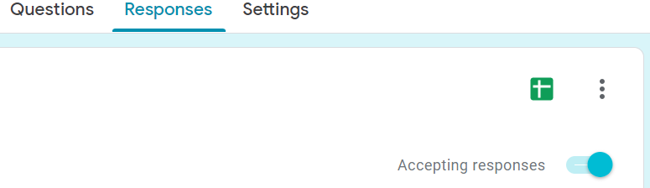
- From the menu items, click on “Select response destination”
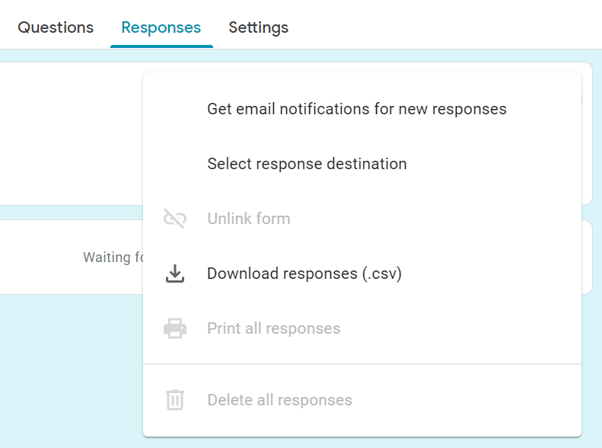
- Select the “Create a new spreadsheet” radio button, rename your spreadsheet, and then click on the “create” button. This will add a new Google sheet to your Google drive.
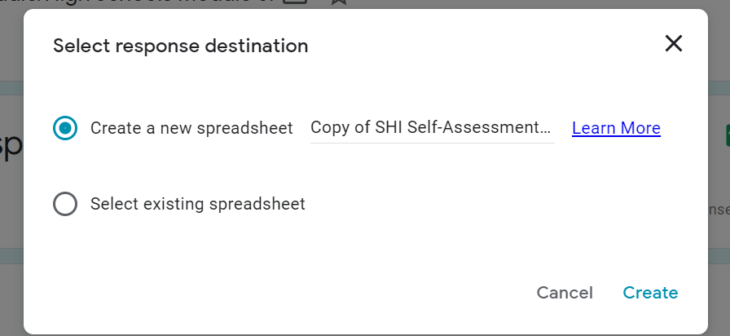
- Repeat this process for all of the forms. Once the forms are copied to your Google drive and a destination spreadsheet is created, you can now send the forms by opening the form and clicking on the “share” button at the top right side of the form.
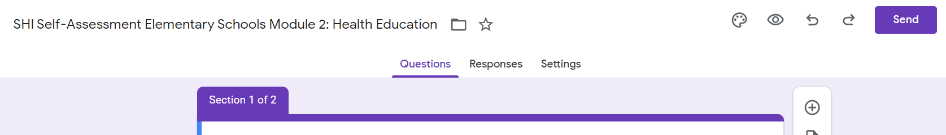
- To send the form by email, enter the recipient(s) email address in the “To” field. Personalize your subject and message if desired and then click the “Send” button the send your form.
