Upload Membership List
These instructions will lead you through the process to download and view the OnDemand Upload files.

Logging On

- Go to the Direct Certification Login page
- Enter your login name and password, click “LOGIN”
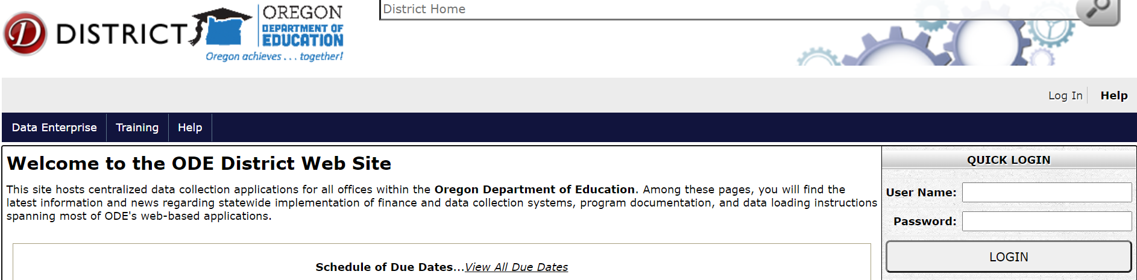

- Click on “Consolidated Collections”

- Click on “Student Collections”
Click on “Child Nutrition - Direct Certification Match (NSLP) –> Direct Certification (SNAP and FOSTER data) ->Membership List Upload”
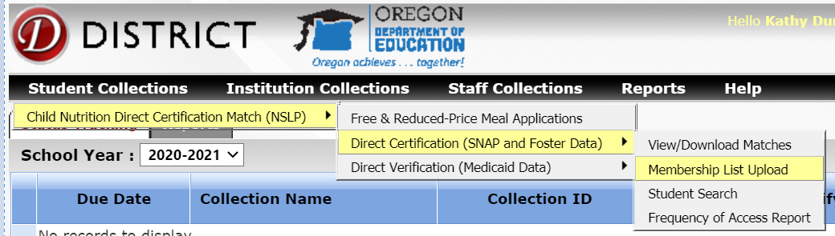

Click “Choose File” and find your data template where it is stored on your computer.
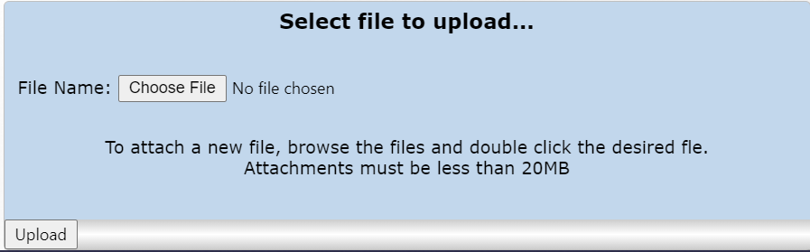

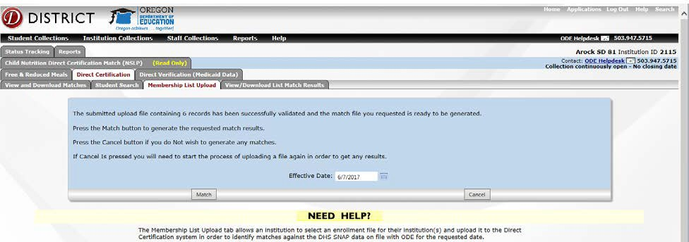
- Click “Upload”. The system will make sure the file meets the formatting requirements and if it passes, the
following message will be displayed.

- If the file does not meet the formatting requirements, an error message will be displayed and will either provide a reason for the fail on the screen or will tell you that an email is being sent with a link to a document that will provide more details on why the upload attempt has failed. Browse the list of common errors.

- If the information provided above looks good and you wish to go ahead and generate the Match results, select the date (defaults to the current date) that you want to run the Match for and click on the “Match” button:
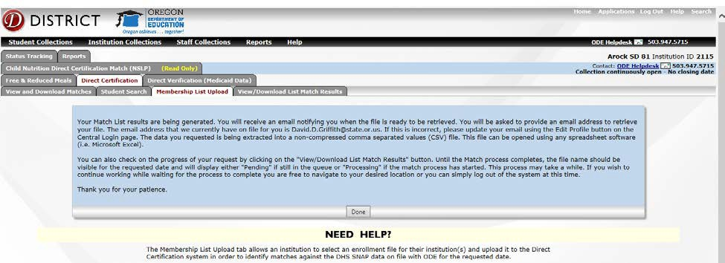
- 9. Click “Done”. A file to download will be sent to the email address on file.

Access Saved Membership Files

In the “Membership files uploaded” section, uploaded files are saved and accessible for future use. Files are listed by year, then month, then day.

- Click on the “Direct Certification (SNAP and Foster Data)” tabs. Click the “Membership Upload Results” radio button. Click on the box next to the date you wish to view.

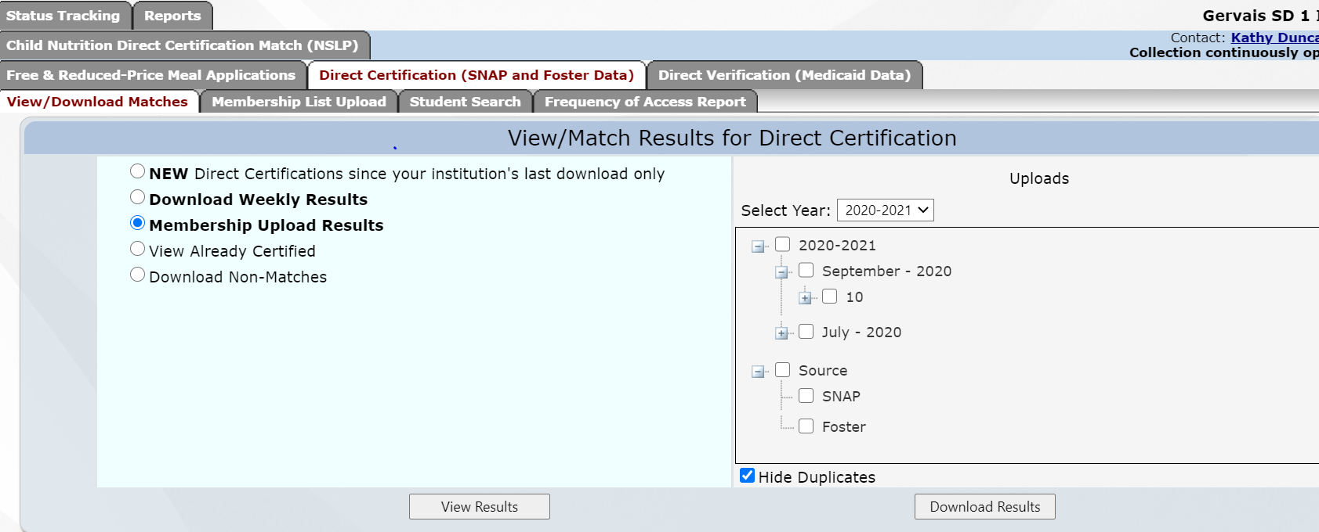

2. Click “View Results” or “Download Results”
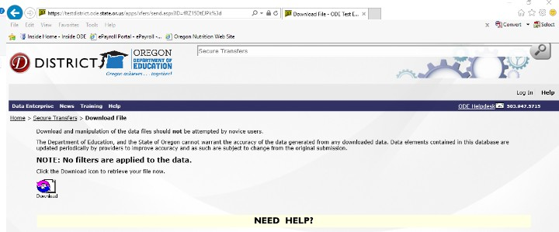
3. If you choose to download your results, you will receive an email indicating that a file has been securely transferred to you. When prompted enter your email address and you will see a download symbol like the one below. Click this and save your results file on your system.

