RCCIs without Day Students

Completing the FNS-742 Verification Collection Report

Submit one FNS-742 report per sponsor by February 1, 2023. The report is in CNPweb, on the Claims tab, click on “Add” under Action to open the report.

If the completed FNS 742 Verification Collection Report is not submitted in CNPweb by February 2, 2023 Claims for Reimbursement will be withheld until it is submitted.

Bla

Sponsor contact information is prepopulated.
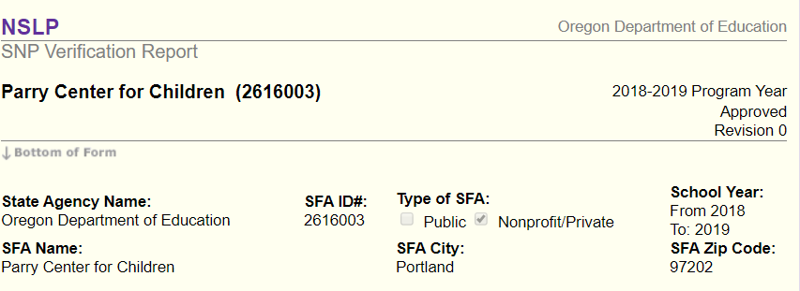

1-2 #2 Column A & B as of the last operating day in October

1-2b #4 A & B as of the last operating day in October

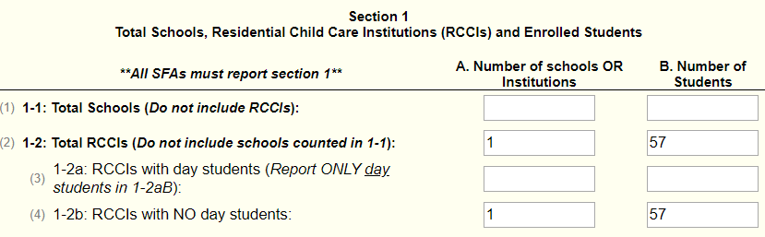

3-1 #12 Check this box if not required to perform direct certification i.e. RCCI with no day students.

5-1 #19 Check the box as RCCIs without day students are exempt from the verification process
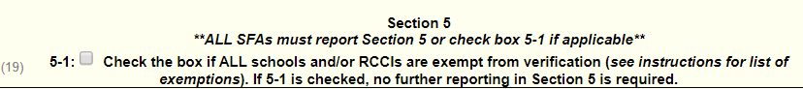

VC-1 Enter N/A if no applications were verified for cause.
Scroll to the bottom and check I certify box #43, then click “Submit.”
