April 24, 2023

TO: Sponsors of the National School Lunch and School Breakfast Programs

RE: Revised - SY 2021-22 Revenue from Nonprogram Food and Adult Meal Prices
Response Due: May 19, 2023
Action Required

The U.S. Department of Agriculture (USDA) requires state agencies to ensure that revenues generated by a sponsor’s sale of non-program foods comply with the requirements set forth in 7 CFR § 210.14(f). “Non-program foods” are foods and beverages, other than those sold as part of a reimbursable meal, purchased with funds from a sponsor’s nonprofit food service account.

Sponsors are required to determine if the percent of total revenue generated from nonprogram food sales is equal to, or greater than, the percent of total food costs that are attributable to the sponsor’s purchase of non-program foods. Sponsors must ensure that nonprogram foods are priced sufficiently to meet the nonprogram foods requirement, or secure non-federal funding to make up the shortfall in the nonprofit school food service account. Sponsors are required to retain records to document compliance with Revenue from Nonprogram Food requirements.

Sponsors must notify ODE CNP of Revenue from Nonprogram Foods status by completing this web based Revenue from Nonprogram Foods Reporting Form. In addition to collecting this information, compliance with Revenue from Nonprogram Food requirements are reviewed during the Administrative Review.

Several tools are available to assist sponsors with determining Revenue from Nonprogram Foods and assessing compliance with requirements.

The USDA Nonprogram Revenue Tool helps sponsors calculate the amount of revenue required to meet requirements. To use the tool, the sponsor must collect the cost of both program and nonprogram food and the total revenue from the previous school year. Based on these amounts, the tool will calculate the minimum amount of revenue from nonprogram foods that is required to meet this requirement. The tool will also calculate the additional revenue, if any, needed to comply.

SY 2021-22 Revenue from Non-program Food and Adult Meal Prices
Page 2

The ODE Nonprogram Cost and Revenue Proportion Calculator assists sponsors in calculating the proportion of program/nonprogram revenue and food costs. To use the tool, the sponsor must collect either the cost of both program and non-program food and nonprogram revenue and total revenue from the previous school year, or, the cost of nonprogram food and total food costs and non-program revenue and total revenue from the previous school year.

Per FNS memo SP 20-2016, pg. 5, an exception from the Revenue from Nonprogram Foods requirement may be granted to sponsors that offer “a limited number of nonprogram foods with an identifiable per serving cost and are not able to accurately perform the assessment”. Adult meals do not have an identifiable per-serving cost and are not eligible for this exception.
Per FNS Instruction 782-5, Rev. 1, Pricing of Adult Meals in the National School Lunch and School Breakfast Programs (June 6, 1988), sponsors that sell adult meals must price those meals so revenues are “sufficient to cover the overall cost of the lunch”.

All program sponsors are required to certify one of the following, using the Revenue from Nonprogram Foods Reporting Form:

- Certification that Revenue from Nonprogram Foods is sufficient and is proportionally greater or equal that Nonprogram Food Costs OR

- Certification that Revenue from Nonprogram Foods is insufficient and is proportionally less that Nonprogram Food Costs, and indicate the plan to ensure that nonprogram foods are priced sufficiently to meet the nonprogram foods requirement or secure non-federal funding to make up any shortfalls in the nonprofit school food service account OR
- Certify an exception from the nonprogram food revenue requirement due to offering “a limited number of nonprogram foods with an identifiable per serving cost, and are not able to accurately perform the assessment.”

- Certify an exception from the nonprogram food revenue requirement due to not selling non-program foods

Sponsors must complete the Revenue from Nonprogram Foods Reporting Form no later than 05:00 PM, on May 19, 2023.

SY 2021-2022 Revenue from Non-program Food and Adult Meal Prices
Page 3

For additional information and resources, please visit the Nutrition Programs Resource Management Webpage.

If you have any questions regarding the Revenue from Non-program Foods requirement or the Certification Form, please contact your Assigned Child Nutrition Specialist.

Sincerely,

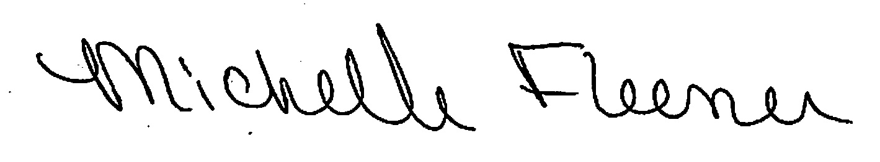
Michelle Fleener
Manager, School Nutrition
Child Nutrition Programs
Office of Child Nutrition, Research, Accountability, Fingerprinting and Transportation
Michelle.fleener@ode.oregon.gov

"K:\~Memos\_SNP\2022-2023\Revenue from Non-Program Foods Reporting Memo - SY 2023.docx"

