August 3, 2021

TO: Sponsors of the National School Lunch Program, School Breakfast Program, Seamless Summer Option, and Special Milk Program

RE: SY 2021-2022 Renewal Information for State Agency-Sponsor Permanent Agreement
Sponsors Operating in July Due Date: August 16, 2021
Sponsors Operating in August or September Due Date: August 30, 2021
Action Required

Sponsors participating in the National School Lunch Program, School Breakfast Program, Seamless Summer Option, and Special Milk Program are required to complete the SY 2021-2022 Program Agreement Renewal with the Oregon Department of Education Child Nutrition Programs (ODE CNP).

The SY 2021-2022 renewal process is a multi-step process. Please follow the attached detailed step-by-step instructions to ensure completion of the following renewal categories:
- Required renewal training
- CNPweb information update
- Submission of applicable offline forms
- Submission of the district/organization’s meal distribution plan

Access to the 2022 Program Year section of CNPweb and the renewal forms are now available. When CNPweb information is updated and submitted to your assigned Child Nutrition Specialist for review, the Packet status will reflect ‘Pending Approval’.
Helpful Hint: Plan ahead to meet the due date of August 16th or August 30th. CNPweb will roll over some information when you activate your renewal, however, you need to verify and update all information and certify that it is true and accurate. As a reminder, due to COVID-19 last year operations maybe different from this year. It is critical that the step-by step instructions are
followed to ensure all information is accurate.

Renewal packet must be in “Pending Approval” status by:
- August 16, 2021 if Sponsor is Operating in July.
- August 30, 2021 if Sponsor is Operating in August or September.

In an effort to help Sponsors complete the renewal process in a timely manner, notices will be sent via the SNP newsletter, email reminders, and posted to the ODE CNP renewal webpage.

If you have questions, please contact your assigned Child Nutrition Specialist.

Sincerely,
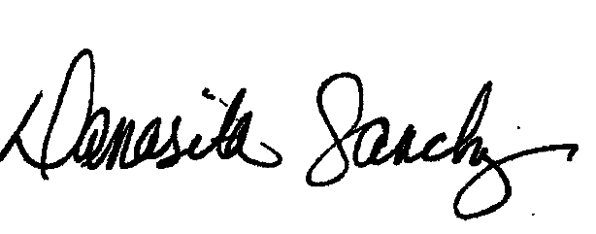
Damasita Sanchez
Manager, School Nutrition
Child Nutrition Programs

Enclosure: Sponsor Renewal Step by Step Instructions

