Sponsors- Community Eligibility Provision (CEP) only
Completing FNS 742 – Verification Collection Report

Submit one FNS-742 report per sponsor by February 1, 2023. The report is in CNPweb, on the Claims tab, click on “Add” under Action to open the report.
If the completed FNS 742 Verification Collection Report is not submitted in CNPweb by February 2, 2023 Claims for Reimbursement will be withheld until it is completed.

Sponsor contact information is prepopulated..
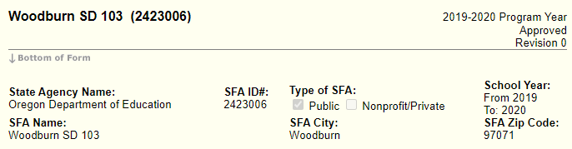

1-1 #1 Column A & B as of the last operating day in October.

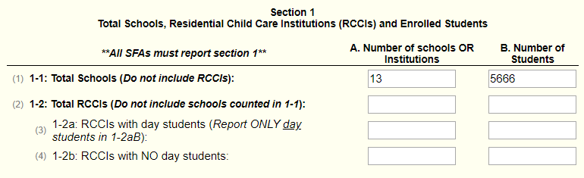

Complete Section 2 -3 with the same numbers recorded in Section 1-1A and B:
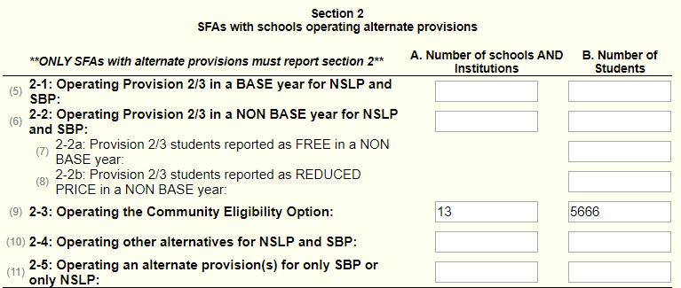

3-1 #12 Check the box, the rest of the section is not applicable and will be grayed out.

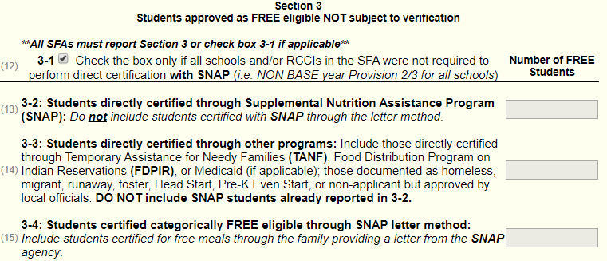

5 -1 Check the box
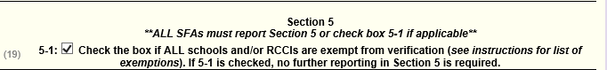

VC-1 Enter N/A if no applications were verified for cause.

Scroll to the bottom and check I certify box #43, then click “Submit.”
