Sponsors Conducting a Verification Process
Completing FNS 742 Verification Collection Report

Submit one FNS-742 report per sponsor by February 1, 2020. The report is in CNPweb, on the Claims tab, click on “Add” under Action to open the report.
If the completed FNS 742 Verification Collection Report is not submitted in CNPweb by February 2, 2023 Claims for Reimbursement will be withheld until it is completed.

Sponsor contact information is prepopulated.
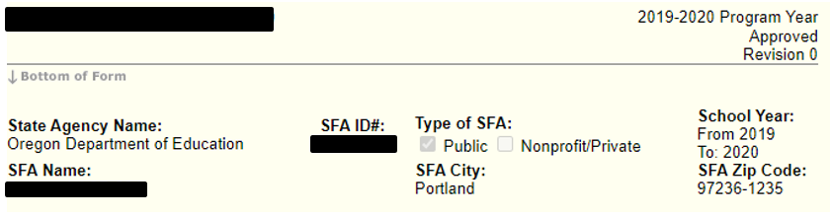

1-1 #1 Column A & B as of the last operating day in October.

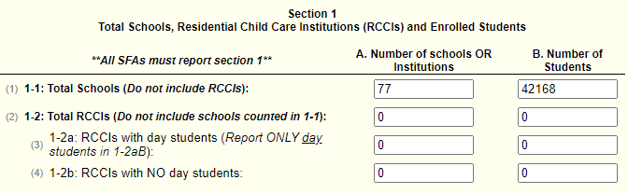

Section 2 - Leave blank unless you have CEP or Provision 2 Schools

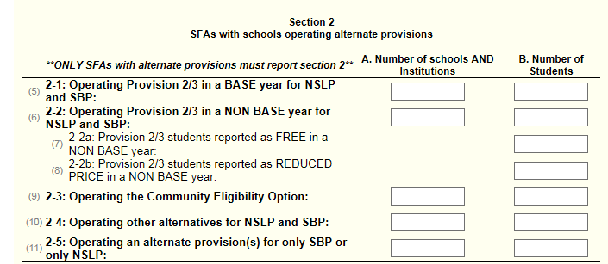

Section 3 –Student counts as of the last operating day in October.
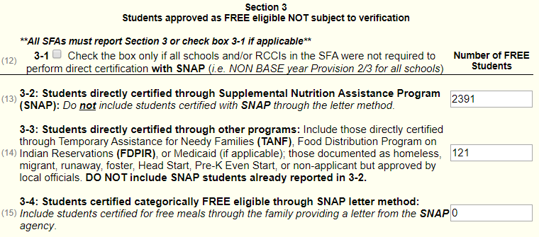

Section 4:
Report number of applications (A) approved as of October 1.
Report number of students (B) as of the last operating day in October.

4-1A & B:
- Number of applications approved FREE eligible based on a case number for SNAP, TANF, or indication of participation in FDPIR on file as of October 1.
- The number of students on these applications as of the last operating day in October.
4-2A & B:
- Number of applications approved FREE eligible based on file as of October 1.
- The number of students on these applications as of the last operating day in October.
4-3A & B:
- Number of applications approved REDUCED PRICE eligible on file as of October 1.
- The number of students on these REDUCED PRICE as of last operating day in October.
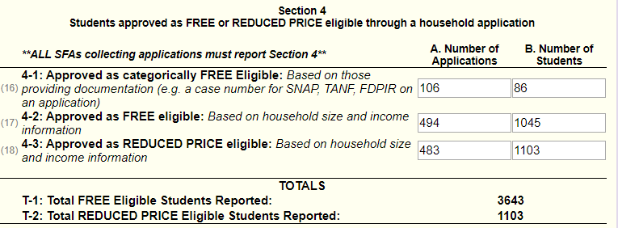

5-2: Indicate whether verification was performed and completed by the deadline of November 15

5-3: Check the type of verification process used
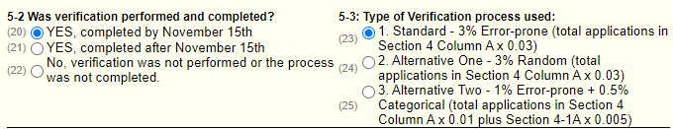

5-4: Error-prone applications are household applications approved as of October 1 indicating monthly income within $100 of the monthly limit or annual income within $1,200 of the annual limit of the applicable income eligibility guidelines.

5-5: Enter the total number of applications initially selected for the verification process.

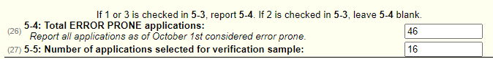

5-6: Check if direct verification was not conducted in the SFA. Direct verification is using Medicaid records on the secure Direct Certification website to verify income and/or program participation.

5-7A & B: Only report applications and students if FREE and/or REDUCED
PRICE eligibility is confirmed through direct verification.

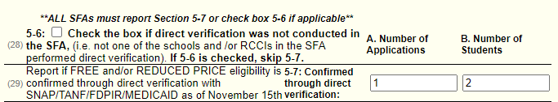

5–8 -Results of Verification by Original Benefit Type
For each original benefit type (A, B & C) report the number of application and students as of November 15th for each result category (1, 2, 3, & 4)
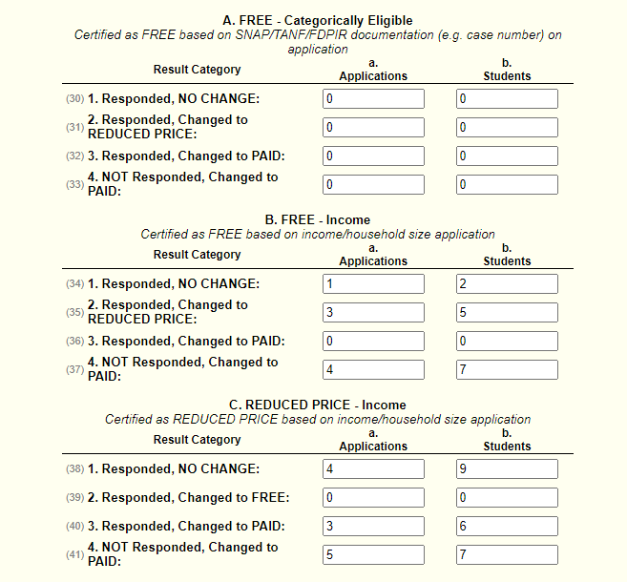

VC–1 Verification for Cause
Report all applications verified for cause outside of the verification process as of November 15th. Applications verified for cause are NOT considered part of the required sample size. If none were selected enter N/A. Include the results of verification for cause by original benefit type in the appropriate category in 5-8

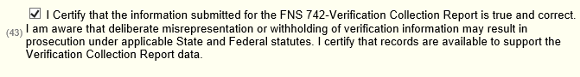
Scroll to the bottom and check I certify box #43, then click “Submit.”

For additional information, refer to Verification at a Glance at:
http://www.oregon.gov/ode/students-and-family/childnutrition/SNP/Pages/Verification.aspx

