Online Order Instructions

Go to: northwestonline.goldstarfoods.com
Scroll to the bottom of the page and click on Online Ordering:
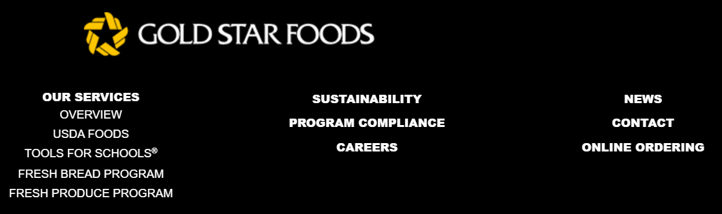

Then click on Sign In:

Enter your username and password:
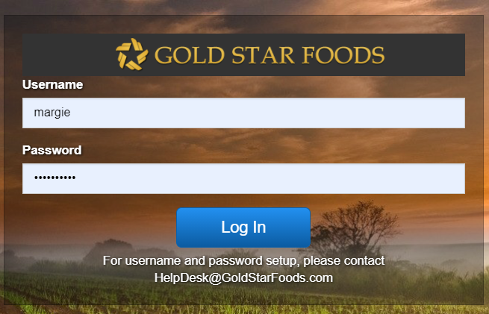

Click on New Order:

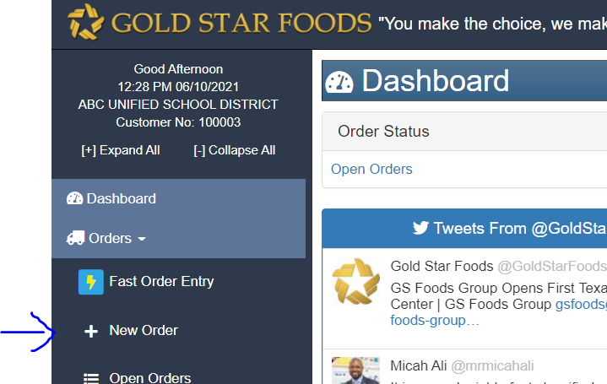

Enter your site, Order Type, Order Guide, Name, and desired delivery date:

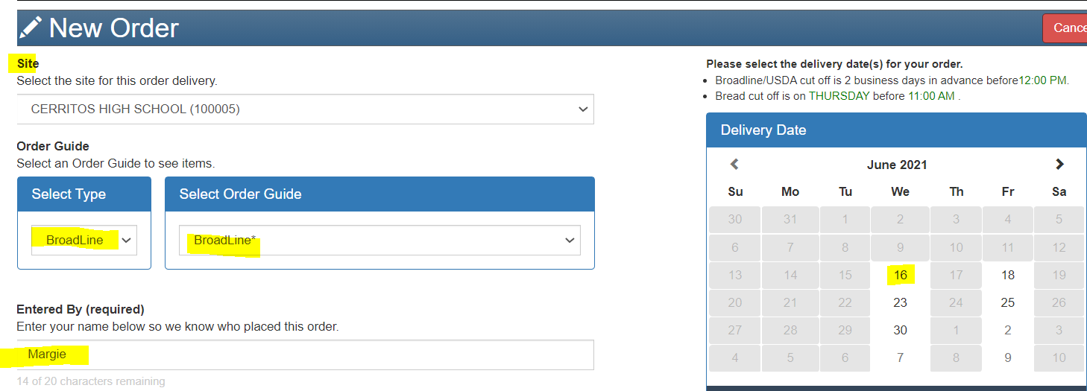

Enter the quantities you wish to order and click on preview order:

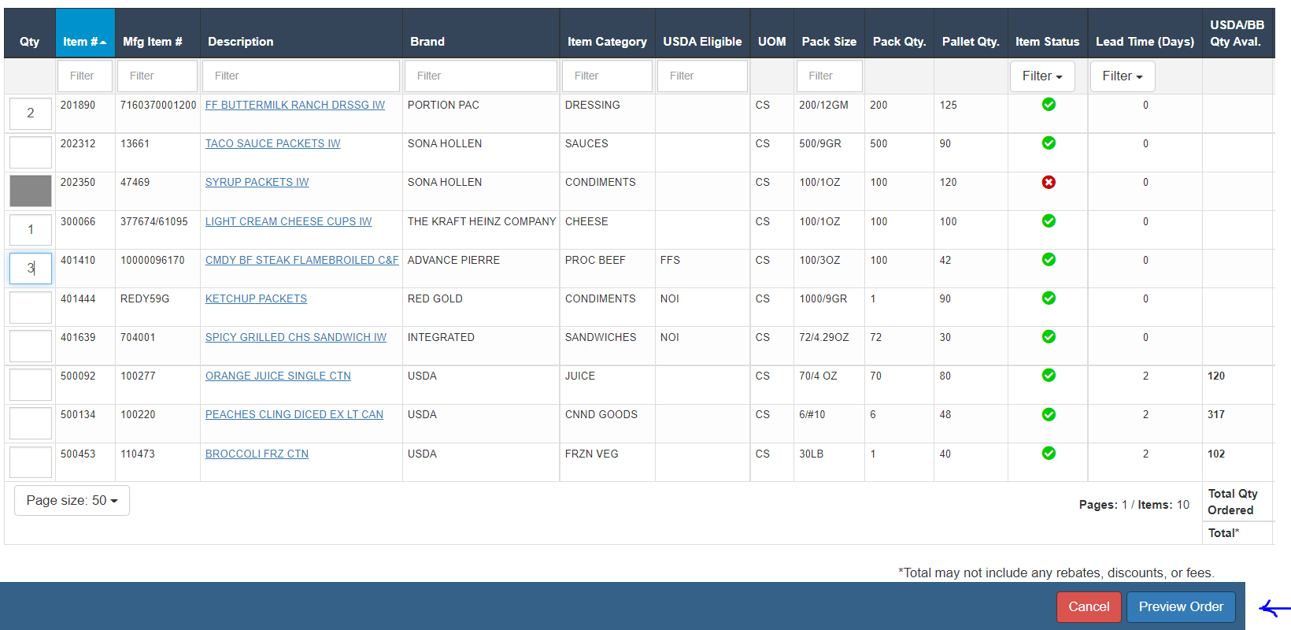

In Preview Order, confirm everything is correct. If you made a mistake click on Go Back and Edit. Once everything is correct, click Submit Order:

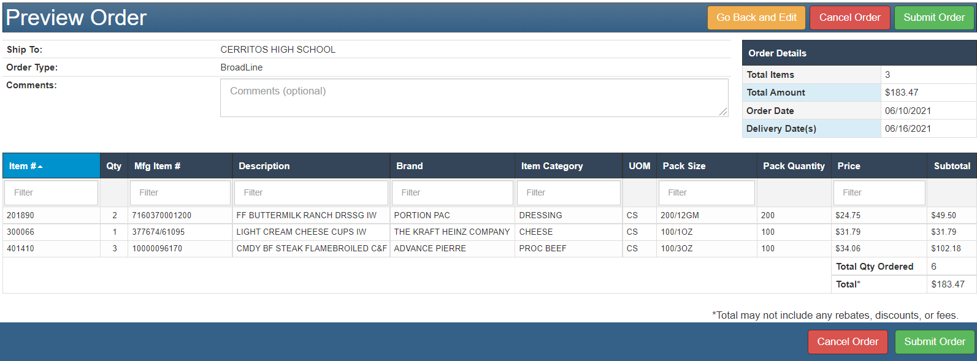

You will get a message that says your order was submitted successfully.

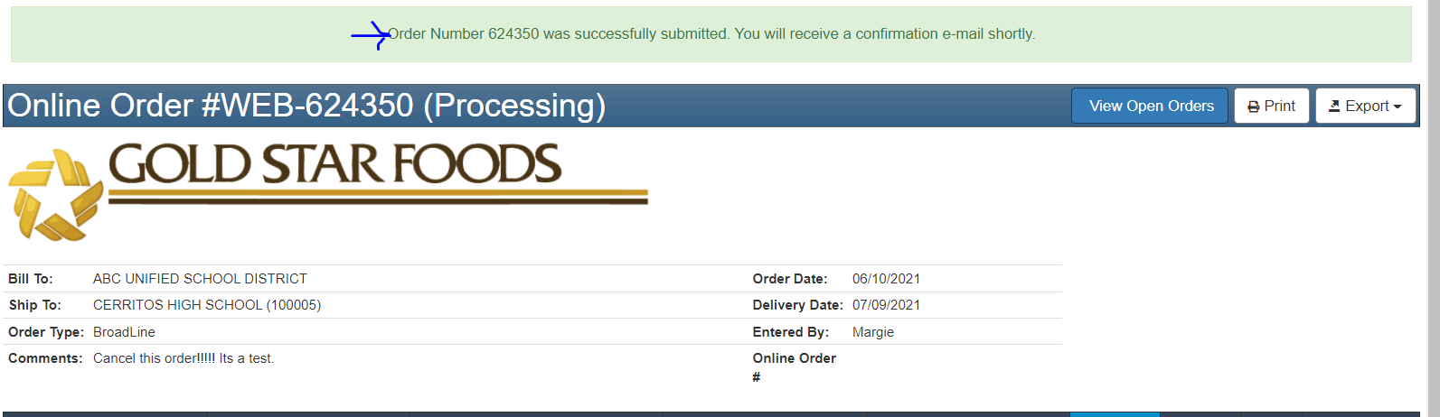

You are all done! Please note the following:

- If you cannot locate an item on your order guide, this is because they must be added to your order guide before they can be ordered.

- If you need to make order changes, please call or email your Gold Star Foods Customer Service Representative. Or, if simply adding items, you can enter a new order.

