ODE USDA DoD Fresh Fruits and Vegetables:

Allocation and Participation Policy
This policy provides the list of current DoD Fresh Program participation requirements to USDA Foods Recipient Agencies (RAs) and guidance for requesting and utilizing their USDA DoD Fresh funds.
What are the requirements to participate in DoD Fresh
- Request the DoD Fresh entitlement allocation during the USDA Foods Ordering Period in Feb-March.
- Commit to fully expend the DoD Fresh funds and submit a usage plan when requested by ODE.
- Spend the first 80% on time to request the remaining 20% to ODE.
- Receipt orders in FFAVORS within 2 business days, or participation may be terminated.
- Minimum order is $150 per delivery site.
- Email contact and delivery site updates as soon as they occur to ode.usdafoods@ode.oregon.gov.
- Be aware of quality reporting & complaints as posted on the ODE USDA DoD Fresh website.
When/How to request the DoD Fresh initial allocation
In February-March, RAs may request to allocate USDA Foods entitlement dollars towards the USDA DoD Fresh program for the upcoming school year during the annual ODE USDA Foods Ordering Period.
RAs must submit the USDA Foods Entitlement Set Aside Request form through the link provided in the ODE USDA Foods Ordering Period Memo which is emailed in advance of the Feb-March ordering season.

Where to find the ODE-approved DoD Fresh allocation in WBSCM
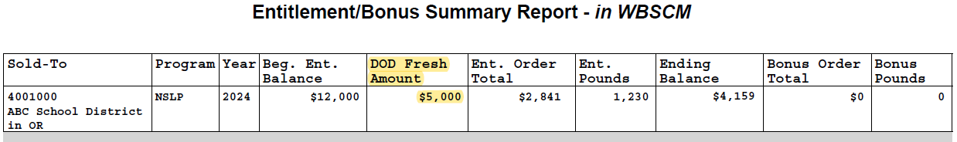
Once approved by ODE, DoD Fresh initial allocations are entered in WBSCM, and RAs can view the allocated amount through their WBSCM Entitlement Summary Report any time – as shown below:
Figure 1 : WBSCM Entitlement Summary Report shows $5,000 has been allocated to DoD Fresh.

When/How are the DoD Fresh funds made available in FFAVORS
In June, DoD Fresh initial allocations approved in WBSCM are distributed as ‘DoD Fresh funds’ in the FFAVORS ordering system for RAs to spend between July 1st and June 30th (last delivery day). Funds do not roll over to the next school year and must be fully expended before the end of the school year.
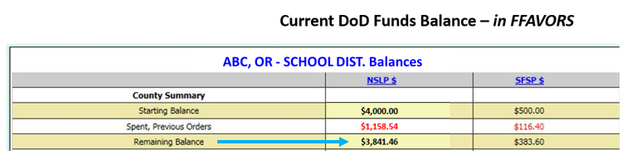
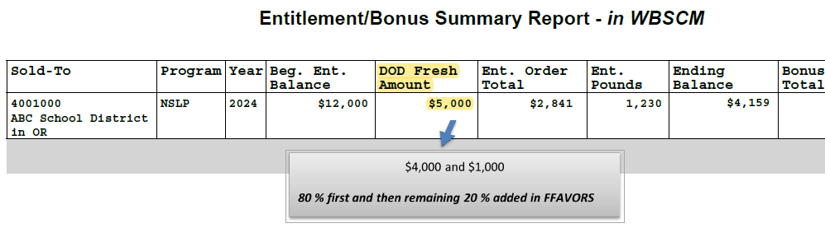
DoD Fresh funds distributed in FFAVORS are available for one school year only based on the 80/20 spending rule: 80% first, then remaining 20% later. Once RAs have spent the first 80%, they must request their remaining 20% to be added to FFAVORS via email to ode.usdafoods@ode.oregon.gov.
Figure 3: In FFAVORS, RAs participating in DoD Fresh Summer Food Program will have the ‘SFSP $’ column next to the ‘NSLP $’.
Figure 2: In this example, 80% of the allocated $5,000 in WBSCM is $4,000 and 20% is $1,000. At the beginning of the school year, the 80% will be entered in FFAVORS to be spent first.
When/How to request a DoD Fresh additional allocation
RAs may request a DoD Fresh Additional Allocation when ODE emails the DoD Fresh Additional Allocation Request form link, generally in October and in January, which is contingent on ODE funding levels with USDA and the RAs having a remaining entitlement balance available.

When/How DoD Fresh funds are adjusted and redistributed to other RAs
ODE monitors RA’s average monthly spending throughout the year based on the usage plan the RAs submitted and will notify RAs with little or no usage or whose spending is not on track. Without response, ODE will adjust the RA’s funds based on actual usage. Therefore, RAs should ensure their usage plan is adequate and read ‘How to be on track with spending your DoD Fresh funds'. Unused funds are redistributed to other RAs that can utilize them and ODE will notify RAs when there is a redistribution opportunity.

Questions? Please email the Oregon Department of Education USDA Foods Distribution Program Team at ode.usdafoods@ode.oregon.gov, do not contact USDA or FFAVORS.

