ODE USDA DoD Fresh Fruit and Vegetable Program:

Allocation and Participation Policy

Revised July 2025

Through this policy, ODE provides information and guidance to all Oregon USDA Foods Recipient Agencies (RAs) participating in the USDA DoD Fresh program regarding:
- DoD Fresh Initial Allocation Request in Feb-March
- 80/20 spending rule and April 1st cutoff
- DoD Fresh Additional Allocation Request 2 times a year
- DoD Fresh funds Adjustments and Redistribution
- Program Participation Requirements
DoD Fresh Initial Allocation Request
When RAs receive their new school year USDA Foods Entitlement Dollars in WBSCM (USDA Web-Based Supply Chain Management), they can choose to spend any portion of entitlement towards the USDA DoD Fresh program. This will result in less dollars available to spend on other USDA food products.
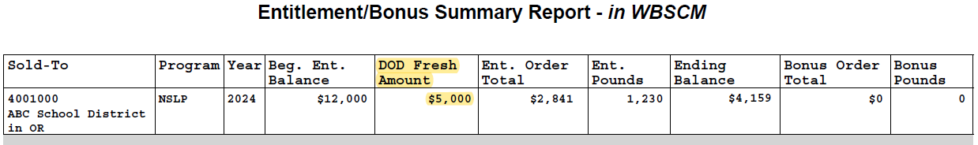
In February-March, during the Annual ODE USDA Foods Ordering Period, RAs submit their DoD Fresh Initial Allocation to ODE through the Set Aside Entitlement Request form link which will be provided in the ODE USDA Foods Ordering Period Memo and emailed to all RAs in advance of the ordering season. The minimum set aside is $150. ODE reviews and approves requests, then enters the DoD Fresh requested amount in WBSCM. RAs should log in to WBSCM and run an Entitlement/Bonus Summary Report to verify the DoD Fresh Amount – as illustrated in the example below:
DoD Fresh Usage Plan Requirement
RAs should request what they can use. RAs must submit the ODE USDA Foods Usage Plan Form at the beginning of the school year to determine if the DoD Fresh funds spending budget they want to commit to is adequate. Please use the ODE USDA DoD Fresh Budgeting Tool to help calculate how much should be spent weekly/monthly so all funds are expended by the end of the school year.
80/20 spending rule Back to page 1
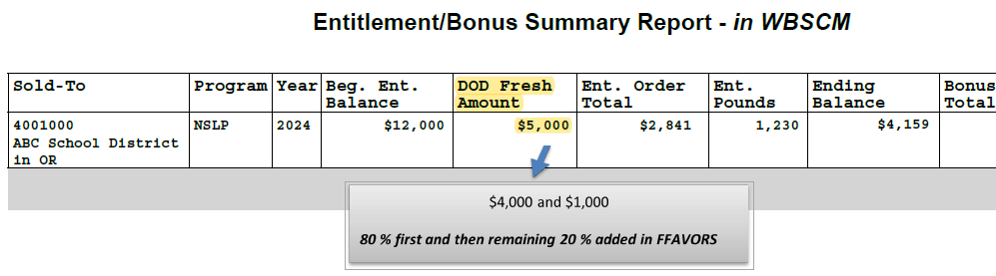
DoD Fresh produce is ordered in FFAVORS, the USDA DoD Fresh Fruit and Vegetable Order Receipting System. Per regulations, ODE first distributes in FFAVORS 80% of the DoD Fresh Initial Allocation that was entered in WBSCM. Once the first 80% DoD funds are spent, the remaining 20% is added in FFAVORS as illustrated in the example below:
The DoD Fresh Initial Allocation for one school year should be spent based on the 80/20 spending rule between July 1st and June 30th (last delivery day).
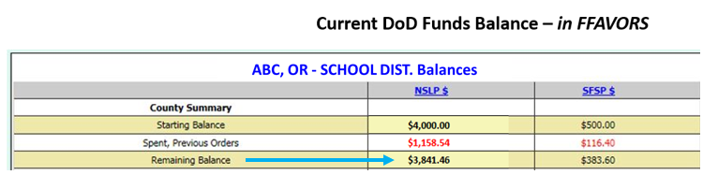
RAs should check their current DoD funds balance from within the FFAVORS ordering process to keep track of their spending as shown in the example below:
RAs participating in DoD Fresh Summer Food Program will have the SFSP $ column next to the NSLP $.
April 1st cutoff
Although ODE monitors spending and adds remaining 20% amounts regularly in FFAVORS, RAs should contact ODE to request their remaining 20% up to 2 weeks prior to running out of DoD funds, before April 1st or it will be swept on April 1st and redistributed to other DoD sponsors that can use it.
DoD Fresh Additional Allocation Request Back to page 1
When RAs have remaining entitlement available, they may request a DoD Fresh Additional Allocation two times during the year: December 1 and March 1 each time opening for a period of approx. 2 weeks. ODE will notify RAs if the DoD Fresh Additional Allocation Request form opens, which is also contingent on ODE funding levels with USDA. ODE reviews and approves requests. When approved, ODE enters the amount in WBSCM and notifies RAs which should then verify their DoD Fresh Amount in WBSCM. The additional allocation is not added to FFAVORS until the initial 80% has been spent.
DoD Fresh funds Adjustments and Redistribution
DoD Fresh funds do not rollover to the next school year. To avoid waste at the end of the school year, ODE monitors spending in FFAVORS throughout the year. ODE will notify RAs that show little or no usage, or spending is not on track, and adjust their RAs’ DoD budgets. Their unused committed DoD Dollars will then be redistributed to other RAs that can utilize them. If you are not familiar with readjusting your budget based on actual spending, click here. RAs that plan on beginning spending their DoD Dollars ‘later’ in the year should communicate their usage plan to ODE as soon as possible.
DoD Fresh Program Participation Requirements
- Submit the ODE USDA Foods Usage Plan form at the beginning of the school year. Failure to submit the form by end of September will result in RAs losing access to their DoD funds in FFAVORS.
- RAs must spend their DoD Fresh funds in FFAVORS based on their usage plan or ODE will adjust their funds according to actual usage.
- RAs must spend 80% of their initial DoD Fresh allocation by April 1st to receive the remaining 20% or it will be swept and redistributed to other RAs.
- Minimum order $150 per delivery site.
- Email contact and delivery site updates as soon as they occur to ode.usdafoods@ode.oregon.gov
- Receipt entry in FFAVORS within 2 business days after the requested delivery day (RDD):
- Receipts are past due if not entered in FFAVORS by the end of the 2nd business day after the scheduled RDD. Orders cannot be placed until past due receipts are processed. RAs receiving a ‘past due’ reminder email from ODE should process their receipts promptly. Lack of response or continued delinquent receipts will result in technical assistance and/or corrective action such as DoD funds suspension and participation discontinued.
All program information including vendor information, poor quality reporting/complaints and crediting methods are posted in the ODE USDA DoD Fresh website.
Questions?
Please email the Oregon Department of Education USDA Foods Program Team at ode.usdafoods@ode.oregon.gov, do not contact USDA or FFAVORS. Back to Top of Document

