Update the Sponsor Management Plan in CNPweb for FY2025. Submit the CNPweb FY2025 Sponsor Management Plan by August 16, 2024.

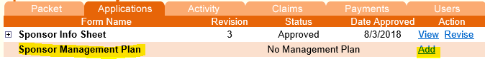

- Click on Add to access the Management Plan
This document is the same Management Plan that is used for CACFP Center-Based Sponsors. We are currently not able to add to CNPweb a management plan for FDCH Sponsors so FDCH Sponsors will complete and submit this form with some minor adaptations.

- Terminology:
  - Facility = FDCH Provider
  - Institution = FDCH Sponsor
  - Point of Service Meal Counts = Meal Counts

- Complete all items noting the exceptions/changes below.

CNPweb Sponsor Management Plan line(s):

- (16), (21) Tuition/parent fees are N/A to FDCH Sponsors. Do not check these boxes.

- (26) Does the institution have a waiting list for enrollment at one or more facilities?
  - Check NO. If you do not check this box the form will error out.

- (34), (35), (36) Answer: FDCH Providers

- (38), (39), (42) Answer: N/A

- (72): Point of service Meal Counts = daily meal counts submitted by midnight daily

- (75): N/A - Do not check this box

- (112): Point-of-Service Meal Counts = daily meal counts submitted by midnight daily

- (113): Meal Count Summary Sheets = Total number of meals claimed per provider

- (123): Check Not Applicable

- (150) Ensure adequate amounts of food and milk are purchased, prepared and served = observing meal to ensure meal meets minimum portion sizes

- When the entire Sponsor Management Plan is completed click Save
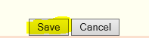

- If it is in Error status after saving it, review the errors and complete or correct the information and click Save

Contact your Assigned Specialist if you have any questions.

