TO: Sponsors of Family Day Care Home Providers

FROM: Meghan Tschida, Manager, Community Nutrition Programs

Date: August 3, 2026

RE: Family Day Care Home CACFP Reimbursement Rates for FY 2026-2027
Effective July 1,2026 to June 30, 2027

The Oregon Department of Education Child Nutrition Programs (ODE CNP) announces the annual adjustment to the national average payment rates for meals served in day care homes and the administrative reimbursement rates for sponsors of the day care homes, effective
July 1, 2026 - June 30, 2027.

Reimbursement Rates: (all amounts expressed in dollars or fractions of dollars)

Breakfast |  | Lunch & Supper |  | Supplement (snack)
TIER 1 | TIER 2 | TIER 1 | TIER 2 | TIER 1 | TIER 2
$ 1.74 | $ 0.62 | $ 3.31 | $ 1.99 | $ 0.98 | $ 0.27

Administrative Reimbursement: (per home/per month)

Initial 50 day care homes . . . . . . . . . . . . . | $ 157
51 – 200 day care homes . . . . . . . . . . . . | $ 119
201 – 1,000 day care homes . . . . . . . . . . | $ 93
Each home over 1,000 . . . . . . . . . . . . . . | $ 82

If you have questions concerning the reimbursement rates, please contact your assigned Child Nutrition Specialist.

Sincerely,
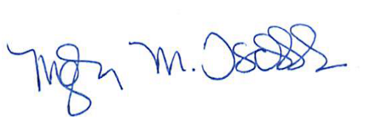
Meghan Tschida
Manager, Community Nutrition
Child Nutrition Programs

