- Our program is always in a deficit because the reimbursement rates don't cover the cost of the program. It is ok to use the expansion grant to reimburse us for already planned advertising and/or mileage to transport food to sites? Or does it have to be for something new that we have never done before or purchased before?
Grant funds may be used for advertising of the SFSP. Grant funds may also be request for mileage, though ideally it is for new sites and/ or meal routes in rural areas.

- Is the CNP start up grant and expansion grant put on hold or can we apply?
The SUE grant is now open and potential applicants are encouraged to apply.

- What is the due date for this grant?
The due dates and times are listed in the Schedule Section of the RFA.
- Regarding the CNP Startup and Expansion Grants Program. Section 3.1.2 of the RFA states that all questions must be emailed to the SPC; however, the program page includes a link to a question submission form (link to the form provided below for reference). Just to confirm, may questions be emailed to the SPC as well as be submitted via the online question form? Question form link: https://app.smartsheet.com/b/form/fbe7f6ee47a5411bbec6d49e57c6f66c
Both ways are acceptable. SPC does a review of the questions submitted on the Smartsheet as well as submitted by email.

- In reference to the ODE CNP Startup and Expansion Grant, Attachment D "Use of Funds" Part 3A. Would the following items be allowable under Transportation Related Purchases:
- Retrofitting a van with a lift gate for mobile meal operations
- Adding a power inverter to the cargo area of a van to transport food warmers for mobile meal operations.
Yes, both retrofitting a van with a lift gate and adding a power inverter to support the delivery of hot summer meals are allowable under Transportation related purchases.

- In the grant will not pay for vehicles, but will it pay for a rental refrigerated truck?
The grant is unable to be used to pay for motorized vehicles. However, a non-motorized refrigeration trailer may be an eligible grant expense.

- Does the Startup and Expansion Grant operate monthly through 2025 (do people have a 1-month window to apply before the next cycle)? I have included an image below to better explain my thoughts:
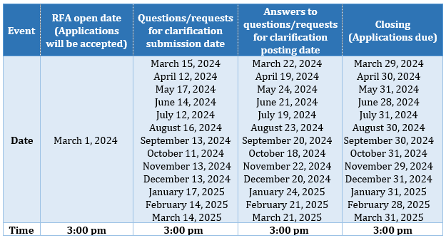

From the information included above, it looks as though there are 12-13 application windows that run for a month. If I were an applicant, would I plan to apply in a certain month? Please correct me if I somehow misinterpreted the chart!
This is a rolling solicitation for Applications related to the CNP Start Up and Expansion Grant. You may apply during any one of the monthly dates listed in the Schedule of the Request for Application (RFA). As an example. if you intend to apply for the month of June, if you have any questions, be sure they are submitted by the submission date of June 14th. The response to your question will be posted on June 21st, and your application must be submitted/received by June 28th. If you miss any of the dates for the month, you should consider applying for any following month available in the Schedule.
- Is this grant similar to the annual renewal grant where we make the purchases then request reimbursement OR does ODE provide the funds and then we do reporting?
This is a reimbursement grant. Grantees may submit documentation and claims in EGMS as costs are incurred. However, a final claim will not be paid until all reporting requirements are met.
- I’m looking for more clarification surrounding the expansion grant and what we could use if we reapply for the next biennium. Would we be able to use the funds awarded for the same items that were used on the last grant cycle? I’m specifically asking for our delivery driver position that the grant paid for and the miles from our rented truck.
Attachment D (Uses of Funds) describes what grant funds may be used for. In the case of labor costs, grant funds "are to be used for new staff, new hours, or new duties for existing staff when current duties are transferred to a different staff member." As for mileage, grant funds can be requested in separate biennium to increase participation in the program.
- Could this grant cover a work contract paid upfront? For example, a person is hired to work 100 hours between June 1, 2025 - August 15, 2025 and paid a lump sum at the start of the contract for hours to be worked, with timesheets provided as supporting documentation as the work was completed

Yes, as this is a startup grant this would be an eligible expense. Contract payment would need to be made by the June 30th deadline. Documentation to include when requesting reimbursement would be a copy of the signed contract and timesheets of time worked.

- We are planning a box meal program at three of our high schools in our district this summer. We would like to plan on making 140 boxes at each of the three schools. At school pick up. Each week the boxes would contain enough meals for 7 breakfast and 7 lunches. Would we be able to apply for the expansion grant to help cover labor costs?

Yes, food service labor costs are an allowable grant expense. For more allowable costs, please see "Att D Uses of Funds" on the grant's webpage.

- Due to the biennium ending 06/30, can districts apply for the new biennium and backdate SFSP expenditures to 07/01?

During the transition between funding bienniums, two conditions must be met to be eligible to be reimbursed for funds spent prior to the grant application awarded. First, the organization's insurance certificates must show the organization had proper insurance across the entire length of time the grant funds are requested for. Second, the organization must include on their grant application a full description of all items being requested and their cost.

- A. When will the 2025-27 biennium Startup and Expansion Grant applications open?
-B. Will there be a grant extension on the 2023-25 biennium Startup and Expansion Grant (possibly extending the expenditure period to 09/30/2025)?

In regards to the next biennium, that is dependent on if funding for the Startup and Expansion Grant is included in the budget. If so, it our goal to have the grant posted in the fall of 2025. As for funding for this biennium, all funds must be expended by June 30, 2025. Please do refer to the Q&A for this grant on the grant webpage for related questions.

- Can you tell me more about this grant and how we could use if we are eligible to apply? I know the deadline is coming quick

The Startup and Expansion Grant funds are intended for the startup or expansion of existing summer or afterschool meals programs. The Startup and Expansion Grant RFA (Request for Applications) outlines all requirements for the grant, including eligibility. This is located on the grants webpage along with the link to the application.

