Date: March 3, 2025

NOTICE OF INTENT TO AWARD

RFA #: 35405
RFA TITLE: CNP STARTUP AND EXPANSION GRANTS APPLICATION OPENING: 3:00 PM, FEBRUARY 28, 2025
This is the Department of Education’s (“Agency”) official Notice of Intent to Award. The Agency intends to award a grant to:
Scio School District

Applicant | Evaluation Score
Scio School District 95 | 4/4

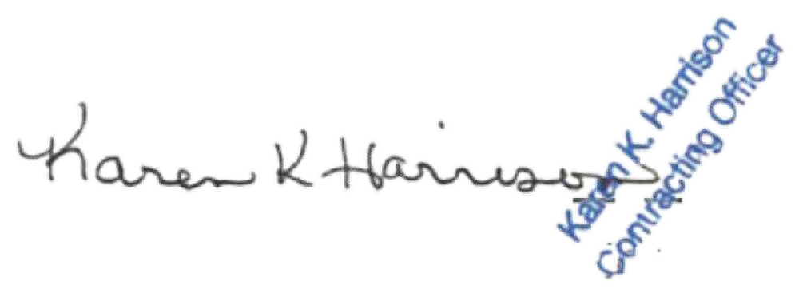
If you have any questions about this Notice of Intent to Award, please contact Karen Kay Harrison, Contract Officer at 503.689.4253 or karen.harrison@ode.oregon.gov

Karen Kay Harrison Contracting Officer

