Submitting CACFP Reimbursement Claims with CNPweb

## To Complete a Monthly Reimbursement Claim

**Step 1:** In the address bar of your internet browser, enter the website: <https://cnp.ode.state.or.us>

*CNPweb* Login page displays

**Step 2:** Enter your CNPweb user ID and password

**Step 3:** Click **Login**

**Step 4:** click on the **CACFP puzzle piece**

*CNPweb* displays the **“Splash”** page. (review the announcements posted here before entering CNPweb)

**Step 5:** Click **“Continue”** on the Splash page

CNPweb displays the **Program Year Selection** page

**Step 6:** Select the program year that needs a monthly claim submitted

* If you are assigned to only 1 Sponsor, *CNPweb* will display the **Sponsor Summary** page for your Sponsor
* If you are assigned to more than 1 sponsor, *CNPweb* will display the **Select Sponsor** page. At this page, select the sponsor that you wish to submit a claim for. *CNPweb* will then display the **Sponsor Summary** page for the selected Sponsor

**Step 7:** On the **Sponsor Summary** page,Click on the Claims tab to display the **Sponsor Summary-Claims** page.

**Step 8:** Locate the claim month.

**Step 9:** Click **Add** in the “Action” column on far right.

The *CNPweb* displays the **Sponsor Claim** form.

**Step 10:** Scroll to the bottom of the claim form. Do not fill out the form at this time.

**Step 11:** Click **Submit**. Do not check the Certify checkbox at this time.

The *CNPweb* checks to see which site claims your organization must submit for this month and displays the **Post Confirmation** page with the **Errors Detected** status. (The Sponsor claim can be left in Error Status until all Site claims are completed)

**Step 12:** Click the **“here”** link in the last line of the Post Confirmation message.

The *CNPweb* displays the **Sponsor Summary - Claims** page.

**Step 13:** Click the folder plus sign icon to the left of the claim month. This expands the Sponsor claim to display the list of sites expected to submit claims for this claim month.

* If this list is incorrect (there are sites listed that you will not submit a claim for or there are sites not listed which you intend to submit a claim for this month) please contact the ODE Specialist assigned to your Sponsor to make the needed changes to the approved Site applications.

**Step 14:** Locate a site that needs a claim for this month.

**Step 15:** Click **Add** in the “Action” column on far right.

The *CNPweb* displays the appropriate site claim form.

**Step 16:** Complete each required field of the claim form

**Center Operating and Enrollment Data** (all sites must complete)

(1) Free Enrollment: Enter the number of participants enrolled at this site qualifying for Free Meals during this claim period. **This field will only be entered in the first monthly claim submitted in each fiscal year. Subsequent months will be pre-filled with this information.**

(2) Reduced Enrollment: Enter the number of participants enrolled at this site qualifying for Reduced Price Meals during this claim period. **This field will only be entered in the first monthly claim submitted in each fiscal year. Subsequent months will be pre-filled with this information. This field is not available for At-Risk Sites.**

(3) Above Scale Enrollment: Enter the number of participants enrolled at this site qualifying for Above Scale Meals during this claim period. **This field will only be entered in the first monthly claim submitted in each fiscal year. Subsequent months will be pre-filled with this information. This field is not available for At-Risk Sites.**

(4) Total Enrollment: Total of lines 1, 2 & 3. (Be aware that a participant enrolled in multiple sites may only be recorded at one site) **This field will only be entered in the first monthly claim submitted in each fiscal year. Subsequent months will be pre-filled with this information.**

(5) Number of Operating Days: Total days the site was open and operating (with participants present) during this claim period (cannot be more than 23 for week-day only sites, and cannot be more than the number of days in the month for any site)

(6) Total Monthly Attendance: Total attendance for this claim period (total attendance day 1 + total attendance day 2 + total attendance day 3 + etc,etc)

(Please be careful to correctly calculate this number, as it will affect many other items on your claim!!)

**Meal Count Data** (all sites must complete)

Column (A) Breakfast: Enter the total number of Breakfasts served at this site during this claim period

Column (B) AM Snack: Enter the total number of AM Snacks served at this site during this claim period

Column (C) Lunch: Enter the total number of Lunches served at this site during this claim period

Column (D) PM Snack: Enter the total number of PM Snacks served at this site during this claim period

Column (E) Supper: Enter the total number of Suppers served at this site during this claim period

Column (F) Evening Snack: Enter the total number of Evening Snacks served at this site during this claim period

**For-Profit Sites Only** (only For-Profit site need complete this section)

(14) Total TitleXX / XIX Beneficiary participants

(15) Total F/RP Eligible participants.

(16) Current Total Enrollment or Site Capacity (whichever is less)

(17) Choose one: (You must choose one option in order to submit the site claim. You may choose the second option if not submitting for this month)

* This organization certifies that during this claim month at the site being claimed, 25% of the Current Enrollment or Site Capacity (whichever is less) are Title XX or Title XIX Beneficiaries or Free/Reduced Priced Eligible Participants.
* This organization realizes that the Site does not meet the 25% Eligibility for For-Profit Sites, and that this claim will not be reimbursed and no meals will be reported.

**Step 17:** When form is completed, click **Submit**.

The *CNPweb* checks the claim form for input errors.

• If the *CNPweb* finds **errors**, it displays the appropriate Post Confirmation page with the **Errors** status. You must correct all errors and resubmit your claim. For assistance in correcting errors, please see the Troubleshooting Section.

• If the *CNPweb* finds **no errors**, it displays the appropriate Post Confirmation page with the **Complete** status.

**Step 18:** Click the **“here”** link in the last line of the Post Confirmation message.

*CNPweb* displays the **Sponsor Summary – Claims** page.

**Step 19:** Repeat **Step 14** through **Step 18** for each site claim. Each site listed should have a claim entered, and should have the status of Complete.

**Step 20:** Locate the sponsor claim for this month on the **Sponsor Summary – Claims** page.

**Step 21:** Click **Edit** in the “Action” column on far right.

The *CNPweb* displays the filled-in **Sponsor Claim** form.

**Step 22:** Check meal counts to ensure they are correct.

* Do not check the **Certify** checkbox until you have confirmed that all data included in the monthly claim is true and complete.
* Sponsor claim may be in Error status at this point. This is normal and should not be cause for alarm.

## To View Reimbursement Value for a Completed Payment

**Step 23:** Scroll to the bottom of the claim form.

The *CNPweb* displays the bottom of the claim form with the **Submit** button.

**Step 24:** Click **Submit** (Do not check the Certify checkbox at this time)

The *CNPweb* displays the **Sponsor Claim Summary** page with the claim payment value information.

**Step 25:** Review claim payment value information displayed.

**Step 26:** Click the **“here”** linkat the bottom of the page to return to the **Sponsor Summary -**

**Claims** page.

* If the Sponsor claim was in Error status, this action may remove the error status from Sponsor claim, but DOES NOT submit the claim to ODE!!

## To Submit a Completed Claim for Payment

**(Once you do this any revision must wait until notice of payment is made.)**

**Step 27:** Locate the sponsor claim for this month on the **Sponsor Summary – Claims** page.

**Step 28:** Click **Edit** in the “Action” column on far right.

The *CNPweb* displays the filled –in **Sponsor Claim** form

**Step 29:** Carefully review the claim for accuracy.

**Step 30:** If **all** information is true and correct to the best of your knowledge, scroll to the bottom of the claim form and check the **Certify** checkbox.

**Step 31:** Click **Submit**

The *CNPweb* displays the **Sponsor Claim Summary** page with the claim information and status. **\*\***You may want to print this page for your records.

**Step 32:** Click the **“here”** linkat the bottom of the page to return to the **Sponsor Summary -**

**Claims** page.

* At this point, the monthly claim is complete and submitted. The claim should be in either pending Approval or Approved status, and no changes may be made to it until after the claim is paid. To make revisions after payment of this claim has been made, see the To Revise a Monthly Claim section.
* You may review the amounts and statuses of past and current claim payments by clicking on the **Payments** tab on the **Sponsor Summary** page.

## To Revise a Monthly Claim

**(Revisions can only be made once a claim has been Paid)**

**Step 1:** Locate the sponsor claim for the month that needs to be revised on the **Sponsor Summary-Claims** page

**Step 2:** Click on **Revise** at the far right hand column

The *CNPweb* displays the **Sponsor Claim** for the selected month

**Step 3:** Scroll to the bottom of the claim form

**Step 4:** Make sure that the **Certify** checkbox is not checked

**Step 5:** click **Submit**

The *CNPweb* displays the Post Confirmation message

**Step 6:** Click the **“here”** link in the last line of the Post Confirmation message.

The *CNPweb* displays the Sponsor Summary-Claims page

**\*\***Note: there should now be a plain +/- icon to the left of the folder +/- icon. This plain +/- icon controls the expansion of past and current revisions.



**Step 7:** Click on the folder +/- icon to the left of sponsor claim for the month



The *CNPweb* displays the list of sites expected to be included in the monthly claim. Sites that have been submitted and Paid previously will have a status of Paid.

**Step 8:** Locate a site claim which needs to be revised

**Step 9:** click **Revise** in the “Action” column on the far right

The *CNPweb* displays the Site Claim form

**Step 10:** Make corrections to Claim form as needed

**Step 11:** Scroll to the bottom of the claim form

**Step 12:** Click **Submit**

The *CNPweb* checks the claim form for input errors.

• If the *CNPweb* finds **errors**, it displays the appropriate Post Confirmation page with the **Errors** status. You must correct all errors and resubmit your claim. For assistance in correcting errors, please see the Troubleshooting Section.

• If the *CNPweb* finds **no errors**, it displays the appropriate Post Confirmation page with the **Complete** status.

**Step 13:** Click the **“here”** link in the last line of the Post Confirmation message.

*CNPweb* displays the **Sponsor Summary – Claims** page.

**Step 14:** Repeat **Step 8** through **Step 13** for each site claim that needs revision. Each site listed should have a claim entered, and each revised site claim should have a status of Complete.

**Step 16:** Locate the Sponsor claim for the revised month

**Step 17:** click **Edit** in the “Action” column on the far right

The *CNPweb* displays the filled –in **Sponsor Claim** form

**Step 18:** Carefully review the claim for accuracy.

**Step 19:** If **all** information is true and correct to the best of your knowledge, scroll to the bottom of the claim form and check the **Certify** checkbox.

**Step 20:** Click **Submit**

The *CNPweb* displays the **Sponsor Claim Summary** page with the claim information and status. **\*\***You may want to print this page for your records.

**Step 21:** Click the **“here”** linkat the bottom of the page to return to the **Sponsor Summary -**

**Claims** page.

* At this point, the revised monthly claim is complete and submitted. The claim should be in either pending Approval or Approved status, and no changes may be made to it until after the claim is paid.
* To view past versions of this claim, use the plain +/- icon to expand and view past revisions. Unlike Editing a claim before Submission to ODE, Revising a claim saves a record of the earlier Submitted versions.



## Troubleshooting

**Common Problems and Solutions:**

|  |  |
| --- | --- |
| **Problem** | **Steps to solve** |
| **Input error** (this is an error in the data type or entry format. Common errors: entering text where numbers/intergers are required or vice-versa.) | 1. An input error will not allow you to submit the form. When you click Submit, it will bring you to the top of the form, and the error message will display. 2. find the field or field number highlighted in red 3. The error description should tell you what the error was. 4. Review the information entered in the field and make corrections as neccesary. |
| **Validation error** (this is an error found by comparing one field with other data either on this form or on a form in the approved Application Packet. Example: you’ve claimed suppers, but your approved Site Information Sheet lists your site as serving only Breakfast and Lunch.) | 1. Find the field or field number highlighted in red 2. Read the error message relating to this highlighted field 3. Review the requirements for this field in the detailed field descriptions included in Step 16 of the To Complete a Monthly Reimbursement Claim section. 4. Make the appropriate changes. 5. If Error still is not resolved, continue to next question below: “Validation error won’t go away…” |
| **Validation error won’t go away**, and the data I entered is correct! (most commonly caused when the approved Site Information Sheet has incorrect information. Example: the Site information sheet lists that this Site only serves Breakfast, but it really serves Breakfast and Lunch.) | 1. Find the field or field number highlighted in red 2. Double check that the data you entered is correct 3. Exit claim, and click on Applications tab on the Sponsor Summary 4. Find the Site Information Sheet for the Site in question 5. Review the Information Sheet to make sure the information there is correct |
| A **Site** I need to claim for **is not listed** (when Sponsor Claim is expanded to display Sites expected to submit a claim) | 1. Exit claim, and click on Applications tab on the Sponsor Summary 2. Find the Site Information Sheet for the Site in question 3. Review the Information Sheet to make sure the information there is correct (the most common mistake is that the checkbox for the month in question is unchecked on the Site Information Sheet) 4. Work with your ODE Specialist to make the necessary revisions to the Site Information Sheet. 5. Return to Claims tab – Site should now be included on displayed list |
| A **Site is listed which was not operational** or for which I do not intend to submit a claim for this month (when Sponsor Claim is expanded to display Sites expected to submit a claim) | ** If it is a For-Profit site which simply did not meet the eligibilty requirements this month, fill out all fields as usual, but click the second option on field #17.  *For all Others:   1. Exit claim, and click on Applications tab on the Sponsor Summary 2. Find the Site Information Sheet for the Site in question 3. Review the Information Sheet to make sure the information there is correct (the most common mistake is that the checkbox for the month in question is checked on the Site Information Sheet when it should be unchecked) 4. Work with your ODE Specialist to make the necessary revisions to the Site Information Sheet. 5. Return to Claims tab – Site should no longer be included on displayed list |
| The instructions say **I should get a Post Confirmation message**, but I do not get that message at this step. | You may have triggered an input error. This type of error will not allow you to submit the form. When you click Submit, it will bring you to the top of the form, and the error message will display. If this is the case, See Input Error section above  You may be getting a message that states that a record has not been created (often, this will state that this submission is a duplicate submission). In this case, click the “here” link provided to return to the Sponsor Summary-Claims page. Review the claim status on this page and add or edit the Site Claim as needed. |
| **Sponsor Claim is in Error** Status | Not all Site claims have been submitted. When first creating the monthly claim you will be purposefully creating an incomplete Sponsor Claim, in order to open and add a monthly claim for each Site. It is fine for the Sponsor claim to remain in Error status until all Site claims have been entered and are in **Complete** status. Once all Site claims are entered, and all data is correct, check the Certify checkbox and Submit the Sponsor claim. |
|  |  |

**Miscellaneous Tips, Hints and Guides:**

**Quick hint: when viewing a form with errors displayed, the *CNPweb* highlights (in red) either the edges of the problem field or the field number. In most cases, this field that is marked with the highlight is the one that needs to be changed.

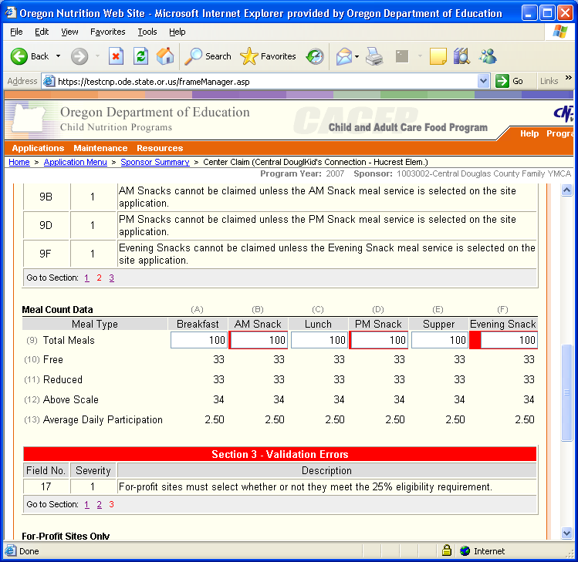

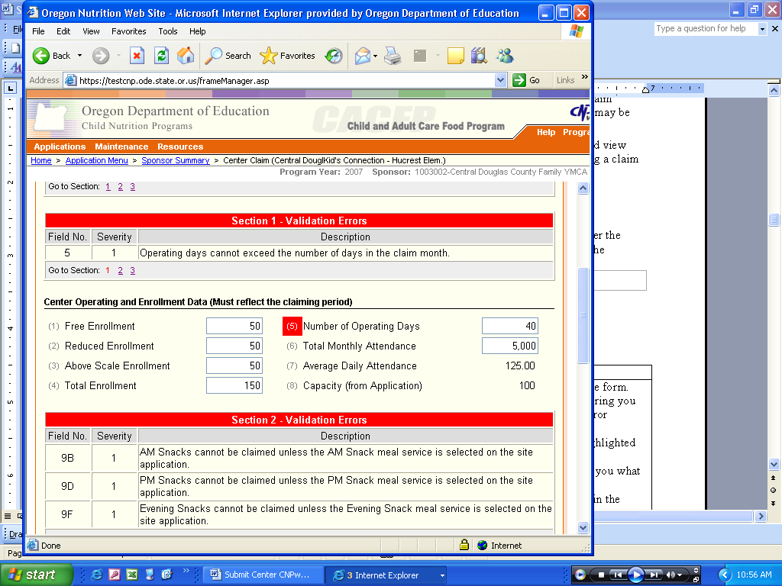

**Guide to a typical Error display:**

|  |  |
| --- | --- |
| **Section of Display** | **Description** |
| Field Number | Provides the unique field number where the error occurs. (the field or field number will be highlighted as noted above) |
| Severity (most errors will be Severity 1 and must be corrected in order to submit the form) | The CNPweb rates the severity of error.  **Severity 1** - Errors that you must correct before you submit the form approval.  **Severity 2** - Errors that you should correct before you submit the form for approval.  You must correct all errors on this form. |
| Description | A statement of the error condition, with information designed to help you fix the error. |
| Go to Section | Click on these hyperlinked numbers to quickly jump to each section with errors |

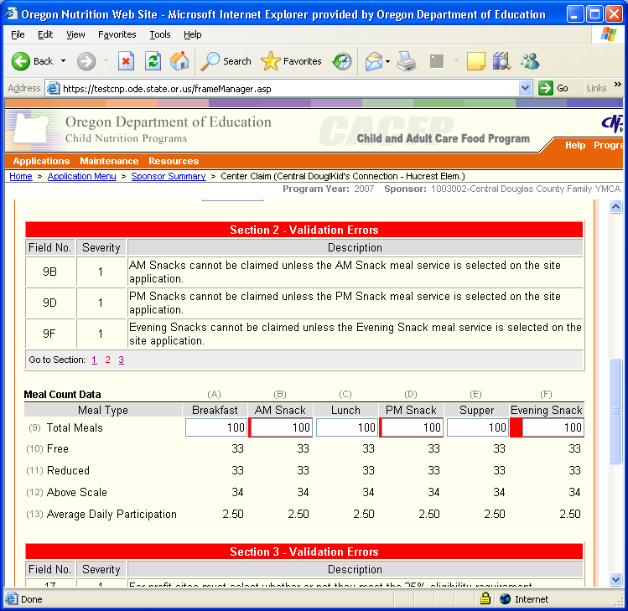

* What’s the difference between “Edit” and “Revise”?? Both are used to refer to making changes to a Claim, but the differences are based in what “change history” is saved and when in the process each one can be used.
  + When in Edit mode, changes are not tracked. The Edit option is only available until the claim is submitted.
  + When in Revise mode, changes are tracked and each version is saved. When displaying a revised form, fields that were changed the last revision are highlighted in yellow, and hovering the cursor over the highlighted field will display what information was previously entered. The Revise option is only available once a claim has reached **Paid** status.
* The CNPweb does not submit a claim to ODE for approval unless you check the Certify checkbox in the Sponsor claim - even if the claim contains no errors.

My claim has a status of ____________. What do I have to do to reach **Paid** Status???

| Current Status | Action |
| --- | --- |
| Errors | Click Edit in the “Action” column; correct each highlighted error; Click Submit; repeat as needed to correct all errors. |
| Complete | No action required on the site claim.  You must submit the sponsor claim (claim summary) to submit the site claims. |
| Pending Submission | Click Edit in the “Action” column for the Sponsor Claim; review the claim and check the payment checkbox if all is correct; Click Submit. |
| Pending Approval | No action required.  Your organization cannot change claims in this status. The OR Department of Education must review your claim if to move it forward.  If the state agency automatically approves claims from your organization, the CNPweb never assigns the **Pending Approval** status to your claims, and your claim will go directly to **Approved** status. |
| Approved | No action required.  Your organization cannot take any action on a claim with the **Approved** status. |
| Paid | No action required.  Your organization cannot edit a paid claim. If you need to submit a claim adjustment, you must revise the paid claim. |

My claim has a status of ____________. How can I **make a change** to my claim???

| Current Status | Action |
| --- | --- |
| Errors | Click Edit in the “Action” column; correct each highlighted error; Click Submit; repeat as needed to correct all errors. |
| Complete | Click Edit in the “Action” column; make corrections as needed; Click Submit. |
| Pending Submission | Click Edit in the “Action” column; make corrections as needed; Click Submit. |
| Pending Approval | No changes allowed.  Your organization cannot change claims in this status. You will have to wait until claim has the status of **Paid** in order to make any revisions.  If the state agency automatically approves claims from your organization, the CNPweb never assigns the **Pending Approval** status to your claims. |
| Approved | No changes allowed.  Your organization cannot make any changes to a claim with the **Approved** status. |
| Paid | Click Revise in “Action” column for Sponsor claim; make sure Certify checkbox is cleared and click Submit; Click Revise in the “Action” column for each Site needing revision; make changes as necessary; when you are finished revising Site claims and all Site claims have a status of **Complete**, click Edit in the “Action” column for the Sponsor claim; review Sponsor claim and check the Certify checkbox if all is correct; Click Submit. |

If, after reviewing this Troubleshooting section, you are unable to solve a problem with your Claim submission, please contact your assigned ODE Specialist. If your assigned Specialist is not available, please press zero to be redirected to another Specialist.

This institution is an equal opportunity provider