Summer Food Service Program

Reimbursement Rate SHEET
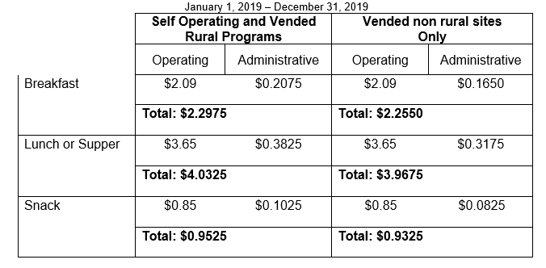
Use this chart for determining the eligibility of applications for summer 2019 program.
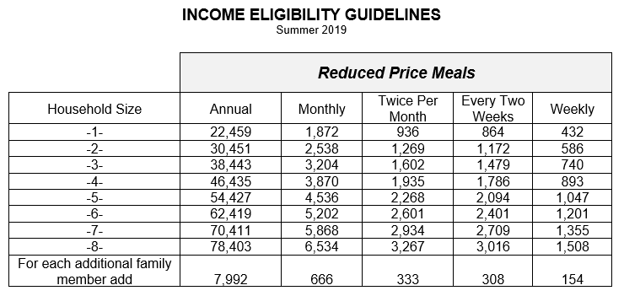

Form 581-3526b-E

