SB 13 Tribal History/Shared History
Monthly Update – February 2020

Greetings! We welcome a new year and great things to come for SB 13 Tribal History/Shared History. We hosted our first SB 13 Tribal History/Shared History Train the Trainer event on December 12, 2019 at Western Oregon University. It was a huge success with 78 educators in attendance from all across the state.
A big thank you to all of the amazing facilitators that presented at the event. We received a blessing of aboriginal lands by Jon George, Tribal Council Member of the Confederated Tribes of Grand Ronde and presentations by, Dr. Shadiin Garcia, Educator Advancement Council, Mercedes Jones, Confederated Tribes of Grand Ronde Education Division, Sarah Pierce, Education Northwest, Dr. Leilani Sabzalian, University of Oregon Indigenous Studies in Education and Sapsik'wałá Teacher Education Program, Brent Spencer, Confederated Tribes of the Umatilla Indian Reservation, and Louise White, Yup’ik Tribal Elder.

Our goals for the event were to:
- Have participants come away with the ability to teach, train and be a source of support, knowledge, and advocacy within their school/district for SB 13 Tribal History/Shared History
- Provide a full background on SB 13 (the what and the why – where it came from, etc.)
- Overview of Critical Orientations for Indigenous Studies Curriculum (The 6 P’s)
- Educator Toolkit and ODE Website Resources
- Lesson Plan Development (template of lesson plan – the what and why of the lesson format creation)
- Essential Understandings Process/Document
- Introduce final version lessons of the curriculum through lesson modeling and activities, allow for discussion and discourse of the curriculum
- Create a community/network of support for educators
Participants that attended the event will be listed as a resource to provide future professional development on Tribal History/Shared History.

Updates were recently made to the Educator Toolkit. This is a compilation of SB 13 materials developed for educators that include:

- Introductory letter
- Approaches in Indigenous Education
- Critical Orientations for Indigenous Studies Curriculum (6 P’s)
- Frequently Asked Questions
- SB 13 General Overview/Talking Points
- SB 13 Flyer
- Youth Reading List
- Resource List
- Pre-Assessment
- The Essential Understandings of Native Americans in Oregon

*All items in the Educator Toolkit are available on the ODE SB 13 Tribal History/Shared History web page.
Lesson plans are now available in grades 4, 8 and 10!
To view/download visit the ODE Tribal History/Shared History web page at:
https://www.oregon.gov/ode/students-and-family/equity/NativeAmericanEducation/Pages/Senate-Bill-13-Tribal-HistoryShared-History.aspx
Districts will be able to choose one lesson per grade in each content area to implement for the 2019-20 academic year – teaching a minimum of 15 lessons. Additional lessons are currently being created, so please keep visiting the website.
Upcoming Events
- Next SB 13 Tribal History/Shared History Training Opportunity: February 20, 2020 – Salem – Train the Trainer Part II (This is a continuation of the December 12th training)

- March 19, 2020 – SB 13 Tribal History/Shared History Train the Trainer Part I – Registration is open! If interested, please complete the link below. Space is limited! Registration will be on a first come, first serve basis. A second training (Train the Trainer Part II) will follow this training and be held in April or May - TBA

https://www.eventbrite.com/e/sb-13-tribal-historyshared-history-train-the-trainer-part-i-tickets-90234765613?ref=estw

- Grand Ronde Education Summit – A session will be available that allows for dialogue and discussion on SB 13 Tribal History/Shared History curriculum and training facilitation - network of support for SB 13 Trainers/Educators - June 25 and 26, 2020
Exciting things to come:
- An online network of support for SB 13 Tribal History/Shared History educators to access. This will allow for a platform of discussion and questions on the new curriculum. Visit the link at:
https://www.oregonednet.org/groups/sb-13-tribal-historyshared-history

- We are in the process of sending out an RFP for further SB 13 professional development. Our hope is that this will assist in meeting the demand for training through web-based platforms and other avenues.

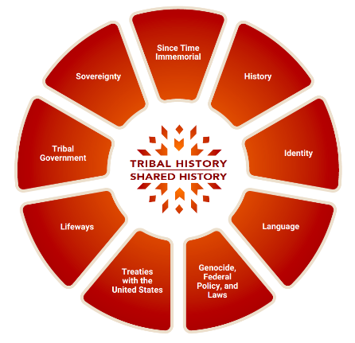
The 2019-2020 school year will be considered a "soft roll-out" of the SB 13 Tribal History/Shared History curriculum. It will be a limited preview release allowing for adjustments to be made before a wider release and implementation in 2020-2021. That being said, you will have access and are welcome to teach and share all lessons available through the SB 13 Tribal History/Shared History website.

To receive updates on Tribal History / Shared History please visit the Tribal History / Shared History on ODE’s website or contact April Campbell, Indian Education Advisor to the Director of Public Instruction via email or call her at (503) 947-5810.
We are grateful for all of you for your support of SB 13 Tribal History/Shared History as we continue to move forward in implementation!
With gratitude and appreciation,
The Office of Indian Education

