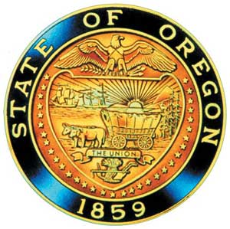
Tina Kotek, Governor

AI/AN Advisory Committee Members

Chair Tamara Henderson
Vice Chair Leilani Sabzalian
Angie Fasana
Tamara Henderson
Kainoa Sandberg
Sonya Moody-Jurado
Marsha Frost
Chris Mansayon
Juliana Marez
Julie Bettles
Luhui Whitebear
Jamie Crane
Nicole Butler-Hooton
Robin Butterfield
Shelby Maerz
Valerie Switzler
Diane Teeman
Jemiah Wassman
Rochelle Weiser-Nieto

Office of Indian Education
April Campbell, Assistant Superintendent
Renee Roman Nose, Native American Student Success Coordinator
Brent Spencer, Indian Education Coordinator
Brandon Culbertson, Education Engagement Coordinator
Stacy Parrish, Indian Education Specialist
Raina Reece, Executive Support Specialist
Jennifer Belle, Office Specialist
Stephanie Gluck, Research & Data Analyst

2024 Meeting Dates
November 9:30 am – 3:30 pm

American Indian/Alaska Native Advisory Committee
October 18, 2024
9:30 a.m. – 12:00 p.m.
Oregon Department of Education
AGENDA
Join ZoomGov Meeting
https://www.zoomgov.com/j/1603617048?pwd=kASTkPzp3YAERpsSbmxVjGaVHHRU3h.1

9:30 1.0 Call to Order, Opening Remarks Chair Henderson
1.1 Opening Blessing TBD
1.2 Committee Roll Call/Introductions
1.3 Introductions & Welcome to Partners Chair Henderson

9:35 2.0 Review of September 2024 Minutes All

9:40 3.0 Office of Indian Education
3.1 Q & A
3.2 Advisory Committee Retreat

10:00 4.0 Community Comment Chair Henderson
Public testimony may be submitted ahead of time in writing to
AIAN.AdvisoryCommittee@OregonLearning.org

10:05 5.0 Other Business and Next Meeting Agenda Items All
5.1 OIEA Update

10:15 6.0 Charter Committee Creation Renee Roman Nose

10:25 Break

10:35 7.0 Student Success Plan OIE
7.1 Discussion
7.2 Break out 11:45
7.3 Full Group Debrief 11:30

11:50 8.0 AI/AN Advisory Committee Business
8.1 2024 State Training Required for all Advisory Committee Members

12:00 Adjourn

