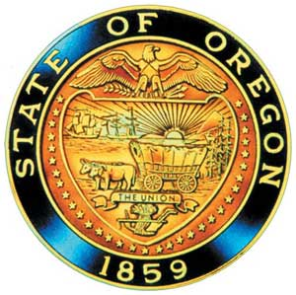
Tina Kotek, Governor

AI/AN Advisory Committee Members

Chair Tamara Henderson
Vice Chair Leilani Sabzalian
Angie Fasana
Alt. Bethany Mason
Jen Anderson
Crystal Hinds
Sonya Moody-Jurado
Marsha Frost
Chris Mansayon
Julie Bettles
At large representative - Open
Jamie Crane
Nicole Butler-Hooton
Robin Butterfield
Shelby Maerz
Valerie Switzler
Mileah Skunkcap
Jemiah Wassman
Roshelle Weiser-Nieto
Jennifer Reid
Alt. Jesse Jackson

Office of Indian Education
April Campbell, Assistant Superintendent
Renee Roman Nose, Native American Student Success Coordinator
Brent Spencer, Indian Education Coordinator
Brandon Culbertson, Early Literacy Senior Advisor
Stacy Parrish, Indian Education Specialist
Raina Reece, Executive Support Specialist

2026 Meeting Dates
March 13th 9:30am – 11:30pm
April 17th 9:30 am – 3:30pm

American Indian/Alaska Native Advisory Committee
February 13th , 2026
9:30 a.m. – 11:30 a.m.
Oregon Department of Education
DRAFT AGENDA

9:30 1.0 Call to Order, Opening Remarks Chair Henderson
1.1 Opening Blessing TBD
1.2 Committee Roll Call
1.3 Introductions with Shana Radford, Tribal Affairs Director AC
1.4 Introductions & Welcome to Partners Chair Henderson

9:40 2.0 Review of January 2026 Minutes All

9:45 3.0 Assistant Superintendent Update
3.1 April Campbell

10:05 4.0 OIE Updates OIE Team
4.1 AI/AN Student Success Plan Goals Renee Roman Nose
4.2 Tribal Languages Brandon Culbertson
4.3 TAPP Update Stacy Parrish
4.4 Tribal History/ Shared History Brent Spencer
4.5 AI/AN Talking Circle Renee Roman Nose

10:45 5.0 AI/AN Advisory Committee Business Chair Henderson
5.1 Participation & Satisfaction Survey Results
5.2 2026 Charter Review Committee Poll
5.3 Open Seat: At Large Representative
5.4 What is happening in your community?
a. Rising Community Concerns
b. Celebrations & Upcoming Events
5.5 Future Meeting Dates

11:20 6.0 Community Comment Chair Henderson
Public testimony may be submitted ahead of time in writing to
RainaReece@Ode.Oregon.gov

11:25 7.0 OIEA Update

11:30 Adjourn

