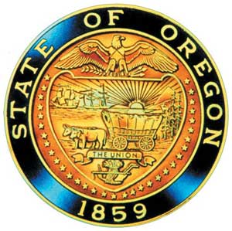
Tina Kotek, Governor

AI/AN Advisory Committee Members

Chair Tamara Henderson
Vice Chair Leilani Sabzalian
Angie Fasana
Alt. Bethany Mason
Jen Anderson
Crystal Hinds
Sonya Moody-Jurado
Marsha Frost
Chris Mansayon
Julie Bettles
At large representative - Open
Jamie Crane
Nicole Butler-Hooton
Robin Butterfield
Shelby Maerz
Valerie Switzler
Mileah Skunkcap
Jemiah Wassman
Roshelle Weiser-Nieto
Jennifer Reid
Alt. Jesse Jackson

Office of Indian Education
April Campbell, Assistant Superintendent
Renee Roman Nose, Native American Student Success Coordinator
Brent Spencer, Indian Education Coordinator
Brandon Culbertson, Early Literacy Senior Advisor
Stacy Parrish, Indian Education Specialist
Raina Reece, Executive Support Specialist

2026 Meeting Dates

American Indian/Alaska Native Advisory Committee
January 9th , 2026
9:30 a.m. – 11:30 a.m.
Oregon Department of Education
AGENDA
Join ZoomGov Meeting
https://www.zoomgov.com/j/1612428448

9:30 1.0 Call to Order, Opening Remarks Chair Henderson
1.1 Opening Blessing TBD
1.2 Committee Roll Call/Introductions
1.3 Introductions & Welcome to Partners Chair Henderson

9:40 2.0 Review of November 2025 Minutes All

9:45 3.0 Assistant Superintendent Update
3.1 April Campbell

10:05 4.0 OIE Updates OIE Team
4.1 AI/AN SSP RFA Renee Roman Nose
4.2 AI/AN Town Hall Renee Roman Nose
4.3 SPED Guide Communication Plan Stacy Parrish
4.4 Tribal History/ Shared History Brent Spencer
4.5 Tribal Affiliation Brandon Culbertson

10:45 5.0 AI/AN Advisory Committee Business Chair Henderson
5.1 Participation & Satisfaction Survey
5.2 2026 Charter Review Committee
5.3 Open Seat: At Large Representative
5.4 Future Meeting Dates

11:20 6.0 Community Comment Chair Henderson
Public testimony may be submitted ahead of time in writing to
RainaReece@OregonLearning.org

11:25 7.0 OIEA Update

11:30 Adjourn

