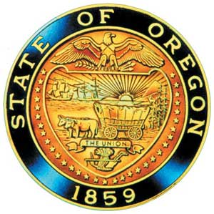
Tina Kotek, Governor

AI/AN Advisory Committee Members

Chair Tamara Henderson
Vice Chair Leilani Sabzalian
Angie Fasana
Beaverton SD – Open
Title VI - Open
Sonya Moody-Jurado
Marsha Frost
Chris Mansayon
Julie Bettles
Luhui Whitebear
Jamie Crane
Nicole Butler-Hooton
Robin Butterfield
Shelby Maerz
Valerie Switzler
Diane Teeman
Jemiah Wassman
Roshelle Weiser-Nieto
Jennifer Reid

Office of Indian Education
April Campbell, Assistant Superintendent
Renee Roman Nose, Native American Student Success Coordinator
Brent Spencer, Indian Education Coordinator
Brandon Culbertson, Early literacy Senior Advisor
Stacy Parrish, Indian Education Specialist
, Early Literacy Education Specialist
Raina Reece, Executive Support Specialist
Stephanie Gluck, Research & Data Analyst

2025 Meeting Dates

American Indian/Alaska Native Advisory Committee
May 7th , 2025
1:00 p.m. – 3:00 p.m.
Oregon Department of Education
AGENDA
Join ZoomGov Meeting
https://www.zoomgov.com/j/1617779915

1:00 1.0 Call to Order, Opening Remarks Chair Henderson
1.1 Opening Blessing TBD
1.2 Committee Roll Call/Introductions
1.3 Introductions & Welcome to Partners Chair Henderson

1:10 2.0 Review of March 2025 Minutes All

1:15 3.0 SPED Toolkit Brandon Culbertson
1:45 4.0 AI/AN Charter Robin Butterfield & Nicole Butler-Hooten
4.1 Charter Review

2:00 5.0 April Campbell – Assistant Superintendent
5.1 Federal Update

2:15 6.0 AI/AN Advisory Committee Business Renee Roman Nose
6.1 Appointment Term Letters
6.2 State Mandated Training
6.3 Open Positions: Title VI & Beaverton School District
– Beaverton: Jennifer (Jen) Anderson, Native education & Development TOSA/ Student Success Coach
6.4 June AI/AN Retreat

2:50 7.0 Community Comment Chair Henderson
Public testimony may be submitted ahead of time in writing to
AIAN.AdvisoryCommittee@OregonLearning.org

3:00 Adjourn

