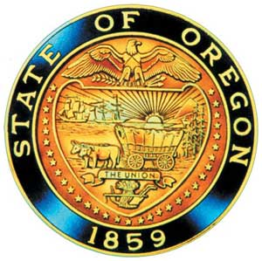
Tina Kotek, Governor

AI/AN Advisory Committee Members

Chair Tamara Henderson
Vice Chair Leilani Sabzalian
Angie Fasana
Alt. Bethany Mason
Jen Anderson
Crystal Hinds
Sonya Moody-Jurado
Marsha Frost
Chris Mansayon
Julie Bettles
Samantha Hatfield
Jamie Crane
Nicole Butler-Hooton
Robin Butterfield
Shelby Maerz
Valerie Switzler
Mileah Skunkcap
Jemiah Wassman
Roshelle Weiser-Nieto
Jesse Jackson
Alt. Jennifer Reid

Office of Indian Education
April Campbell, Assistant Superintendent
Renee Roman Nose, Native American Student Success Coordinator
Brent Spencer, Indian Education Coordinator
Brandon Culbertson, Early Literacy Senior Advisor
Stacy Parrish, Indian Education Specialist
Raina Reece, Executive Support Specialist

2026 Meeting Dates
May 15th 9:30 am – 11:30 pm
September 30th 9:30 – 11:30am
October 23rd 9:30 – 3:30pm
November 20th 10:00 – 12:00

American Indian/Alaska Native Advisory Committee
May 15th , 2026
9:30 a.m. – 11:30 p.m.
Oregon Department of Education
AGENDA

Join by Zoom
https://www.zoomgov.com/j/1612791607

9:30 1.0 Call to Order, Opening Remarks Chair Henderson
1.1 Opening Blessing TBD
1.2 Committee Roll Call
1.3 Introductions & Welcome to Partners Chair Henderson

9:40 2.0 Review of April 2026 Minutes All

9:45 4.0 Office of Indian Education
4.1 Assistant Superintendent, April Campbell Standing Updates
4.2 Indian Education Coordinator, Brent Spencer
a. Follow up Q & A on TH/SH from last meeting
4.3 Early Literacy Senior Advisor, Brandon Culbertson
a. Advancing Equitable Identification of Native Students

10:30 5.0 Office of Equity, Diversity, and Inclusion Angie Foster-Lawson
5.1 LGBTQ2SIA+ Two-Spirit & Indigiqueer Community Engagement

11:00 AI/AN Advisory Committee Business
5.2 Onboarding Framework

11:10 12.0 OIEA Update Chair Henderson

11:20 13.0 Community Comment Chair Henderson
Public testimony may be submitted ahead of time in writing to:
RainaReece@Ode.Oregon.gov

11:30 Adjourn

