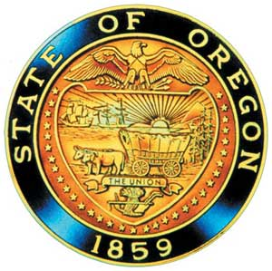
Tina Kotek, Governor

AI/AN Advisory Committee Members

Chair Tamara Henderson
Vice Chair Leilani Sabzalian
Angie Fasana
Jen Anderson
Crystal Hinds
Sonya Moody-Jurado
Marsha Frost
Chris Mansayon
Julie Bettles
Luhui Whitebear
Jamie Crane
Nicole Butler-Hooton
Robin Butterfield
Shelby Maerz
Valerie Switzler
Mileah Skunkcap
Jemiah Wassman
Roshelle Weiser-Nieto
Jennifer Reid

Office of Indian Education
April Campbell, Assistant Superintendent
Renee Roman Nose, Native American Student Success Coordinator
Brent Spencer, Indian Education Coordinator
Brandon Culbertson, Early Literacy Senior Advisor
Stacy Parrish, Indian Education Specialist
Raina Reece, Executive Support Specialist

2025 Meeting Dates
TBD

American Indian/Alaska Native Advisory Committee
November 17th , 2025
2:00 p.m. – 4:00 p.m.
Oregon Department of Education
AGENDA
Join ZoomGov Meeting
https://www.zoomgov.com/j/1617700895

2:00 1.0 Call to Order, Opening Remarks Chair Henderson
1.1 Opening Blessing TBD
1.2 Committee Roll Call/Introductions
1.3 Introductions & Welcome to Partners Chair Henderson

2:10 2.0 Review of October 2025 Minutes All

2:15 3.0 Assistant Superintendent Update
3.1 April Campbell

2:30 4.0 SpEd Resources EdNW & Team
4.1 Presentation

3:00 5.0 2025-2030 AI/AN Student Success Update Renee Roman Nose
5.1 AI/AN Student Success Plan - Communication Plan
5.2 AI/AN Student Success Plan Next Steps

3:25 6.0 AI/AN Advisory Committee Business Chair Henderson
6.1 Charter Review – Quorum & Attendance
a. Vote on Charter
6.2 Reminder: State Mandated Training
6.3 Future Presentations
6.4 Participation & Satisfaction Survey

3:45 7.0 Community Comment Chair Henderson
Public testimony may be submitted ahead of time in writing to
RainaReece@OregonLearning.org

3:50 8.0 OIEA Update

4:00 Adjourn

