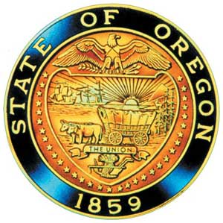
Tina Kotek, Governor

AI/AN Advisory Committee Members

Chair Tamara Henderson
Vice Chair Leilani Sabzalian
Angie Fasana
Beaverton SD – Open
Title VI - Open
Sonya Moody-Jurado
Marsha Frost
Chris Mansayon
Julie Bettles
Luhui Whitebear
Jamie Crane
Nicole Butler-Hooton
Robin Butterfield
Shelby Maerz
Valerie Switzler
Mileah Skunkcap
Jemiah Wassman
Roshelle Weiser-Nieto
Jennifer Reid

Office of Indian Education
April Campbell, Assistant Superintendent
Renee Roman Nose, Native American Student Success Coordinator
Brent Spencer, Indian Education Coordinator
Brandon Culbertson, Early literacy Senior Advisor
Stacy Parrish, Indian Education Specialist
Raina Reece, Executive Support Specialist

2025 Meeting Dates
TBD

American Indian/Alaska Native Advisory Committee
October 23rd , 2025
1:00 p.m. – 3:30 p.m.
Oregon Department of Education
AGENDA
Join ZoomGov Meeting
https://www.zoomgov.com/j/1617700895

1:00 1.0 Call to Order, Opening Remarks Chair Henderson
1.1 Opening Blessing TBD
1.2 Committee Roll Call/Introductions
1.3 Introductions & Welcome to Partners Chair Henderson

1:10 2.0 Review of May 2025 Minutes All

1:15 3.0 Assistant Superintendent Update
3.1 April Campbell

1:45 4.0 AI/AN Proposed Charter Robin Butterfield & Nicole Butler-Hooten
4.1 Charter Review
4.2 Charter Vote

2:00 5.0 Election of New Members Tamara Henderson

2:15 6.1 2025-2030 AI/AN Student Success Plan Renee Roman Nose
6.1 Discussion regarding sharing of SSP by Committee members
6.2 AI/AN Student Advisory Council

2:30 Break

2:40 7.0 AI/AN Advisory Committee Business Renee Roman Nose
7.1 State Mandated Training
7.2 Native Voices Film Update
7.3 Community Conversations
7.4 Meeting Schedule for the Upcoming School year

3:15 8.0 Community Comment Chair Henderson
Public testimony may be submitted ahead of time in writing to
AIAN.AdvisoryCommittee@OregonLearning.org

3:20 9.0 OIEA Update

3:30 Adjourn

