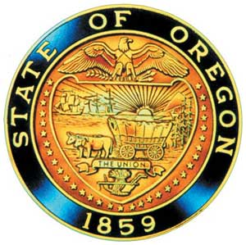
Tina Kotek, Governor

AI/AN Advisory Committee Members

Chair Tamara Henderson
Vice Chair Leilani Sabzalian
Angie Fasana
Alt. Bethany Mason
Jen Anderson
Crystal Hinds
Sonya Moody-Jurado
Marsha Frost
Chris Mansayon
Julie Bettles
Samantha Hatfield
Jamie Crane
Nicole Butler-Hooton
Robin Butterfield
Shelby Maerz
Valerie Switzler
Mileah Skunkcap
Jemiah Wassman
Roshelle Weiser-Nieto
Jesse Jackson
Alt. Jennifer Reid

Office of Indian Education
April Campbell, Assistant Superintendent
Renee Roman Nose, Native American Student Success Coordinator
Brent Spencer, Indian Education Coordinator
Brandon Culbertson, Tribal Language Policy Analyst
Stacy Parrish, Indian Education Specialist
Aujalee Moore, Literacy Policy Analyst
Raina Reece, Executive Support Specialist

2026 Meeting Dates
September 9th 1:00 – 3:000pm
October 23rd 9:30 – 3:30pm
November 20th 10:00 – 12:00

American Indian/Alaska Native Advisory Committee
September 9th , 2026
1:00 p.m. – 3:00 p.m.
Oregon Department of Education
AGENDA
Join by Zoom
https://www.zoomgov.com/j/1654009281
Meeting ID: 165 400 9281

1:00 1.0 Call to Order, Opening Remarks Chair Henderson
1.1 Opening Blessing TBD
1.2 Committee Roll Call
1.3 Introductions & Welcome to Partners Chair Henderson

1:10 2.0 Review of May 2026 Minutes All

1:15 4.0 Office of Indian Education
4.1 Assistant Superintendent, April Campbell: Standing Updates
a. Welcome New OIE Member – Aujalee Moore
4.2 Student Success Plan Grant Updates, Stacy Parrish
a. Strengthening Consultation Readiness in Toolkit 3.0
4.3 Indian Education Coordinator, Brent Spencer
a. Developing Rules for TH/SH

2:40 AI/AN Advisory Committee Business Renee Roman Nose
5.2 AI/AN Advisory Committee Workspace

2:45 6.0 OIEA Update Chair Henderson

2:50 7.0 Community Comment Chair Henderson
Public testimony may be submitted ahead of time in writing to:
RainaReece@Ode.Oregon.gov

3:00 Adjourn

