Foundational Supports Interview Questions
Possible script to share with the interviewee – “The Tribal Attendance Promising Practices program is built off of the research-based methods from Attendance Works. In our TAPP monthly meetings this year, we have been learning more about the Three Tiers of Intervention, especially about the importance of “Foundational Supports”. I would like to learn more about the foundational supports in place at [insert name of school], so I can better understand the school and in turn, better support the students and the educators who serve them each day.
----------------------------------------------------------------------------------------------------------------------------------------------------
General Questions to ask for the various quadrants described below –
Please describe the things in place to support…

In what ways are students and families informed about these supports/resources/this information?

What are some of the goals the school has for _________________________?

How do school staff ensure students have access to ____________________?

How are staff initially supported or trained on this and how do they receive follow up support?

Can you say more about that?

Where might I find out more information on that?
--------------------------------------------------------------------------------------------------------------------------------------------------
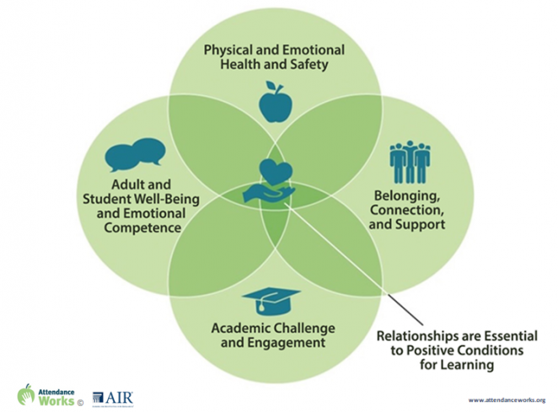
Foundational Supports Which Promote Positive Conditions for Learning
- Physical and Emotional Health and Safety
  - Healthy learning environments
  - Welcoming, safe school climate
  - Access to food and other basic needs
  - Restorative circles
- Belonging, Connection and Support
  - Active student and family engagement
  - Advisories/meetings to build community
  - Enrichment and clubs
  - Positive peer connections
- Academic Challenge and Engagement
  - Access to tech and internet
  - Learning supports
  - Project-based learning
  - Credit recovery opportunities
  - Internships/community service
  - Alternative scheduling options
- Adult and Student Well-Being and Emotional Competence
  - Restorative check-ins
  - Access to health care and mental health supports
  - Trauma-informed practice
  - Staff self-care

This document has been adapted from the Attendance Works resources found here - https://www.attendanceworks.org/chronic-absence/addressing-chronic-absence/examples-of-tiered-practices/

