Oregon Topography

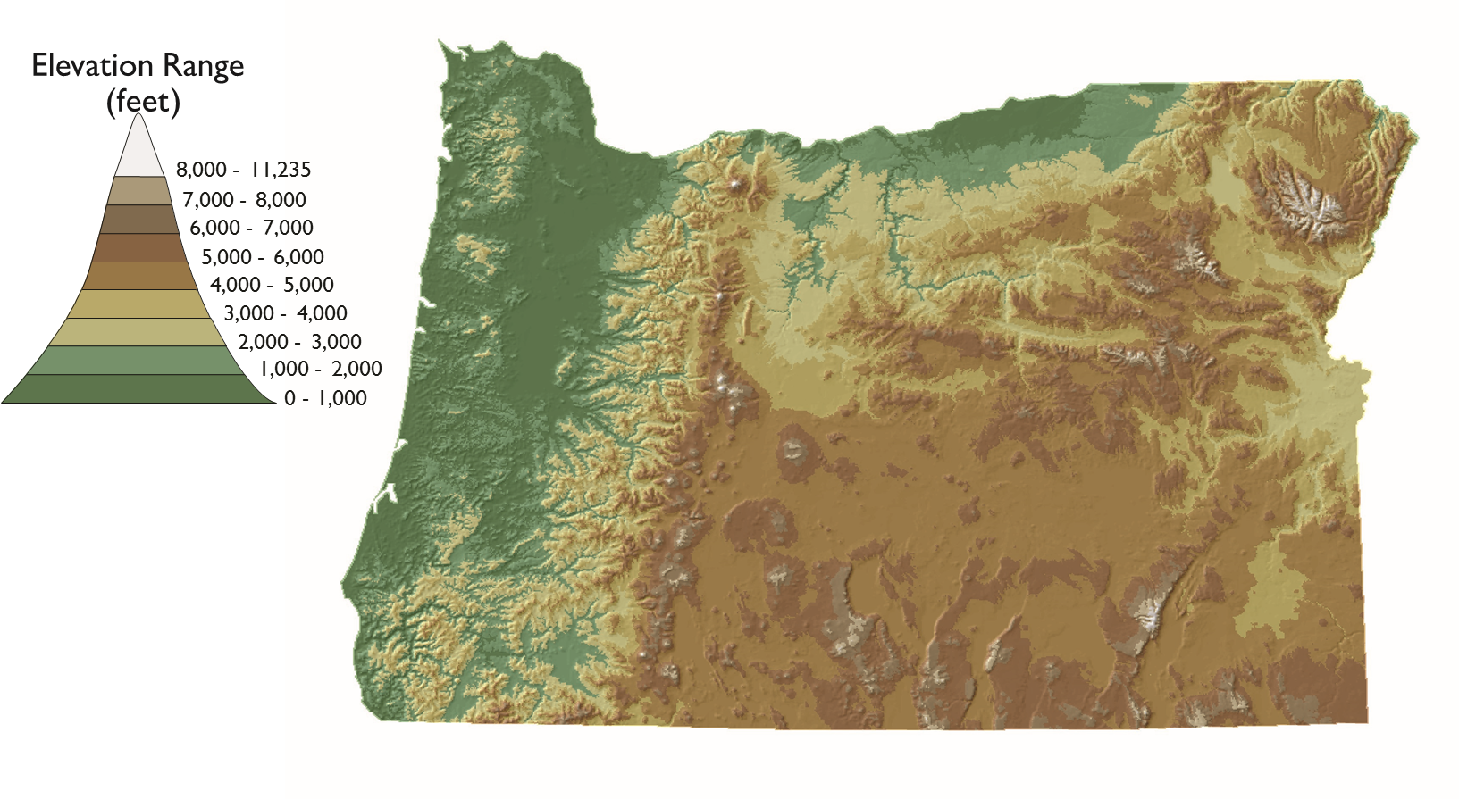
Topography is the shape and features of land surfaces.

Source: Center for Geography Education in Oregon, Portland State University. The Student Atlas of Oregon. Used with permission.

