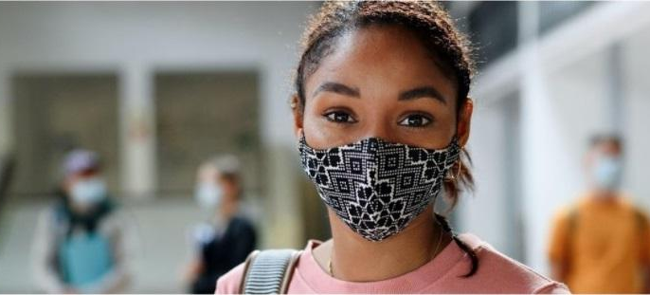

Oregon Department of Education | Oregon Health Authority

Centering Safety and Belonging as Schools Transition to Local Mask Policy

Communications Toolkit

March 2022

Dear Education Leaders and Partners,

OHA and ODE co-developed this communications toolkit to support school staff, students and families as Oregon transitions to local mask policy on March 12. The materials in the toolkit center mental health and well-being, belonging, safety, and respect for choice during this transition. In alignment with ODE’s Integrated Model of Mental Health, the goal is to create safe, supportive, welcoming schools, and prevent bullying and harassment linked to student and family choice to wear or not wear a face covering at school.

The shift to the optional wearing of face coverings presents an additional transition in an already challenging school year. Many young learners have never attended school without wearing a mask or face covering. This new experience may bring up feelings like joy, excitement, anticipation, stress, and nervousness. These are perfectly understandable responses to any change in environment and will likely be felt by everyone in the school community in some way.

We invite you to make use of these messages and resources to initiate conversations and communication with staff, students, families, and your community. As we move into this phase of optional mask wearing, we must ensure that students who most frequently experience bullying, including students who experience disability and those who are Black, Indigenous, Latina/o/x/e, People of Color, Tribal members, and/or are members of the LGBTQ2SIA+ community, feel safe and welcome in their schools. The templates in this toolkit are designed to help schools support students, families, and the school communities in navigating this transition. These customizable messages provide a starting point for school leaders and staff to facilitate conversations about safety and belonging, and to create cultures of care and connection.

If you have any questions about this toolkit or would like additional ideas and thoughts in using some of the communication tools provided in this document, please contact ODECOVID19@ode.oregon.gov.

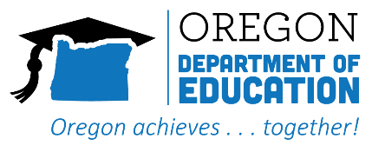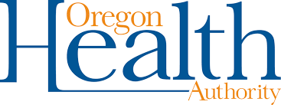

Key messages for educators and school leaders

It is our responsibility to ensure the school environment is safe and welcoming to every student and staff member. This includes honoring individual decisions around COVID-19 safety, including the wearing, or not wearing, of face coverings where schools have created mask optional policies.

Many students and staff will choose to continue to wear face coverings at school for a variety of reasons. Every individual has the right to make that decision and schools need to support the continued use of face coverings by individuals and create an environment where individual decisions to wear a face covering are honored.

Every person deserves to be treated with fairness, respect and dignity. Oregon is strong because of its diversity. Differences in culture, religion, ideas, ethnicity, abilities, health decisions, and other forms of identity contribute to the strength and richness of our communities. This includes the choice to wear or not wear a face covering.


We are in this together. We are all affected during public health emergencies, national disasters, and crises. When one person in our classroom or community is treated disrespectfully, we all suffer. It is important to support and comfort each other, share accurate and timely public health information, make informed decisions that benefit our communities, and work together, particularly during periods of transition and stress.

Bullying, discrimination, and othering do not belong in schools or communities. Kindness, compassion, empathy and understanding are the most powerful tools for coping with transitions, stress, and uncertainty. This is the time for our communities to come together, and to unite in the purpose of creating safe, healthy, happy environments for students to thrive.

COVID-19 is still present in Oregon, and we now have multiple tools to fight infection and slow the spread. We have widely accessible and highly effective vaccines, proven interventions like face coverings and personal distancing, and treatments that are becoming more readily available. When these efforts are in place, schools are some of the safest community settings.

We know that the transition to optional face coverings can bring up a wide range of emotions. It is perfectly understandable to feel frustration, hesitation, joy, anxiety, fear, or relief about wearing or removing a face covering, even if you know you’re doing everything that experts say can keep you safe.

Tips for Educators to Promote Safe, Inclusive Spaces and Conversations

Be mindful to share only accurate information, and to clearly counter misinformation. Accurate information about people, events, reactions and feelings is empowering. Youth should be provided with factual, age-appropriate information about how to avoid infections and the spread of disease. Explore ways that youth can make decisions about their health and safety.

Understand that many students may be experiencing fear, uncertainty and other feelings during this and other transitional periods. Many students, educators, and their families have been negatively affected by the pandemic, have experienced loss and traumatic stress, and may experience a wide range of feelings.

Make time and space for youth to explore their feelings. Talk with youth about their feelings. Use activities, role-playing, creative/artistic assignments, and discussions to explore their feelings about the events and their feelings about various groups from diverse cultures or lifestyles.

Model compassion, empathy, kindness and acceptance of differences. Youth take their emotional cues from the adults in their lives. Avoid making negative statements about any group.

Use inclusive language and practices and provide explanations for behaviors or values that do not align with school values or policies. Youth can generalize negative statements to students in their classes and community. Appearing suspicious of individuals who think or behave differently, making hostile, hurtful comments and innuendos about individuals or communities, or bullying, cyberbullying, or physically/emotionally threatening or harming others creates a stressful and unsafe learning environment.

Be mindful of your statements and biases, and help youth be aware of their attitudes and biases. This is an opportunity for self-reflection, understanding others, and providing education regarding the nature and impacts of biases. Let students and adults know your expectations of respect for all, and that kindness and compassion are expected and modeled.

Always speak up and take action if you observe discriminatory or unkind comments made by students or staff. Adults have a responsibility to interrupt and safely confront harmful words. This means consistently speaking up every time hurtful words are observed. Inconsistently responding to harmful words sends the message that stigmatizing, othering, and racism are acceptable. Adults can use incidents as an opportunity to explain why a statement is not acceptable, explore how it may be interpreted by others, and offer alternative behaviors and opportunities for reparation.



Stop harassment or bullying immediately. Make it clear that bullying, harassment, and other harmful behaviors in any form (in-person, online, social media, etc.) are unacceptable. Ask questions of the individual exhibiting bullying behavior(s); find out the rationale for their actions. Offer alternative behaviors, and additional information/education to help address underlying feelings or concerns.

Counter microaggressions with micro-affirmations. Micro-affirmations are subtle acknowledgements to help individuals feel valued and included. These include acknowledging microaggressions, supporting individuals when they report micro-aggressions, bullying, discrimination or othering, and directly confronting inequitable, hostile or biased behavior.

Encourage students/youth to seek help. Adults should encourage students/youth (those who bully, those who are bullied, those who witness bullying) to tell a trusted adult or speak out against bullying, harassment or microaggressions (if they feel safe doing so).

Ensure that staff, parents, caregivers and community members are respected and protected at all times. Students may not be the only individuals at risk of experiencing overt bias or microaggressions from peers or students. Make sure staff and adults know their rights, what an appropriate response may be in the face of such behavior and how to communicate a concern to school leaders.

Emphasize positive, familiar images of diverse groups. Identify people of numerous ethnicities, religions and/or lifestyles that youth know and who have a positive place in their lives. These could be neighbors, friends, school personnel, healthcare professionals, members of their faith community or local merchants. Discuss the many characteristics, values and experiences the youth have in common.

Read books with youth that address prejudice, tolerance and hate. There are many, many stories appropriate for varying age groups that can help youth think about and define their feelings regarding these issues. Work with your librarian to get recommendations.

Letter/email to students and families

Use this letter/email to help build awareness and understanding about the importance of staying vigilant and protecting students, staff and families as we make this transition. Let students and families know how they can support these efforts and where to go for more information.

Suggested subject line: Centering Care, Connection, and Community during Masking Transition

Dear Students & Families,

On March 12, the statewide indoor face covering requirement was lifted for indoor public spaces including Oregon’s schools. This may bring up a mix of feelings for youth and families. School/District x recognizes that many students and staff will continue to wear face coverings at school to protect their family’s health.

Every family is unique. The decision to wear face coverings or not is a personal decision. Health experts continue to recommend wearing face coverings for those at increased risk for more severe impacts of COVID-19. This includes people who are not vaccinated, are immunocompromised, have underlying health conditions, are 65 and older, or who live with someone in one of these categories. The CDC has developed a community metric tool to help families and communities make health decisions.

It continues to be important that we actively work together to build cultures of care, connection, and community at home and school. This includes respecting individual and family decisions to wear or not wear a face covering.

There are many things you can do with your student to support their health and well-being during this transition.
- Consider reviewing these materials together with your student. Talk with them about what they can do to build care, connection, and community in their classrooms and schools.
- Explore how your student can support other students who choose to continue to wear face coverings, and what you can do to support your student’s health and well-being.
- Have conversations with your student about how they are feeling about the change to an environment without face coverings. How might that be affecting their mental health and well-being? See ODE’s Mental Health Toolkit for some ideas.
- Familiarize yourself with policies and tools for addressing bullying in schools.

Also, please remember:
- If your child has COVID-19 symptoms, do not send them to school. Seek a COVID-19 test. Primary and Non-Primary Symptoms of COVID-19 can be found within the Resiliency Framework on page 25.
  - Families may order free tests from the US government.
- Eligible students ages 5 and up should get vaccinated and boosted now if they’re not.
  - Vaccination remains the best protection against serious illness from COVID-19 and reduces spread of the disease.
  - Find a vaccine appointment at Get Vaccinated Oregon.

Oregon school districts are updating their health and safety plans to serve the needs of students and families now and in the future. Learn how our school district is preparing for this latest transition at ODE’s Ready Schools website.

The best person to contact should you have questions is: ____________(Insert Name).

Warm regards,
(Insert Principal/School Superintendent)



Key messages for parents, caregivers, and families:

We are all responsible for ensuring that school environments are safe and welcoming for every student and staff member. This includes respecting individual decisions around COVID-19 safety, including the wearing or not wearing of face coverings.

Every person deserves to be treated with fairness, respect, and dignity. This includes respecting an individual’s choice to wear or not wear a face covering.

We are in this together. We are all affected during public health emergencies, national disasters, and crises. When one person in our classroom or community is treated disrespectfully, we all suffer. It is important to support and comfort each other.

Share accurate information from reliable sources. Accurate and timely public health information is essential for making informed decisions that benefit our families and communities. It is important to explain what is happening to youth using language that they can understand.

Bullying, discrimination, and othering do not belong in schools or communities. Kindness, compassion, empathy and understanding are the most powerful tools for coping with transitions, stress, and uncertainty. This is the time for our communities to come together, and to unite in the purpose of creating safe, healthy, happy environments for youth to thrive.

COVID-19 is still present in Oregon, and we have multiple tools to fight infection and slow the spread. We have widely accessible and highly effective vaccines, proven interventions like face coverings and personal distancing, and treatments that are becoming more readily available.

Every family is unique. The decision to wear face coverings or not is a personal decision. It is perfectly understandable to have a range of emotions about wearing or removing a face covering, including feelings of hesitation or relief.


Resources for Educators

Care and Connection: Resources for building strong, positive relationships within schools and in school communities.

Five key ways to support mental health during the COVID-19 outbreak and beyond

Every Student Belongs Guidance on the Issue of Bullying

Bullying (and cyberbullying) is unwanted, aggressive behavior involving a real or perceived power imbalance among individuals. The behavior is, or has the potential to be, repeated over time. Individuals who bully use their power— such as physical strength, access to embarrassing information, race or class privilege, or popularity— to control or harm others.

Bullying in school and other settings can often mirror systematic oppression in society at large. Power imbalances can change over time and in different situations, even if they involve the same people. There are negative outcomes for both people who bully and those who are bullied including: challenges with academic achievement, social isolation, and negative physical and mental health outcomes.

In Oregon, there are multiple policies to support students and staff in school settings to both understand and respond to bullying. Focusing on protective factors such as positive peer interactions, social competencies, low frequency of technology use, and sexuality education can significantly reduce bullying behavior.

School Safety & Prevention System: ESD-based bullying prevention specialists who can provide support to schools and districts in responding to actions that threaten school safety.

SafeOregon Tip Line: Program created for Oregon students, families, school staff and community members, and law enforcement officers to report and respond to student safety threats.

Oregon Youth Suicide Prevention Programs: Compiled list of youth suicide prevention resources and programming available.

Learning for Justice - Speak up at School: Resources to respond to everyday prejudice, bias, and stereotypes.


Resources for Youth and Families

Learning for Justice - Speak Up Pocket Card: Resources to respond to everyday prejudice, bias, and stereotypes.

Oregon Student Voice: Empowering youth voice in education.

Stopbullying.gov - Youth Leaders Toolkit: Resources for teens to launch a bullying prevention campaign.

Uplift Youth Era Event: Virtual summits are held every few months, check the calendar on the website to see a calendar of upcoming events.

SafeOregon Tip Line: Program created for Oregon students, families, school staff and community members, and law enforcement officers to report and respond to student safety threats.

Safe + Strong Oregon: Provides information about COVID-19 symptoms, vaccinations, and safety measures, as well as resources for all Oregonians.

Oregon Youth Suicide Prevention Programs: Compiled list of youth suicide prevention resources and programming available.

Help Lines

24-hour National Suicide Prevention Line (run by Lines for Life): 1-800-273-8255.
- Contact Lines for Life by texting “273TALK” to 839863 (text services available Monday – Friday 2-6PM Pacific).
- 24/7 Crisis Text Line: Text “OREGON” to 741741.
- Youthline is a teen-to-teen crisis and help line. Call 1-877-968-8491 or text “teen2teen” to 839863.

Sample social media posts

The following social media posts are intended to be used as a starting point for Tribal communities, community-based organizations, schools, school districts, or PTAs to share with students, families, teachers, staff, or community members. These are customizable, so please feel free to adjust for tone, voice and framing to better suit your needs and the people you plan to send it to.

If you need additional support or have questions, please contact meg.boyd@ode.oregon.gov.

ODE Sample Social Media Post Copy Options:

After March 12, 2022, students and families have the right to wear or not wear masks in school. This can be a stressful time of both excitement and trepidation. As students in __________ make choices for themselves and their families, we encourage everyone to create safe spaces that promote care, connection, and community.

Beginning March 12, 2022, masks will be welcome but no longer required at ______________. We are committed to creating a climate of safety and support as students and staff make these personal mask-wearing decisions as they consider their health, the health of family members, and the health of their community.

While wearing a mask becomes optional on March 12, 2022 in our school, our commitment to a safe and welcoming environment does not change. Students and staff are welcome to exercise their right to wear a mask to support their own health, the health of family members, or community health.

It’s important that we continue to build a culture of tolerance and acceptance for all people who choose to continue wearing masks, and for those who choose not to wear a mask. Student, family, and staff choices will be respected, and we will continue our focus of ensuring that everyone in our learning community knows they matter.

Hashtags:
- #MasksWelcome
- #MyMasksMyHealth
- #CubrebocasBienvenidos
- #MiCubrebocasMiDecision
- #WeCare
- #UseYourSuperpower (elementary/middle)
- #Decide (high school)

Sample infographics and flyers for posting in schools

In the coming weeks, check OHA’s COVID-19 Community and Communication Resources page for these materials in additional languages.



OHA “Masks Welcome Here” flyers for schools
English – High School
English – Elementary and Middle School

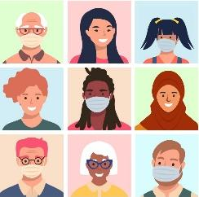
OHA “Masks are Welcome Here” sign


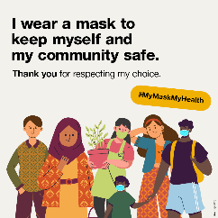
OHA Respect My Mask
English
Spanish

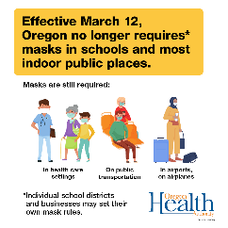
OHA No Longer Requires Masks Social Card

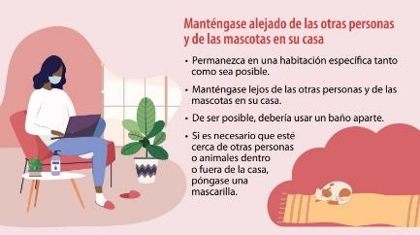
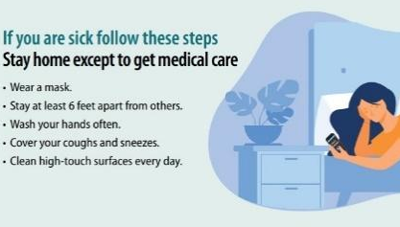
CDC: “Stay home when you're sick. Once you are better, wear a mask to protect others.”
English flyer
Spanish flyer

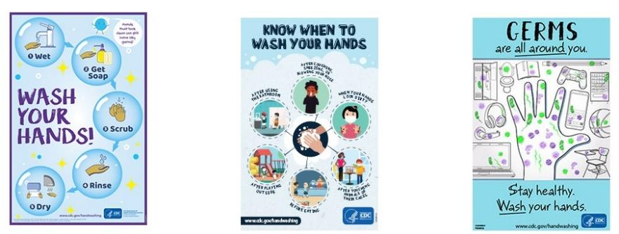
CDC Handwashing Resources
- Includes posters, videos, stickers, fact sheets
- Multiple languages available

