

Oregon School Health Policy Navigator
Tool Last Updated: May 2025 - (Next planned update: February 2026)
- What is the Oregon School Health Policy Navigator?
- Background and Context
- Related School Health Policies
- How to use the Oregon School Health Policy Navigator
- Resources and Contacts

What is the Oregon School Health Policy Navigator?
The Oregon School Health Policy Navigator is a spreadsheet containing a collection of rules, state statutes, and other laws related to Oregon’s health in education. This tool was designed to help school administrators, staff, families, and others gain insight into the policies that shape Oregon’s health in education. Due to the ever-shifting nature of policy, this tool is not intended to be viewed as the full and complete picture on Oregon schools' health requirements. The Oregon School Health Policy Navigator is not a rule, regulation, guidance, or legal advice, nor should it be relied on as legal advice. For questions about the application of any rules, state statutes, and other laws listed in the Oregon School Health Policy Navigator, you may wish to consult your legal counsel.
Each policy/rule contains a summary. While these summaries cannot substitute for reading the policy, they are useful for those familiarizing themselves with school health requirements. Overall, this tool is best used by those who are curious about their school community’s health and want to learn more about the various policies that work to prioritize health.
The Oregon School Health Policy Navigator was originally developed by Amy Lahrman while she undertook her Master’s of Public Health (MHP) practicum at the Oregon Department of Education (ODE). We thank her for her work in providing more transparency for school health!

Background and Context
The Oregon School Health Policy Navigator was published to encourage the proactive learning of school health policy. The health of everyone in a school community affects the success of its students. The categories of the Navigator are based off the Whole School, Whole Community, Whole Child (WSCC) model, to reflect the connection between school community health and student success.
Developed by the Centers for Disease Control and Prevention (CDC), the basis of the WSCC model is encouraging engagement between teachers, families, and communities to support youth’s overall health and well-being. In the WSCC model, students’ active presence is prioritized in their health, community partners are engaged to strengthen supports, and families are involved in shaping school communities.

For aligning with compliance to Oregon laws, we recommend schools explore the Full-Service Community School (FSCS) framework, for community planning that leverages the uniqueness of each community to build stronger supports in schools and lead to better student outcomes.

Related School Health Policies
Some requirements supporting students’ health in schools are larger than the Oregon School Health Policy Navigator’s intended scope. These requirements are vital for understanding health in Oregon schools. We have included them below as additional policies for review.

- Civil Rights 504/Americans with Disabilities Act
  - This webpage from the Oregon Department of Education (ODE) contains information on both Section 504 of the Rehabilitation Act of 1973 as well as the Americans with Disabilities Act (ADA).

  - Section 504 states that, “No otherwise qualified individual with disabilities in the United States… shall solely by reason of his/her disability, be excluded from the participation in, be denied the benefits of, or subjected to discrimination under any program or activity receiving federal financial assistance.”

  - The webpage includes resources on both Section 504 and the ADA, including Student Access, a manual published by ODE which provides information on both.

- Individuals with Disabilities Education Act (IDEA) Policy

  - This webpage from ODE contains information on the Individuals with Disabilities Education Act (IDEA). IDEA is, “a federal law governing special education services and federal funding for eligible infants, toddlers, children, and youth with disabilities across the country.”

  - This webpage includes both state reporting under IDEA as well as state resources.

- Student Records and Privacy

  - This webpage from ODE contains information on the Family Educational Rights and Privacy Act (FERPA), a federal law related to student records and privacy.

  - This webpage includes useful resources for FERPA familiarization. This includes a toolkit as well as a FERPA definitions handout.

How to use the Oregon School Health Policy Navigator
Once you access the Oregon School Health Policy Navigator spreadsheet, you can filter through the navigator to find specific information on policy categories, years, state or federal policies, and more.
The categories of the Oregon School Health Policy Navigator are based on the 10 components of the WSCC model. An additional category of “Out of School Time” was added to the list. To simplify the filter process, each category is linked below and will take you to the navigator, showing all the catalogued policies that fall under each category.
- Health Education
- Nutrition Environment and Services
- Physical Education and Physical Activity
- Employee Wellness
- Social and Emotional Climate
- Physical Environment
- Health Services
- Counseling, Psychological, and Social Services
- Community Involvement
- Out of School Time

How to Make a Filter for the Oregon School Health Policy Navigator
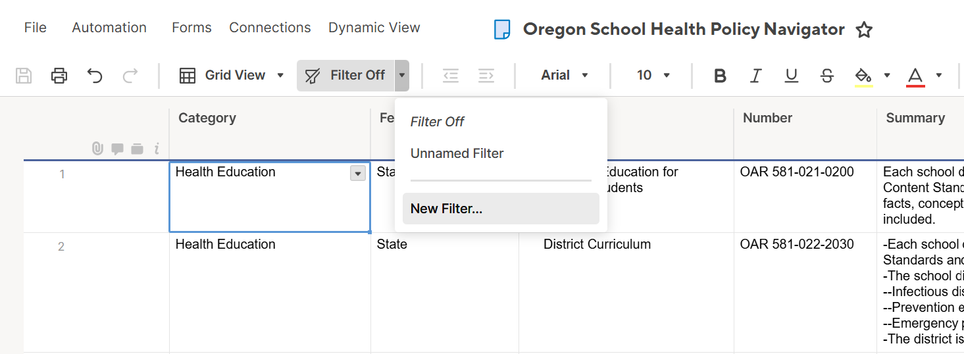
Select the arrow to the right of the button titled, “Filter Off” and then click the button labeled “New Filter...”
A box will appear which says, “Create New Filter”. You may enter a name for your filter, if you wish. Your filter will not save or populate for others. Underneath there will be options to create the filter to your liking. In the example below, I have selected the column, “Year Certified”, chose the condition, “is less than” and entered a value of 2015. The result is that the spreadsheet will only show policies that were certified before the year 2015.

This is just one example of how you can make your own filter to find relevant information.
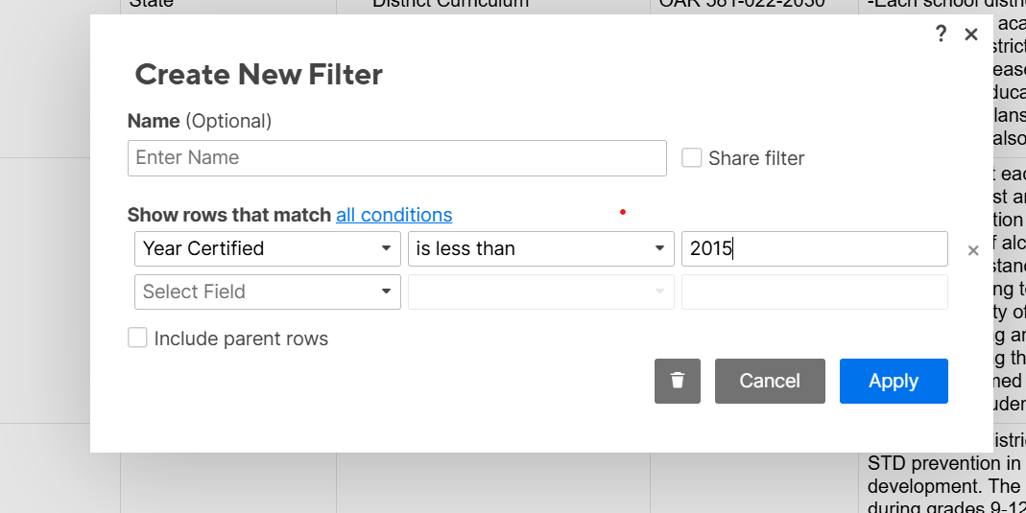

Resources and Contacts
For more information on the Oregon School Health Policy Navigator, we have a Resources and Contact list you can use for inquiries. The list is organized according to the navigator’s categories. For questions or feedback about the navigator, you can reach us at, ode.healthyschools@ode.oregon.gov.

