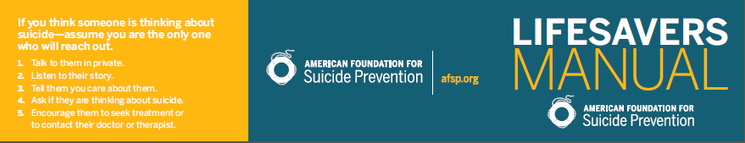
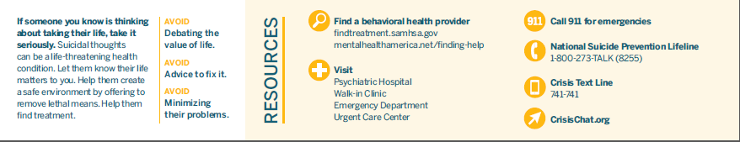

Community Resources:
Benton County Crisis Line: 1-888-232-7192 Parent Help Line: 1-800-345-5044
Linn County Crisis Line: 1-800-304-7468 Oregon Youth Line: Text “teen2teen” to 839863
Crisis Hotline for Youth and Families: 1-800-999-9999 National Suicide Prevention Lifeline: 1-800-273-8255
Crisis Hotline for Youth: 1-800-448-4663
Trillium Family Services: 1-888-333-6177

