School Medicaid Information for Parents
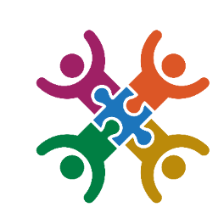

The Oregon Health Authority administers the School Based Health Services (School Medicaid) program. This program helps schools by allowing them to receive Medicaid reimbursement for covered health services provided to Medicaid-enrolled children and young adults. This guide is intended to provide answers to frequently asked questions regarding parent consent.
Why are schools billing Medicaid?
Billing Medicaid for health services is a way to bring more money and resources into schools and programs. This money can be used to help hire more providers, offer more services, and ensure students get the care they need to access their education and thrive.
What can schools bill Medicaid for?
Schools can bill Medicaid for health services such as:
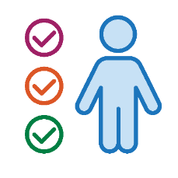
- Nursing
- Speech-Language Pathology
- Occupational and Physical Therapy
- Mental and Behavioral Health
- Evaluations and Assessments

Does School Medicaid billing affect your family’s Medicaid benefits?
No. School Medicaid reimbursement has no impact on a family’s community Medicaid benefits or eligibility. OAR 410-141-3565(8)(D)(h).

Do schools need your consent to bill Medicaid?

Yes. Schools must have your written permission before they can bill Medicaid. Before they obtain your permission, the school must provide you with written notice informing you of your rights. The school must provide this notice each following year after your consent is obtained.
What if you do not give consent?
Your student’s right to access their education is not impacted by whether you consent to Medicaid billing. Your child will still receive the health services that they are eligible to receive.
Can you withdraw your consent later?
Yes. You can withdraw consent at any time by notifying the school in writing.
Can schools charge me for health services provided in my student’s IEP, IFSP, or Section 504 plan?
No. If your child is eligible to receive a health service under the Individuals with Disabilities Education Act or Section 504 of the Rehabilitation Act of 1973, the health service must be provided at no cost to you.
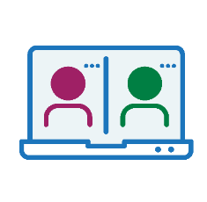
What type of information may be shared? Who will see the information?
The Family Educational Rights and Privacy Act (FERPA) is a federal law that protects your child’s education records. Schools are required to adhere to the privacy standards contained in FERPA. This includes sharing information for Medicaid billing. Personally Identifiable Information that may be shared:
- Name; date of birth; type of services provided, the date(s) services are provided, and by whom; attendance records, and State Student Identification Number (SSID).
Who may see the information outside of school staff:
- The Oregon Health Authority and Affiliates
- Third-Party Billing Agents (if used)


For questions about this document please contact: Jennifer Dundon, School Medicaid Operations & Policy Analyst for the Oregon Department of Education, at jennifer.dundon@ode.oregon.gov

