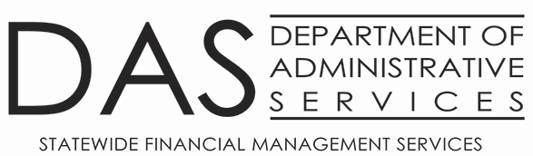
1099 Copy Request

Request Date: Click or tap to enter a date.

Agency #: Click or tap here to enter text.

Requested By: Click or tap here to enter text.

Vendor #: Click or tap here to enter text.
Vendor Name: Click or tap here to enter text.

Tax Year Requested: Choose an item.

1099 Form: 1099MISC ☐ 1099NEC ☐

Delivery Method: Mail ☐ Email ☐

Mail (Only if TY2022 or earlier):
Agency confirms address on the 52 Screen is correct: Yes ☐ No ☐
Address on 52 Screen is not correct update information:
Address Line 1: Click or tap here to enter text.
Address Line 2: Click or tap here to enter text.
Address Line 3: Click or tap here to enter text.
City: Click or tap here to enter text.
State: Click or tap here to enter text.
Zip: Click or tap here to enter text.

Email:
Email address request to send: Click or tap here to enter text.

Email Request form to Karlene.hancock@das.oregon.gov

*************************************SFMS Processing******************************************

Request Received: Click or tap to enter a date.
Request Processed: Click or tap to enter a date.
Email Agency: Click or tap to enter a date.
Packet Complete & Filed: Click or tap to enter a date.

