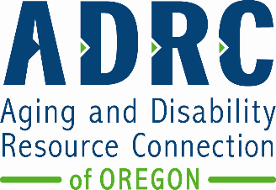
Aging and People with Disabilities
Community Services and Supports Unit

ADRC Statewide Advisory Council Membership Form
Other formats and languages
You can get this document in other languages, large print, braille or a format you prefer free of charge. Contact Aging and People with Disabilities at 1-800-282-8096 or email sua.email@odhs.oregon.gov. We accept all relay calls.

Applicant name: Click or tap here to enter text.

Email address: Click or tap here to enter text.

Phone number: Click or tap here to enter text.

Date: Click or tap here to enter text.

Check all that apply to you:
☐I am 60 years of age or older.
☐I have a disability or chronic condition.
☐I am an unpaid caregiver.
☐I am in an advocacy role for older adults or people with disabilities.
☐I am a member of a racial, ethnic, or other minority community.
☐I live in a rural area. City of residence: Click or tap here to enter text.
☐I live in an urban area. City of residence: Click or tap here to enter text.
☐I am a member of a stakeholder or advocacy organization. If selected, what is the name of the organization you are a member of: Click or tap here to enter text.

Please explain your interest in joining this advisory council?
Click or tap here to enter text.

What experience or background do you bring to the advisory council?
Click or tap here to enter text.
Please email completed form to dawn.l.rustrum@odhs.oregon.gov

