Department of Human Services
Office of Developmental Disabilities Services
500 Summer St. NE Salem, OR 97301
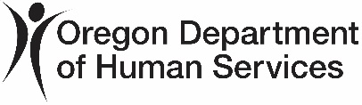
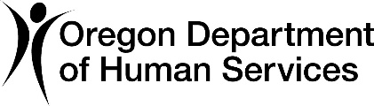

Hello,
We are writing you because you get services through the Office of Developmental Disabilities Services (ODDS). You just had a new Oregon Needs Assessment (ONA).
Please read this report. It will tell you about changes from your old ONA to your new one.
A Service Group is a group of people with a similar needs. Learn more by going to this website: https://www.oregon.gov/odhs/compass/Pages/resources-individuals.aspx#servicegroup. You can also use the QR code at the end of this letter.
You are getting this report because your Service Group changed. This change happened because of answers on your new ONA.
On Page 1, you will find:
- Your name
- Your Prime Number
- Your Service Group score
On Page 2, you will find a table with the scores for each Service Group.
These scores decide your Service Group:
- General Support Needs (GSN)
- Behavior Support Needs
- Medical Support Needs
The next pages show your answers from two different ONAs.
Not all ONA questions change your Service Group. This report only shows the questions that can change your service group.
If an answer changed on the new ONA, it is shaded gray.
What can you do?
If you want to see all your answers, you can ask your services coordinator or personal agent for a full report.
If you disagree with your new ONA results, you can:
- Talk to your services coordinator or personal agent.
- Make a complaint.
Sincerely,
Office of Developmental Disabilities Services
You can get this document in other languages, large print, braille or a format you prefer free of charge. Email dd.directorsoffice@odhsoha.oregon.gov or call 503-945-5811. We accept all relay calls.

