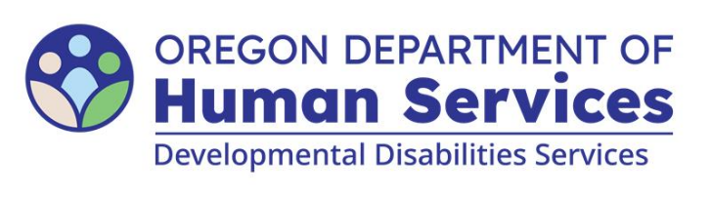

Adult Foster Home Caregiver Qualifications

Include this completed form with your application
Provider Name:
AFH Address:

 | Provider Name | Co-Provider Name | RM/Caregiver Name | RM/Caregiver Name | Caregiver Name | Caregiver Name | Caregiver Name
Background check (expiration date)
CPR/1st Aid (expiration date)
Mandatory Abuse (date)
AFH Basic Test (date)
Annual training (# of hours completed)
Inclusive Care point of contact (yes or no)
Inclusive Care training (date)

 | Provider Name | Co-Provider Name | RM/Caregiver Name | RM/Caregiver Name | Caregiver Name | Caregiver Name | Caregiver Name
Hire Date
Application asks about founded abuse
(yes or no)
18 years of age or older (yes or no)
Orientation to home/records (date)
RN delegation/physician training (date)
Emergency Plan annual training (date)
ODL expiration (date - if transporting)

 | Provider Name | Co-Provider Name | RM/Caregiver Name | RM/Caregiver Name | Caregiver Name | Caregiver Name | Caregiver Name
ISP's/Service Agreement Training (date)
Individual’s initials and ISP date:
Individual’s initials and ISP date:
Individual’s initials and ISP date:
Individual’s initials and ISP date:
Individual’s initials and ISP date:
Individual’s initials and ISP date:
Individual’s initials and ISP date:
Positive Behavior Support Plan (date)
Individual’s initials and PBSP date:
Individual’s initials and PBSP date:
Individual’s initials and PBSP date:
Individual’s initials and PBSP date:
Individual’s initials and PBSP date:
Individual’s initials and PBSP date:
Individual’s initials and PBSP date:
Safeguarding interventions/equipment (date)

 | Provider Name | Co-Provider Name | RM/Caregiver Name | RM/Caregiver Name | Caregiver Name | Caregiver Name | Caregiver Name
2B: 2 years behavioral experience
(yes or no)
2B: OIS (expiration date)

 | Provider Name | Co-Provider Name | RM/Caregiver Name | RM/Caregiver Name | Caregiver Name | Caregiver Name | Caregiver Name
2M: RN/LPN or 2 years’ experience
(yes or no)
2M: 6 of 12 training hours are medical
(yes or no)

You can get this document in other languages, large print, braille or a format you prefer free of charge. Contact the Office of Developmental Disabilities Services at dd.licensing@odhsoha.oregon.gov or 503-373-2052. We accept all relay calls.

