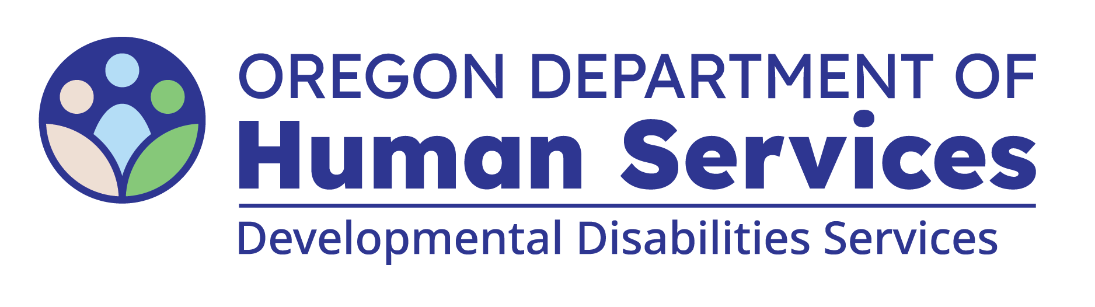
Renewal Inspection Questionnaire
Quick Reference Guide

Note: This guide is to be used as a supplemental document to help you understand what information should be included for each question of the inspection questionnaire.
Site Address: The address of the licensed or certified setting
Individual Names | List the full name of each person receiving services in the home. The Person Code (P1, P2, etc) to each person. The Person Codes, instead of individuals’ names, will be used in the licensing report to protect confidentiality.
Entry/Exit | If individual(s) moved in (entry) or out (exit) of the home since the last renewal inspection, include the date(s) of their entry or exit. If you need more space for individuals, you can use another page.
Aspiration Risk | Check the box if the individual has an identified risk of Aspiration.
Dehydration Risk | Check the box if the individual has an identified risk of Dehydration.
Constipation Risk | Check the box if the individual has an identified risk of Constipation.
Seizures | Check the box if the individual has an identified risk of Seizures.
Fall Risk/with Injuries | Check the box if the individual has had an injury due to falling since the last renewal inspection.
Ingest non-edibles | Check the box if the individual has an identified risk of Ingesting Non-Edible Objects.
Specialized Diet | List the specialized or modified diet for each person. If not applicable, mark as “N/A”
Major Medical Issues | List the current major medical issues each individual experiences. If not applicable, mark as “N/A”
RN Services/  Delegation/Training | Check the box if the individual has Registered Nursing services, delegation, or training.
Most Medical | Check one box for the individual who has the most medical support needs.
Positive Behavior Support Plan | Check the box if the individual has a Positive Behavior Support Plan.
Safeguarding Interventions | Check the box if the individual has approved Safeguarding Interventions in their Positive Behavior Support Plan.
Safeguarding Equipment | Check the box if the individual has approved Safeguarding Equipment in their Positive Behavior Support Plan.
Emergency Physical Interventions | Check the box if the individual has needed an Emergency Physical Intervention since the last renewal inspection.
Most Behavioral | Check one box for the individual who has the most behavioral support needs.
Police Involvement, Jail, Court Orders | Check the box if the individual has had any police involvement, been to jail, or had court orders, since the last renewal inspection.
Home/Community Alone | Check the box if the individual has an approved variance to remain home alone or if they spend time in the community without paid caregivers.
Alarms/Motion detectors | List all places in the home that have alarms or motion detectors for individual safety. This does not include fire or smoke alarms.
Locks | List all items in the home that are locked, that are not already required by rule.
List any IBL’s and the reason they are being used | List all Individually Based Limitations for each individual and why are they are being used.
Rep Payee | List each person’s representative payee.
Substantiated PSI's | Check the box if the individual has had substantiated abuse since the last renewal inspection.
Most Changes in Support Needs (Increase or Decrease) | Check one box for the individual who has the most changes in support needs since the last renewal inspection. This can be either an increase or decrease in need.
Potential Causes of Distress | List situations, environments, or interactions that may cause someone in your home to feel unsafe, anxious, or unsettled. This helps ODDS licensing prepare for your inspection.

You can get this document in other languages, large print, braille or a format you prefer free of charge. Contact the Office of Developmental Disabilities Services at dd.licensing@odhsoha.oregon.gov or 503-945-7800. We accept all relay calls.

