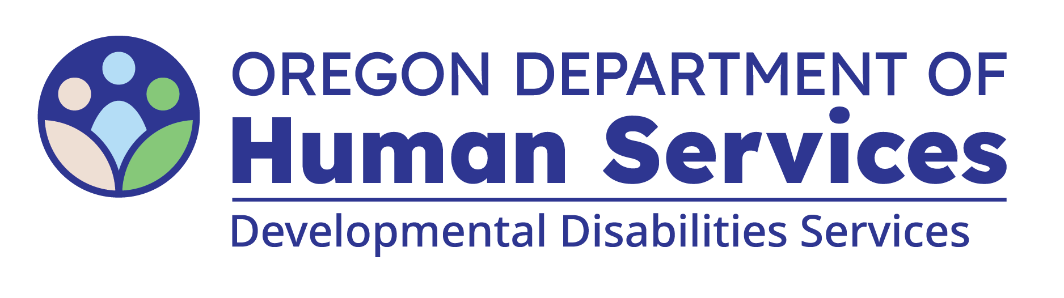
Inspection Questionnaire

Site Address:
Please complete this form to provide the ODDS Licensing Department with information about your 24-Hour Residential, Host Home, or Foster Home. Each line includes guidance in parentheses to help you know what to enter—this may include checking a box or writing in specific details. Please include all information since your last license or certificate was issued.
Individual Names  (full names) | P1 | P2 | P3 | P4 | P5
Entry/Exit/Transfers
(dates, if applicable)
Aspiration Risk
(check box if applicable)
Dehydration Risk
(check box if applicable)
Constipation Risk
(check box if applicable)
Seizures
(check box if applicable)
Fall Risk/with Injuries
(check box if applicable)
Ingest non-edibles
(check box if applicable)
Specialized Diet (list diet)
Examples: low calorie, low fat, no added salt, modified food/liquid texture (puree, mechanical soft, dime-sized, etc.)
Major Medical Issues (list)
Ex: Diabetes, Cancer, Organ Failure, Ostomy/Tube, Hospice
RN Services/Delegation/
Training (check box if applicable)
Most Medical
(check box if applicable)
Positive Behavior Support Plan
(check box if applicable)
Safeguarding Interventions
(check mark if in plan)
Safeguarding Equipment
(check box if applicable)
Emergency Physical Interventions
(check mark if used)
Most Behavioral
(check box if applicable)
Police Involvement, Jail, Court Orders (check box if applicable)
Home/Community Alone
(check box if applicable)
Alarms or motion detectors
(list what has an alarm/detector)
Locks
(sharps, clothing, etc.)
(list what is locked)
List any IBL’s and the reason they are being used
Rep Payee
(list who Rep Payee is)
Substantiated PSI's
(check box if applicable)
Most Changes in Support Needs (Increase or Decrease)
(check box if applicable)
Potential Causes of Distress
(Situations, environments, or interactions that may cause someone to feel unsafe, anxious, or unsettled. This helps us prepare for the onsite visit. Ex: liquid seeking, sensitivities to gender interactions, preferences around hair being up, jewelry, loose or colored clothing etc.)

You can get this document in other languages, large print, braille or a format you prefer free of charge. Contact the Office of Developmental Disabilities Services at dd.licensing@odhsoha.oregon.gov or 503-945-7800. We accept all relay calls.

