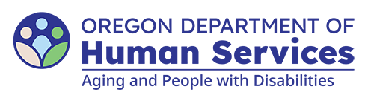
Aging and People with Disabilities
Medicaid Services and Supports

<<Office name>>
<<Office address>>
<<Office city>>, <<Office state>> <<Office Zip code>>

<<Individual name>>
<<Individual address>>
<<Individual city>>, <<Individual state>> <<Individual Zip code>>

The Oregon Department of Human Services (ODHS) prioritizes the health and well-being of all people it serves. This letter provides information about reporting abuse of older adults and people with physical disabilities.

Abuse includes:
- Physical harm or injury;
- Failure to provide basic care;
- Financial exploitation;
- Verbal or emotional abuse;
- Involuntary seclusion;
- Wrongful restraint;
- Unwanted sexual contact;
- Abandonment by the caregiver; or
- Self-neglect (when individuals lack the cognitive ability to care for themselves, which can lead to harm).
If any type of abuse is happening to you or someone you know, you can report it. State law protects your identity when you report abuse. You do not have to give your name if you wish to remain anonymous. Your identity can only be given under certain legal exceptions, such as when there is a report of a crime or an order by a judge.
After a report of abuse is made, ODHS Office of Aging and People with Disabilities (APD) and Area Agency on Aging (AAA) offices:
- Provide protective services;
- Investigate reports of suspected abuse;
- Determine if abuse or neglect occurred; and Work with law enforcement if there may be a crime.
You do not need to be certain that abuse occurred to report it. It is important to make a report even if you suspect you or someone else is being harmed. To report abuse or suspected abuse, call 1-855-503-SAFE (7233) or your local APD or AAA office. To find your local office, please visit: www.oregon.gov/odhs/pages/office-finder.aspx
Sincerely,

<<Office name>>
<<Office address>>
<<Office city>>, <<Office state>> <<Office Zip code>>
You can get this document in other languages, large print, braille or a format you prefer free of charge. Contact the Aging and People with Disabilities at apd.communications@odhs.oregon.gov or 503-945-5600 or you can dial 711. We accept all relay calls.

