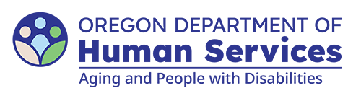
Aging and People with Disabilities
Medicaid Services and Supports

Extended Waiver Eligibility (EWE) Planning Form (Updated April 6, 2026)

Consumer name: Click here to enter text. Prime number: Click here to enter text.
Care setting type: Choose an item. SPL: Choose an item.
Benefit type: Choose an item. PMDDT approved: Choose an item.

Risk mitigation plan
Identify risks, steps to mitigate the risks, and who will assist the individual.
Risk 1. Describe the individual’s risk. For example, the consumer may lose housing.
Steps to mitigate risk. For example, the consumer will contact the local housing authorities to ensure their name is on the list.
Assigned to: Click here to enter text.

Risk 2.
Assigned to: Click here to enter text.

Risk 3.
Assigned to: Click here to enter text.

Notes:

The goal of the Extended Waiver Eligibility (EWE) Program is to help you safely transition from the services you currently receive. By signing below, you are agreeing to take the action steps detailed above.

Consumer/representative signature Date

Case manager signature Date

Individuals who do not complete or show progress in completing the tasks or steps to mitigate risks and barriers to independent living may be determined ineligible when eligibility is reviewed in six months. See OAR 411-015-0030(4)(a) through (8).

You can get this document in other languages, large print, braille or a format you prefer free of charge. Contact the Aging and People with Disabilities at apd.ltss@odhs.oregon.gov or 503-945-5600. We accept all relay calls.
Aging and People with Disabilties
Medicaid Services and Supports
500 Summer St. NE, E-10
Salem, OR 97301-1076
503-945-5600
odhs.info@odhs.oregon.gov
www.oregon.gov/odhs

