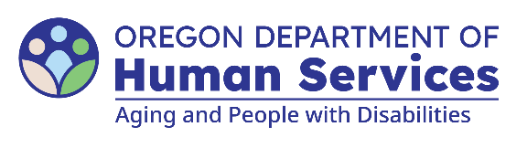

Manager Lift Chair Approval Checklist
January 8, 2026
Date of request: Select a date.
Consumer Name: Enter text. Prime: Enter text.
Case Manager: Enter text. Manager: Enter text.
Select request type: Choose an item.
☐ Individual is receiving LTSS or OPI-M services.
☐ Need for transfer assistance in the CA/PS and/or OPI-M PLAN.
☐ Request and review of alternative options is documented in OA.
☐ Selected chair meets needs, size and if possible, capacity is at least 50 pounds above the individual’s weight.
☐ Three bids received; if fewer, the reason is documented in OA.
☐ Lift chair purchase is up to $1,500. Does not include delivery and disposal fees.
Note: Checklist must be uploaded to consumer’s electronic file with the final invoices. After delivery, the checklist must be sent to KPlan.Requests@odhsoha.oregon.gov for LTSS and OPIM.Support@odhsoha.oregon.gov for OPI-M.
I confirm this request meets all policy criteria.
Signature (Manager/District Manager): Enter text.
Date: Select a date.
You can get this document in other languages, large print, braille or a format you prefer free of charge. Contact the Medicaid Services and Supports Policy Unit at apd.ltss@odhsoha.oregon.gov or 503-945-5811. We accept all relay calls.

