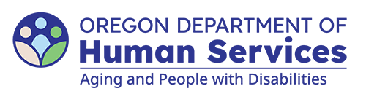
Aging and People with Disabilities
Medicaid Services and Supports

Request for Adult Day Service (ADS) Exception Request
Updated: April 21, 2026

Local office, individual and provider information

Local office
Branch: Select to enter text.
Case manager name: Select to enter text.
Manager name: Select to enter text.
Date completed: Select to enter text.

Individual’s information
Name: Select to enter text.
Prime: Select to enter text.

ADS provider information
Name: Select to enter text.
Provider number: Select to enter text.

Authorization
Please use the space below to summarize the individual’s service needs or to provide additional information. You may include a separate sheet if necessary. Be sure to include the following:
- Obtain the plan of care for both the AFH provider and the ADS program, and attach it to form 0541.
- Obtain the behavior support plan, if available.
- Explain the individual’s need to attend ADS while residing in the AFH. Ensure that the described needs do not include general communication, socialization, nursing, or health-related activities.
Select to enter text.
You can get this document in other languages, large print, braille or a format you prefer free of charge. Contact the Aging and People with Disabilities at apd.ltss@odhs.oregon.gov or 503-945-5600. We accept all relay calls.
Aging and People with Disabilties
Medicaid Services and Supports
500 Summer St. NE, E-10
Salem, OR 97301-1076
503-945-5600
odhs.info@odhs.oregon.gov
www.oregon.gov/odhs

