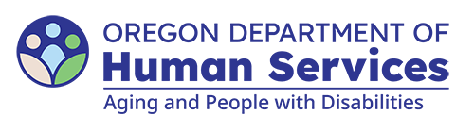
Aging and People with Disabilities
Medicaid Services and Supports

Adult Day Service (ADS) Payment Authorization
Updated: April 21, 2026

Local office, individual and ADS information

Local office
Branch number: Select to enter text.
Date completed: Select to enter text.
Case manager name: Select to enter text.

Individual’s information
Name: Select to enter text.
Prime: Select to enter text.

ADS provider information
Name: Select to enter text.
Provider number: Select to enter text.

Authorization
Authorized begin date: Select to enter text.
Authorized end date: Select to enter text.
Number of full days of month (OH112): Select to enter text.
You can get this document in other languages, large print, braille or a format you prefer free of charge. Contact the Aging and People with Disabilities at apd.ltss@odhs.oregon.gov or 503-945-5600. We accept all relay calls.
Aging and People with Disabilties
Medicaid Services and Supports
500 Summer St. NE, E-10
Salem, OR 97301-1076
503-945-5600
odhs.info@odhs.oregon.gov
www.oregon.gov/odhs

