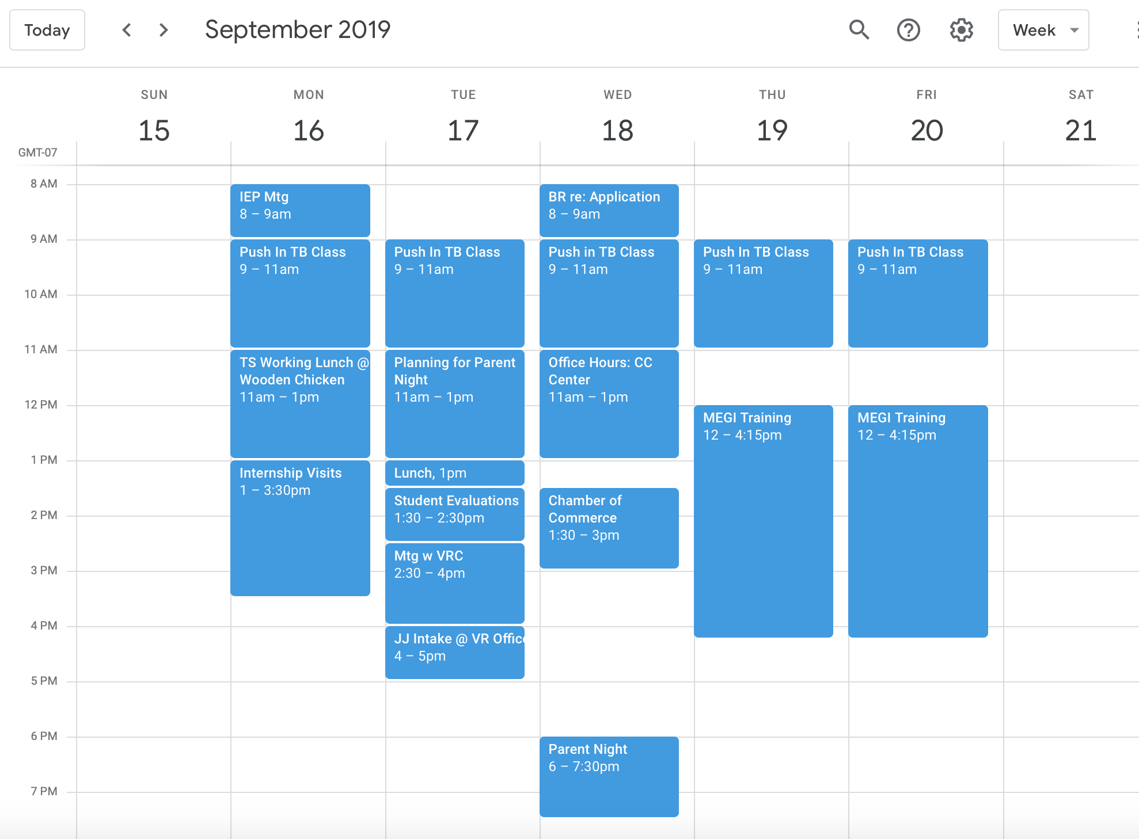

The Transition Specialist has a varied calendar. Their schedule will not look like that of the typical employee. Expect your TS to be offsite at least 50% of their time, and allow them to flex their schedules to attend later meetings for students, evening events, etc. TSs can and should attend IEPs for students with whom they are working. They can co-teach or push into classes and can provide instruction on employment related goals. They cannot be the teacher of record for a class, however, as this is a violation of the grant IGA.

Each team will come up with their own method for “keeping track” of TSs time. Teams sometimes use one or more of the following approaches for accountability:
- Sharing calendars
- Tracking indicators of growth and success
- Task agendas and progress reporting

