|  |  |
| --- | --- |
| library | LITERATURE REVIEW  Automated Tracking for Asphalt Hauling |
| **ODOT Library**  555 13th Street NE  Salem, OR 97301  (503) 986-3280  laura.e.wilt@odot.state.or.us | March, 2019 |

Traditional asphalt-hauling operations involve a cargo tracking ticket that is handled by at least four people: the truck driver, scale person, ticket taker, and an office employee who is responsible for tallying the daily tickets to make payments to the carriers or drivers. Federal and state regulations require the ticket to be in the driver’s possession at all times during cargo or load transportation, and all paper tickets must be physically stored for a period of three years after the completion date of the project – leaving room for misplaced records and the need for increased storage space (Henrie & Ronchetti, 2010). The collection of the load tickets puts construction inspectors at risk, forcing them to be adjacent to traffic and near moving equipment, as well as climbing on to trucks to reach for tickets (NCHRP, 2018).

Additionally, the manual tracking of the transport and delivery of materials often breaks down between the loading of the material batches at the plant and the reception of the batches on-site; in some cases, there are even errors in the delivery locations (François Peyret & Tasky, 2003). A survey of state transportation agencies showed that state-managed lane-miles increased by an average of 4.10% between 2000 and 2010, while the number of full-time employees decreased by 9.68%. Insufficient staffing levels, combined with the fact that resurfacing projects are frequently overshadowed by larger projects, often result in such projects receiving little inspection oversight (Patel, Sturgill, & Dadi, 2019).

Industries in general have embraced technological advancements as a way to conduct their business more efficiently and safely, but the transportation industry has traditionally been slow to adopt new processes. However, the rise of e-construction has led to a re-examination of antiquated practices. As early as 1993, the Research and Development Branch of Alberta Transportation launched a trial project to automate the collection and storage of truck haul data on a paving project using Radio Frequency Identification (RFID) technology. Data was collected from the transponders mounted on each of the trucks involved in the study, but the system was not developed further due to technical issues and limitations, including that fact that external conditions such as wind could affect the capturing of tare weight at the scale, and concern that the data could potentially be altered between the scale house and the job site (Gavin, Lo, & Humphries, 2004). In 2000, the Technical Standards Branch of Alberta Transportation brought in an outside consulting firm to conduct a feasibility study to automate the collection of truck haul data. The study explored a number of communication and information technologies including RFID, GPS, smart cards, wireless communication, bar coding, automated ticket printers and hand held personal computers. A trial Automatic Truck Haul (ATH) project using personal digital assistant (PDA) units equipped with GPS and satellite communication was held on a “shadow” or demonstration basis, with no changes made to the regular measurement procedures. While the study found that the collection of weight data at the scale house worked quite well, there were problems at the paving site; the communication range between the hand held PDA units and the paver mounted PDA units was much smaller than anticipated, and the battery life of the hand held units was often less than a workday. This sometimes resulted in them being turned off to conserve power, which led to some loads being entered without GPS coordinates. Despite the glitches encountered during the trial, both the department and the contractors/consultants recognized the potential for cost savings. The department estimated a savings of $29,000 annually to eliminate the need for a consultant hired scale person, while the contractor and consultant estimated that the automation of the input of haul data would save 1 to 4 hours of administration labor per day (Gavin et al., 2004).

The OSYRIS (Open System for Road Information Support) Project began in 2000, with the goal of developing a European standard for a documentation and work support system for the construction, maintenance and rehabilitation of a road, with a primary focus on asphalt. The project was funded by the European Union, and extended into 2003. The system was built on three main component levels: office on-board computer and measurement system (Ligier, Fliedner, Kajanen, & Peyret, 2001).



OSYRIS components (F. Peyret & Tasky, 2004)

The system made use of RFID technology for storing data into electronic tags and GPS for positioning the material parameters with respect to road projects. While the results showed the feasibility of making use of these technologies, the data had to be uploaded and downloaded with a manual process; the authors acknowledged that a completely automated system would be necessary to make the system truly efficient ( Peyret & Tasky, 2004). Alaska DOT also conducted a project testing the feasibility of RFID/GPS technologies to track asphalt deliveries. While the results were generally satisfactory, this was conducted in a semi-automatic mode which created some problems. Again, there was an acknowledgement that total automation was needed to produce the reliability expected of the process (Henrie & Ronchetti, 2010)

In 2015, Iowa DOT began a transition to automated construction management. In the initial project the agency and contractor worked with [Earthwave Technologies](http://www.earthwavetech.com/), using that company’s Fleetwatcher system (Iowa DOT, 2015). Other pilot projects followed, and the agency anticipates $400 million in contracts utilizing these automated technologies in 2019 (Mulder, 2019). GPS transponders mounted to the trucks used to haul asphalt tracked the location of the trucks and recorded information regarding load cycle times at the plant and on the job, as well as travel times between. Geozones were established around the HMA plant site and the project’s perimeter, as well as a mobile geozone at the paver, recording the truck’s location during the entire cycle (Iowa DOT, 2016). Data was recorded electronically, giving details of the load-out data by truck.

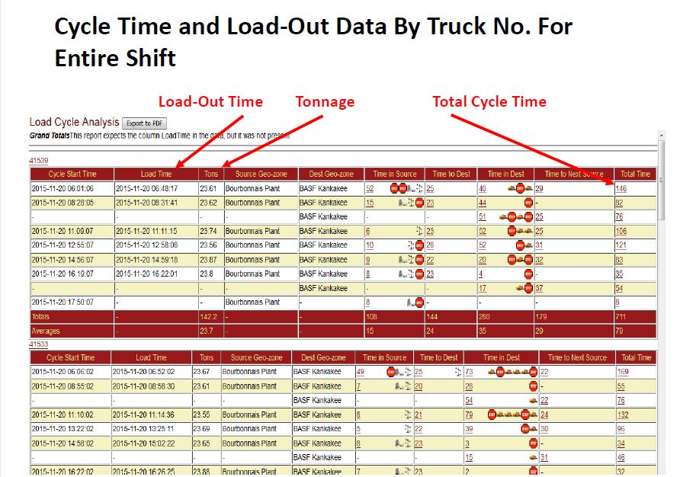

(Mulder, 2017)

Not only did the pilots demonstrate efficiency in e-ticketing automation, Iowa was also able to show a reduction of one truck per 10-hour shift, equating to a savings of up to $1,000 a day (Colorado DOT, 2016). The advantages of Iowa’s e-ticketing process included:

* Geozones at the plant site, scale, job site, pavers, etc. tracking each stage of the operation.
* Scale integration pulls data directly from batch software, eliminating the possibility of record tampering.
* Timestamps – every 60 seconds for delivery trucks and every 30 seconds for pavers.
* Real-time communication of data and results.
* Web-based technology allows for project monitoring from any location.
* Downloadable pdfs of summaries for document management.
* Other file formats allow for effective asset management.

(Mulder, 2019)

Other states have followed Iowa’s example. Colorado DOT detailed plans to conduct pilot projects, projecting the potential elimination of 137,000 asphalt tickets per year (Colorado DOT, 2016). Kentucky is currently conducting a research project looking at technologies for e-ticketing and GPS/GIS tracking of materials (University of Kentucky, 2017). In his master’s thesis at the University of Kentucky, Clyde Newcomer IV outlined the scope of the project, with anticipated outcomes. The anticipated data would include “ticket receipt and acceptance, tracking theoretical tonnage of asphalt, temperature monitoring behind the paver, truck bed and paver hopper, monitoring roller operation and communicating with contractor QC for nuclear density measurements” (Newcomer, 2018).

There is also a current NCHRP synthesis project through the University of Kentucky on electronic ticketing of materials. The project states as its objective to identify state DOTs that have successfully implemented e-ticketing technology and provide an overview of the implementation of such technologies with lessons learned (NCHRP, 2018)

**References:**

Colorado DOT. *Technology Peak and Trails*. Retrieved from <https://www.codot.gov/business/engineeringapplications/assets/tech_magazine_11212016.pdf>

Gavin, J., Lo, A., & Humphries, A. (2004) Automated System for Tracking the Haul of Construction Materials. In, (pp. 14): Transportation Association of Canada.

<http://conf.tac-atc.ca/english/resourcecentre/readingroom/conference/conf2004/docs/s4/lo.pdf>

Henrie, M., & Ronchetti, M. (2010). *Feasibility Study of RFID Technology for Construction Load Tracking* (FHWA-AK-RD-12-27). Retrieved from <https://scholarworks.alaska.edu/bitstream/handle/11122/7549/M.Henrie-et-al_RFID-Technology-for-Construction-Load-Tracking_Final-10.07.pdf>

Iowa DOT. (2015). E-Ticketing Show Promise of Speeding Process and Improving Accuracy at Asphalt Job Sites. Retrieved from <https://www.transportationmatters.iowadot.gov/2015/12/eticketing-show-promise-of-speeding-process-and-improving-accuracy-at-asphalt-job-sites.html>

Iowa DOT. (2016). Improving Accountability in the Construction Process with ETicketing for Concrete Loads. Retrieved from <https://www.transportationmatters.iowadot.gov/2016/11/for-iowa-department-of-transportation-inspectors-tablet-computers-are-quickly-becoming-the-most-essential-tool-on-a-construc.html>

Ligier, A., Fliedner, J., Kajanen, J., & Peyret, F. (2001). *Opem System for Road Information Support*. Retrieved from <https://www.researchgate.net/publication/228602591_Open_system_for_road_information_support>

Mulder, G. (2017). *E-ticketing for Asphalt Delivery.* Paper presented at the 2017 TRB Annual Meeting, Washington, D.C.

Mulder, G. (2019). *E-construction and E-tickets in Iowa*. Paper presented at the 2019 TRB Annual Meeting, Washington, D.C.

NCHRP (2018). Electronic Ticketing of Materials for Construction Management [Project]. In *Synthesis of Information Related to Highway Practices. Topic 50-07.*

<http://apps.trb.org/cmsfeed/TRBNetProjectDisplay.asp?ProjectID=4534>

Newcomer, C. W. IV (2018). *Advanced Technologies for Efficient Transportation Construction Inspection.* (Masters), University of Kentucky, Retrieved from https://uknowledge.uky.edu/ce_etds/67/

Patel, D. P., Sturgill, R., & Dadi, G. B. (2019). *A Case Study Analysis of e-Ticketing Technology for Performance*

*and Practicality on Asphalt Paving Operations.* Paper presented at the 2019 TRB Annual Meeting, Washington, D.C. .

Peyret, F., & Tasky, R. (2004). A Traceability System between Plant and Work Site for Asphalt Pavements. *Computer-Aided Civil and Infrastructure Engineering, 19*(1), 54-63. doi:doi:10.1111/j.1467-8667.2004.00337.x

University of Kentucky, L. (2017). E‐tickets and Advanced Technologies for Efficient Construction Inspection [Project].

<https://trid.trb.org/view/1526417>