
EELearner Login to Workday
This resource article provides step-by-step instructions on how an Extended Enterprise Learner (EELearner) logs into Workday using one of two authentication processes.

Below are the login steps required for an EELearner to login to Workday.

- Login to Workday at https://wd5.myworkday.com/oregon/d/home.htmld.
- From the Workday login screen, select “Sign in using a Personal Device” and enter your username and password.
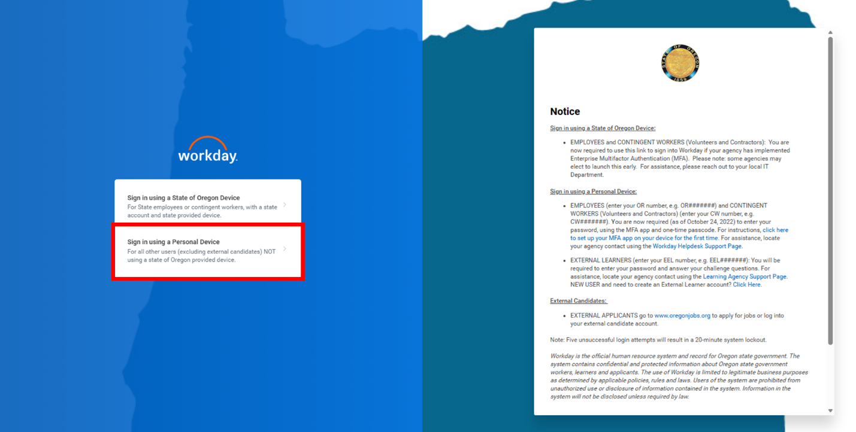

- From the Workday screen to “Setup Multifactor Authentication,” select one of the following methods for all future logins:

  - Preferred option (A): Select “Authenticator App” to approve the login using an authenticator app (like Microsoft or Google Authenticator). These apps are free. You should not have to pay to have either app set up on your phone.

  - Alternative option (B): Select “Email” to receive a one-time access code sent to your email address associated with your Workday account.
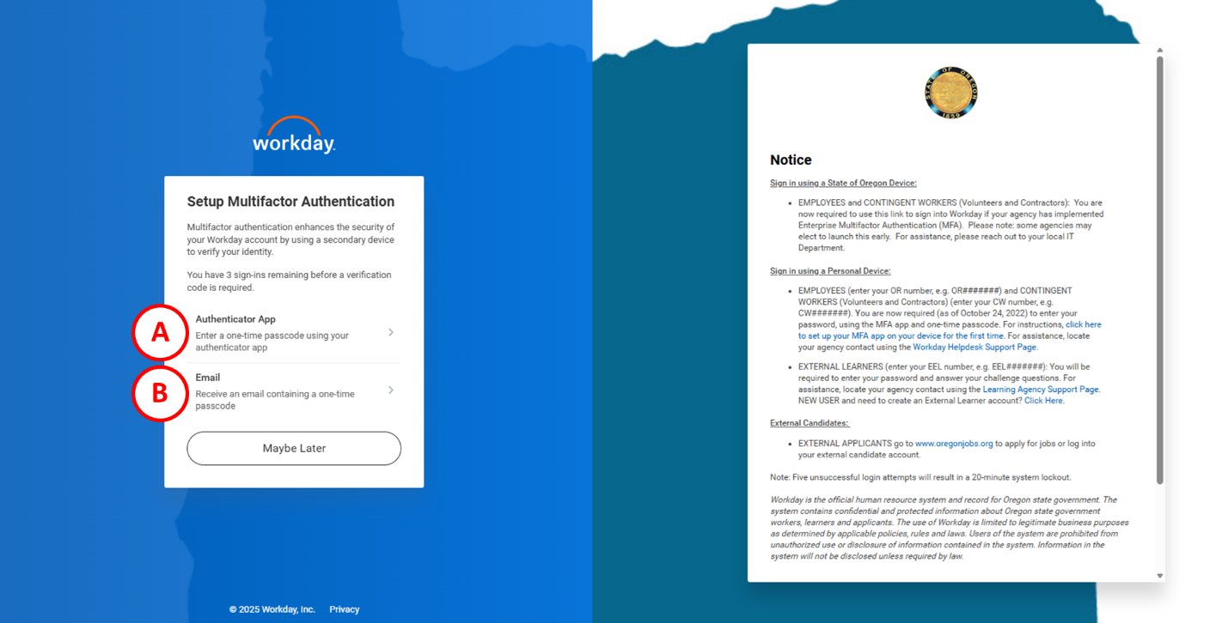

The option chosen for initial setup will be the method Workday will use for future logins with this account.

You may choose to skip multifactor authentication up to three times. After the third sign-in, without using multifactor authentication, you will be required to use one of the two options noted above to sign-in.

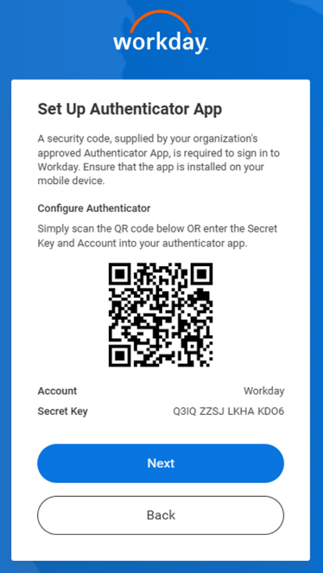
- If using the preferred method (A) using an authenticator app (like Microsoft of Google Authenticator), configure your app with a QR code as indicated below:
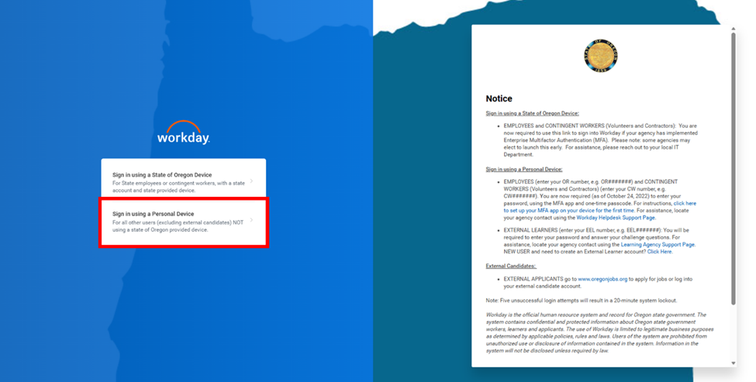
Scanning the QR code will configure your phone’s authenticator app with your Workday account.
QR Code Image Here

- Once the authenticator app is configured, enter the security code sent to your phone into the Workday “Confirm Security Code” screen:
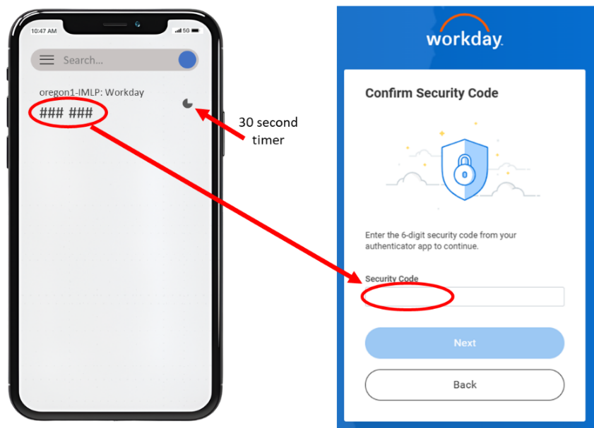
You will have 30 seconds to enter the code, from your phone, into the Workday “Confirm Security Code” screen. If you do not enter the code within 30 seconds, you will be sent a new code to enter.

- If using the alternative method (B), select the “Send an Email” button to receive a one-time verification code sent to the email address associated with your Workday account.

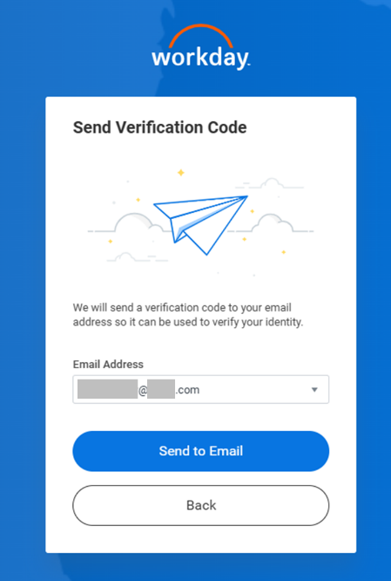

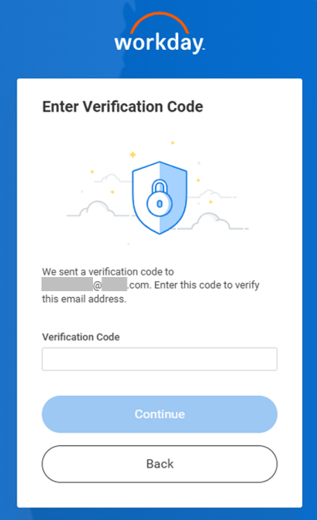
- Once you receive the one-time code to your email, enter it in the “Enter Verification Code” screen, then select the “Continue” button to complete your login.

- A “Success” screen will appear when either authentication process is completed. Select the “Done” button to access Workday.

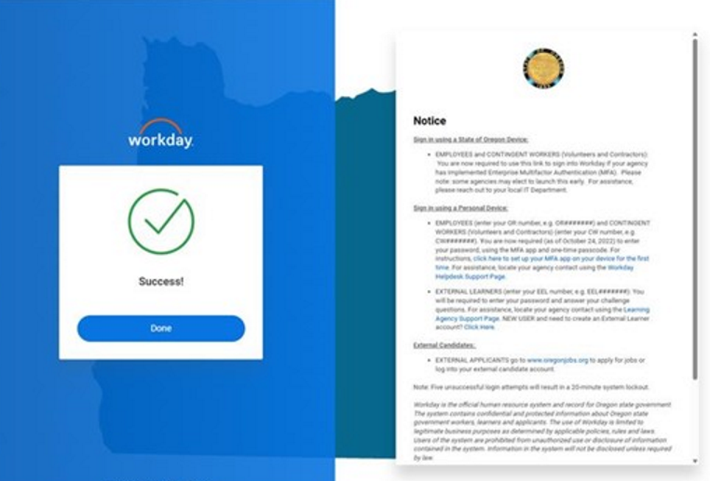

Each future login will require a new verification code.
* End of Resource Article *

