AASHTOWare Estimation Training Guide – Module 2
Updated: October 2022
Table of Contents
PREREQUISITES 3
Workday Training 3
ESTIMATION INTRO 3
GETTING STARTED 3
DAP DELIVERABLE 3
Navigate to Project 3
Ensure Project Data is Filled Out 4
Create Cost Estimate 4
Enter General Cost Estimation Information 6
Enter Contingency Assignment 6
Non-Construction Cost 7
Preliminary Engineering 7
Other Non-Construction Costs 8
Enter Inflation 9
Add Standard Bid Items 9
Add Miscellaneous (9Z9) Bid Items 10
Add Unit Price to Bid Item 11
Reference Pricing 11
Bid Based Pricing – Regression 11
Bid Based Pricing – Ad Hoc 13
Add Category 13
Assign Category to Bid Item 13
Run CN Cost Summary 13
PS&E ESTIMATE 14
Create PS&E Cost Estimate 14
Update CN Cost Estimate 15
Run CN Cost Summary 15
Run Fuel, Steel, Class of Work Report 16
Resources: 16

PREREQUISITES

Workday Training
Prior to taking Estimation – Module 2 (ODOT – ENG – AWProject Estimation – Estimation Certification – Virtual), all users must complete Estimation – Module 1 (ODOT – ENG – AWProject Estimation) in Workday or alternative training platform as specified at time of training. Upon completion of Module 1, you will be able to enroll in Module 2.

ESTIMATION INTRO
- Introduction to AASHTOWare Estimation
- Replacement of Estimator
- Phased Implementation
  - Phase 1 – Replace Estimation. DAP – Engineer’s Estimate (EE)
  - Phase 2 – Replace CET with Estimation at Scoping
  - Phase 3 – Perform all Program and Regional Scoping through Estimation
- When: All projects submitting DAP packages after June 1, 2022, will be required to use Estimation.
- Who: Regional and Consultant Estimators will need to have completed Module 1 and Module 2 to gain access to Estimation
- Why: Estimator is becoming non-supported. Estimation allows for a unified database, data analytics, concept estimates, auditable estimate, and cost change management reports

GETTING STARTED
- Login – Internal ODOT User
  - https://awproject:9000/Account/LogOn?ReturnUrl=/
  - Use network ID (HWY number) and password
- Login – External Consultant User
  - https://ordotawp.odot.state.or.us:9000/
  - Use ProjectWise ID and password
- AASHTOWare External User Access Agreement – all external users need to fill out the user access agreement before access will be granted to the Estimation PROD environment
  - https://www.oregon.gov/odot/Business/AASHTOWare/AWP_EUAA.pdf

DAP DELIVERABLE
The purpose of this section is to provide a real exercise to taking a project excel spreadsheet and entering the project data into a STIP project.

Navigate to Project
- Click Projects
- Search for key number
  - Projects that have been adopted into the STIP will have automatically been assigned key numbers in the STIP
  - Estimation continuously monitors and imports recently added projects to the STIP
    - If the project is not there, contact your STIP coordinator
    - Consultants will only see projects assigned to their firm. Contact the TPM/RECP to assign the project. If you are a sub consultant, contact the primary design consultant to have the estimate assigned to your firm.
- Select Project

Ensure Project Data is Filled Out
- Ensure all available project data is filled in on the Project Summary General page
  - This helps with regression pricing
- Counties
  - Select the Counties tab on the left side of the page
  - Input all counties for the project
    - Regressions work off of county identifier. You can enter more than one county, but you will need to weigh those counties appropriately.
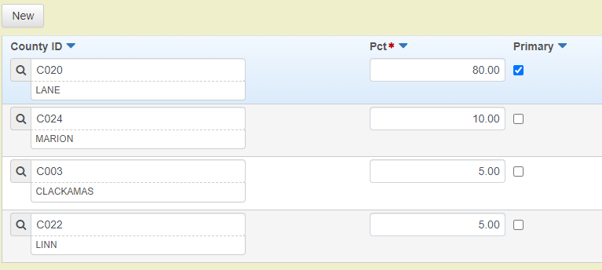
Figure 1 Entering Multiple County Example

Create Cost Estimate
- Click the Cost Estimate at the top of the web page
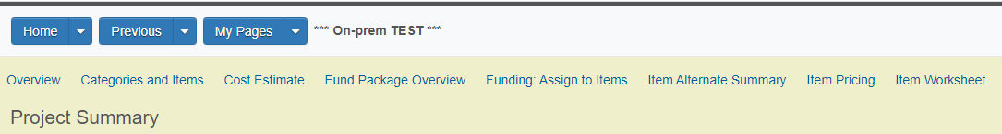
Figure 2 Cost Estimate Location

- Select Cost Estimates tab
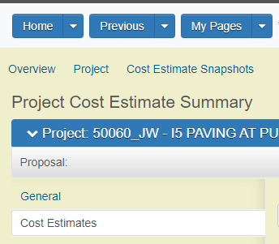
Figure 3 Cost Estimates Tab Location
- Click the blue Action Arrow
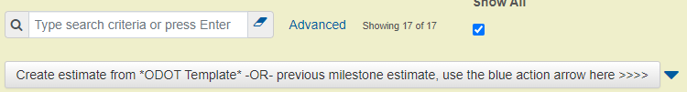
Figure 4 Copy Cost Estimate
  - Select Copy Cost Est
- Select the _ODOT_Template
  - If other projects are showing in the window, make sure Show Profiles is checked to only show the template
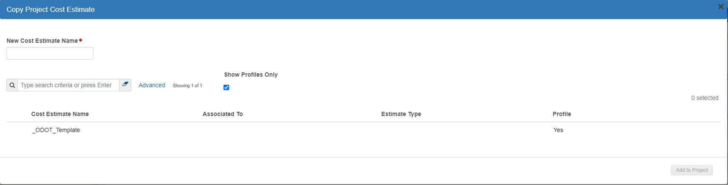
Figure 5 Copy Project Cost Estimate Window
- Enter New Cost Estimate Name
  - K#####_DAP_EST_01
  - This pulls in standard bid items
- Click Add to Project

Enter General Cost Estimation Information
- Select the newly created cost estimate K#####_DAP_EST_01
- In the General tab, fill out the following information in the Estimate Information section:
  - Estimate Phase
  - Estimate Type – select MERGED – Merged
  - Estimated By
  - Cost Estimate Description – update description
- Click Save

Enter Contingency Assignment
- Click the Contingency Assignment at the top of the web page
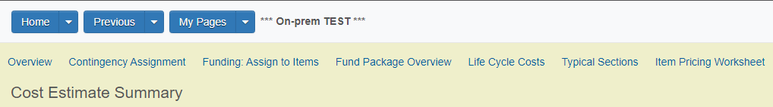
Figure 6 Contigency Assignment Location
- Enter Construction contingency assignment
  - Select Construction
  - Select Phase Ranges
  - Review Contingency Percentage is correct for cost estimate phase
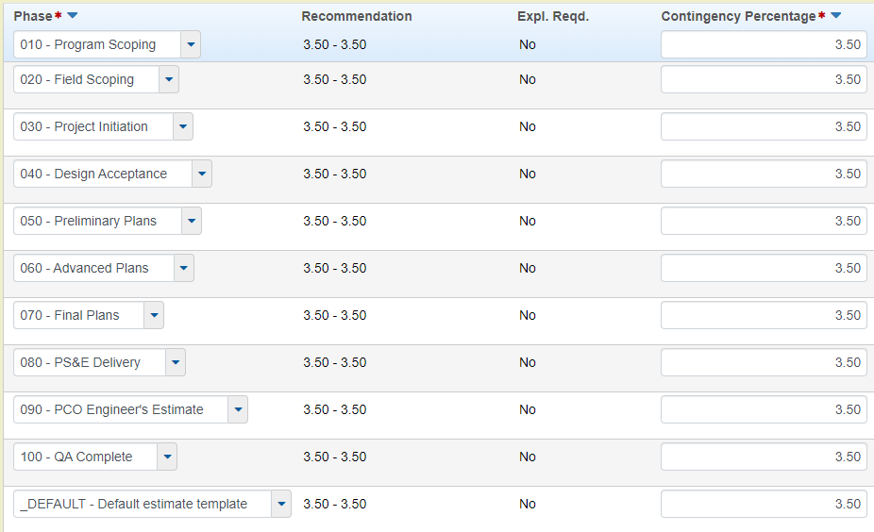
Figure 7 Construction Contingency Assignment
  - Click Save if percentage is changed
- Enter Design contingency assignment
  - Select Design
  - Select Phase Ranges
  - Enter Contingency Percentage for cost estimate phase
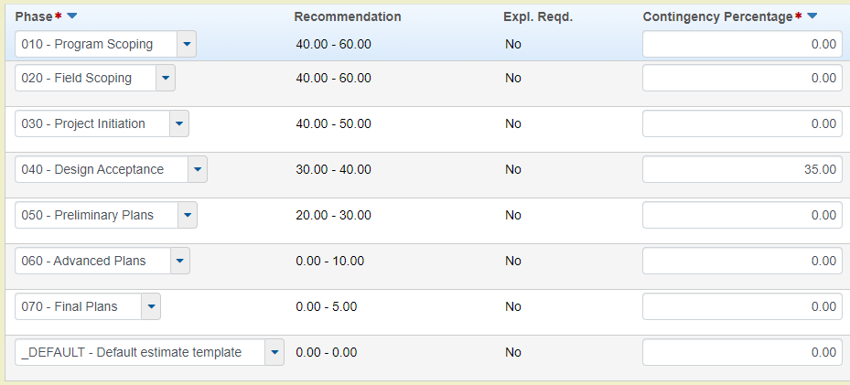
Figure 8 Design Contingency Assignment
  - Click Save

Non-Construction Cost
Non-construction cost include preliminary engineering, right of way cost, and utility reimbursements.
- Navigate to the Non-Construction Costs

Preliminary Engineering
- Select the Preliminary Engineering that pertains to the project
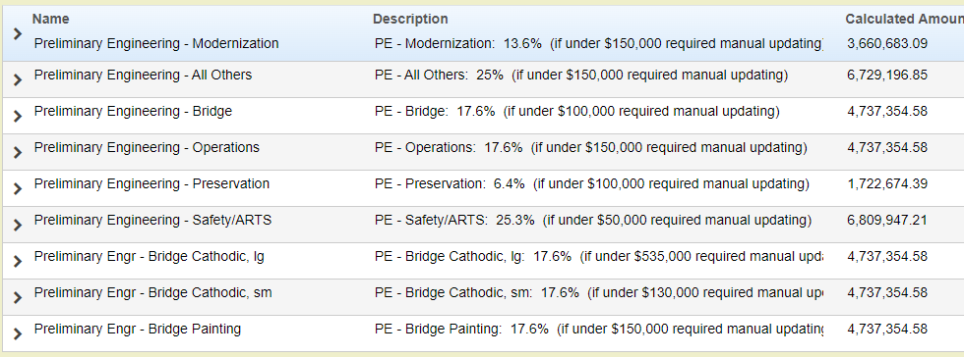
Figure 9 Preliminary Engineering
- Select the Active Box
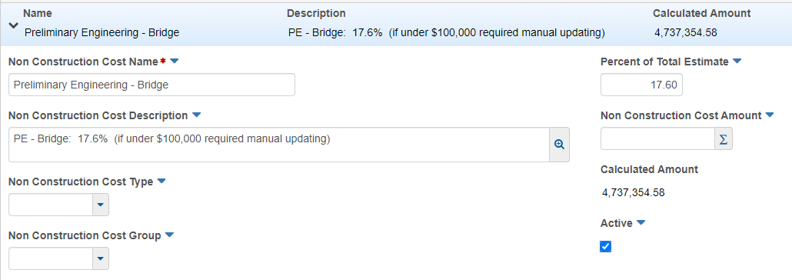
Figure 10 Active Checkbox
- Click Save

Other Non-Construction Costs
- Click New
- Enter Construction Cost Name
- Enter Percent of Total Estimate or Non Construction Cost Amount
  - Make sure Active box is checked
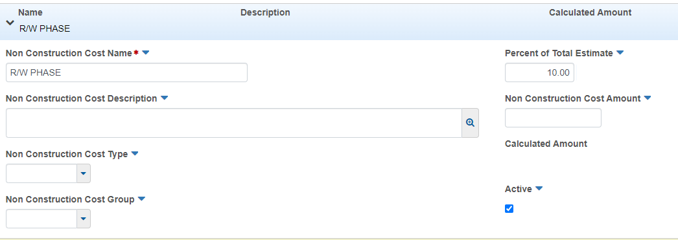
Figure 11 Non-Construction Cost
- Click Save

Enter Inflation
- Navigate to the Inflation tab
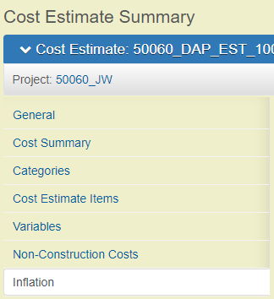
Figure 12 Inflation Tab Location
- Select New
- Select Inflation – Inflation from the Markup drop down
- Enter inflation amount in Amount
- Enter description in the Markup Supplemental Description
Figure 13 Entering Inflation
- Click Save

Add Standard Bid Items
- Navigate to the Item Pricing Worksheet
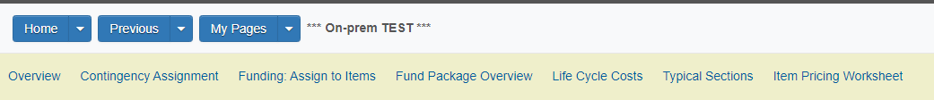
Figure 14 Item Pricing Worksheet Location
- Click Select Items…
  - Search for standard bid item
  - Select bid item
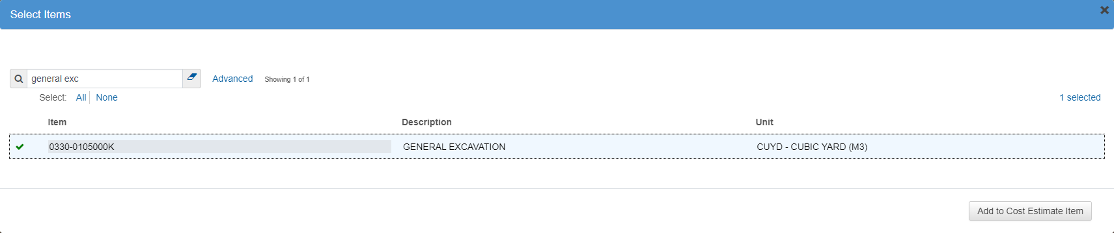
Figure 15 Search for Bid Item
  - Click Add to Cost Estimate
- Add Quantity in Quantity
- Enter supplemental description in Supp Descr if need
  - The supplemental description must include the entire name of the bid item and all of it must be capitalized. Any information in the supplemental description column will appear on the bid schedule.
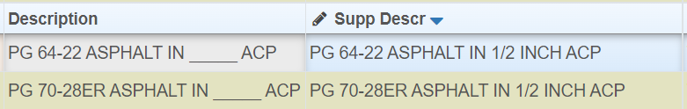
Figure 16 Supplemental Description
- Click Save

Add Miscellaneous (9Z9) Bid Items
Miscellaneous (9Z9) items must be entered in the Cost Estimate Item to ensure the class of work and production information is included for the bid item.
- Navigate to the Cost Estimate Items
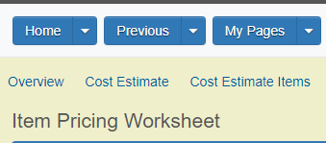
Figure 17 Cost Estimate Items Location
- Click New
- Enter the following information:
  - Item
  - Supplemental Description
  - Quantity
  - Price
  - Supp Item Class
  - Supp Item Sub Class
  - Supp Item Production Rate
- Click Save

Add Unit Price to Bid Item

Reference Pricing
- Select 3 blue lines in Unit Price 
- Select Reference
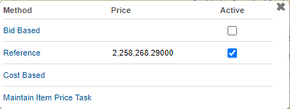
Figure 18 Reference Pricing
- Enter the Percent of for the bid item
- Make sure Active is checked
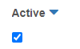
Figure 19 Active Checkbox
- Click Save
- Navigate back to Item Pricing Worksheet

Bid Based Pricing – Regression

Calculate Price
- Select 3 blue lines in Unit Price
- Check the box for Bid Based
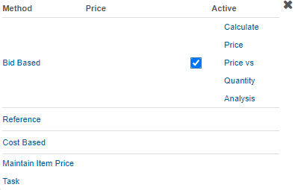
Figure 20 Bid Based Pricing
- Click Save
- Select 3 blue lines in Unit Price
- Click Calculate Price

Price vs Quantity Analysis
- Select 3 blue lines in Unit Price
- Check the box for Bid Based
Figure 21 Check Bid Based Box
- Click Save
- Select 3 blue lines in Unit Price
- Click Price vs Quantity Analysis
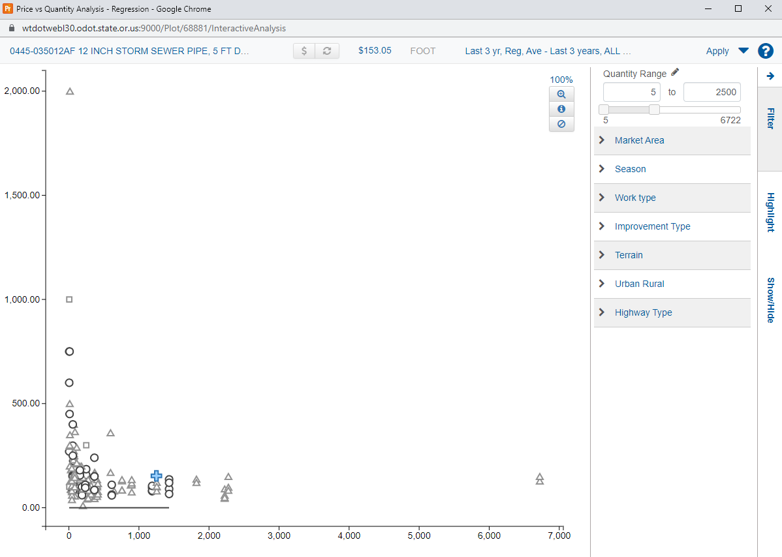
Figure 22 Price vs Quantity Analysis
- Adjust filters as needed
- Click Apply to use price proposed at top

Bid Based Pricing – Ad Hoc
- Enter price in Unit Price

Add Category
- Navigate to Cost Estimate Summary
- Select Categories
- To add a Category:
  - Click New
  - Enter Category (number) and Category Description
    - If the new category is a structure, the category description must include the structure number
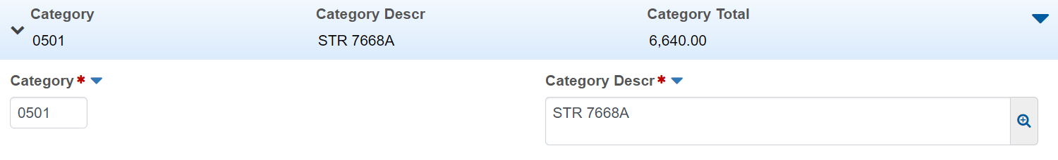
Figure 23 Adding Category
  - Click Save

- To copy a Category:
  - Select the blue Action Arrow on the category you want to copy
  - Select Duplicate Row
  - Enter the Category (number) and the Category Description
  - Click Save

Assign Category to Bid Item
The CAT ID column of the Item Pricing Worksheet will automatically be filled in with the inferred category. If there are multiple structure category groups, the correct category will need to be manually inputted in the CAT ID column of the Item Pricing Worksheet.
- Navigate to the Item Pricing Worksheet
- Select the category you want to change
- Begin typing the category number or name to search
- Select the category
- Click Save

Run CN Cost Summary
- Select the Row Action Arrow.
Figure 24 Row Action Arrow

- Click Cost Estimate Summary Report
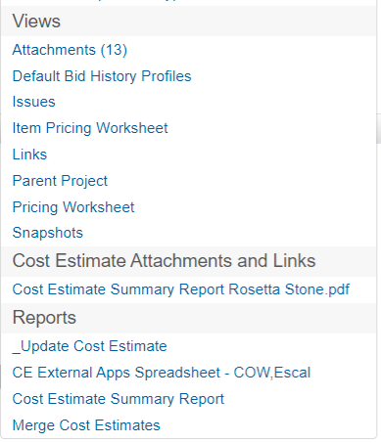
Figure 25 Cost Estimate Summary Report
- Click Execute

PS&E ESTIMATE

Create PS&E Cost Estimate
- Click Projects
- Search for key number
- Select Project
- Select Cost Estimate
- Select the Cost Estimates tab
- Click the blue Action Arrow
Figure 26 Copy Cost Estimate
  - Select Copy Cost Est
- Uncheck Show Profiles Only
  - This will show all cost estimates
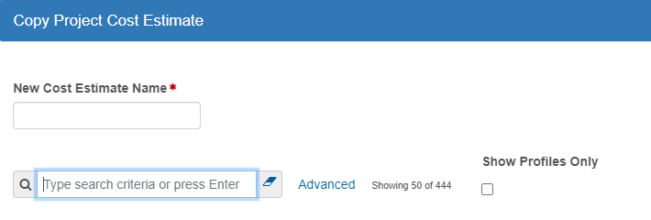
Figure 27 Uncheck Show Profiles Only Box
- Select previous cost estimate for project
- Enter New Cost Estimate Name
  - K#####_PSE_EST_01
- Click Add to Project

Update CN Cost Estimate
- Select PS&E estimate
- Update the Estimate Phase and Cost Estimate Description
- Update Contingency Assignment
- Update Inflation
- Update bid items – add or delete bid items as needed
- Update bid item pricing – adjust pricing as needed

Run CN Cost Summary
- Select the Row Action Arrow.
Figure 28 Row Action Arrow
- Click Cost Estimate Summary Report
Figure 29 Cost Estimate Summary Report
- Click Execute

Run Fuel, Steel, Class of Work Report
- Select the Row Action Arrow
- Click CE External Apps Spreadsheet – COW, Escal
Figure 30 Fuel, Steel, COW Spreadsheet
- Click Execute
- Download the Fuel Index and Scheduling Program – Estimation file from the ODOT AASHTOWare Estimation web page
- Copy the information from Sheet 1 of the Excel sheet from Estimation into the ODOT Fuel Index and Scheduling Program

Resources:
AASHTOWare Estimation web page: https://www.oregon.gov/odot/Business/Pages/AW-Estimation.aspx
- Links to Estimation Production environment for internal and external users
- AASHTOWare External User Access Agreement under Request Access
- Quick Reference Guides
- Fuel Index and Scheduling Program (Fuel, Steel, COW Calculator)
PCO Cost Estimating Team Email: ODOTCostEstimating@odot.oregon.gov
Estimation Exam Link (ODOT – ENG – AWProject Estimation – Estimation Certification Exam): https://wd5.myworkday.com/oregon/learning/course/71a3a9a9f7ba010a5ad5bfa2a401b8bd?record=5835cc413d270116c4ab7e82b6017048&type=9882927d138b100019b928e75843018d

