
ODOT Region 1 Geo-Environmental Unit
Historic Resources Baseline Report

Date: June 19, 2017

Project Name: Foster Streetscapes: SE 50th Ave. to SE 92nd Ave.

Portland, Multnomah County, Oregon

ODOT Key No. 18022, Federal-Aid No. 5900(287)PE

Location: SE Foster Road, Portland, Multnomah County.

Project Description Summary: The Foster Streetscapes project will construct pedestrian, bicycle and transit access improvements along SE Foster Road, from the intersection of SE Powell Boulevard and SE 50th Avenue to SE 92nd Avenue. In particular, the project will reallocate roadway space to create a new three-lane cross-section to add bicycle lanes and preserve existing on street parking. The project also includes construction of curb extensions, sidewalk in-fill, pedestrian scale lighting, street tree in-fill, rapid flashing beacons (SE Cora, 65th, 69th, 70th, 75th, 84th avenues), upgrading of two existing traffic signals (SE Holgate Street and SE 72nd Avenue) to improve multi-modal safety. From SE 82nd Avenue to SE 90th Avenue the project will also do street reconstruction and paving. The project will also provide stormwater treatment facilities along SE Foster Road.

Area of Potential Effect: The Area of Potential Effect (APE) is at discrete locations along SE Foster Road from the intersection with SE Powell Boulevard and SE 50th Avenue to SE 92nd Avenue within the project’s Area of Potential Impact (API). At these nodes, the APE also runs from face-of building to face-of-building across SE Foster Road. Specifically, it includes locations along this section of SE Foster Road where the project will modify sidewalks and, at SE 72nd Avenue, where it will reconfigure the south end of Firland Parkway.

Existing Conditions:
The research methodology to identify newly-discovered and previously-documented historic resources in the potential APE and establish existing conditions included several techniques: 1) a review of the Oregon State Historic Preservation Office (SHPO) statewide databases for historic sites and for National Register properties; and 2) a reconnaissance level (walking and driving) survey of the potential APE.
Literature Search
Review of the State Historic Preservation Office (SHPO) statewide inventory, http://heritagedata.prd.state.or.us/historic/, resulted in the identification of several previously-recorded historic resources along SE Foster Road between SE Powell Boulevard and SE 92nd Avenue. These include:

Property  Name/Address | Construction Date/Resource Type | National Register Status | Notes
Retail  5741 SE Foster Rd. | 1908. | Demolished | Collapsed during windstorm several years ago.
Retail  5820 SE Foster Rd. | c.1914 | Eligible Contributing | RLS. Portland North and Eastside Selective RLS 2013, Unreinforced Masonry Structures
Retail  6350-60 SE Foster Rd. | c.1924. Two-story brick commercial block. | Eligible Significant | RLS. Portland North and Eastside Selective RLS 2013, Unreinforced Masonry Structures
Palestine Masonic Lodge  6401 SE Foster Rd. | 1926. Brick fraternal society building. | NR Listed, 2005
6405 SE Foster Rd. | c.1925/c.1965. Vernacular retail block. | Eligible Contributing
Retail  6433 SE Foster Rd. | c.1925/c.1990. Two-story brick commercial/residential block. | Eligible Contributing
Retail  6504-10 SE Foster Rd. | c.1920/c.1980 | Eligible Contributing | RLS, 2003
Old Phoenix Drugstore  6515 SE Foster Rd. | c.1912. Masonry business block | Eligible Significant
Retail  6803 SE Foster Rd. | 1910/1941 | Eligible Contributing
House  7726 SE Foster Rd. | 1884 | Demolished | Recorded 1999
F. R. Peterson House  8659 SE Foster Rd. | 1922 | Eligible Contributing
U-Haul of Oregon  8816 SE Foster Rd. | c.1940. Utilitarian concrete block building | Eligible Contributing
Auto Service Garage  8901-19 SE Foster Rd. | 1920 | Demolished
Lents Machine Shop 9015 SE Foster Rd. | 1922/1960 | Demolished
Retail  9129 SE Foster Rd. | c.1910 | Demolished
Retail and apartments  9143 SE Foster Rd. | 1913 | Demolished
Lents Library  5827 SE 91st Ave. | 1915/1926. Craftsman bungalow-style building. | Eligible Contributing

Field Survey/Inventory
Robert W. Hadlow, ODOT Region 1 senior historian, and Roy Watters, ODOT archaeologist, performed basic scoping for historic built and archaeological resources in the APE in 2016 and 2017. Specifically, Hadlow surveyed the project area on October 19 and November 2, 2016, and on June 16, 2017, for historic built resources. Hadlow’s goal was to identify any properties that were 45 years old or older within the APE. He identified 41 properties and noted their addresses. The results of the on-site survey are shown in the “Table: Historic Resource Analysis.”

Firland Parkway and Firland Subdivision as Section 106 Historic Properties:
Hadlow also looked specifically at Firland Parkway and the Firland subdivision for potential eligibility for the National Register. Firland Parkway is a historic designed landscape. It is a 60-foot-wide, tree-lined grassy median on SE 72nd Avenue between SE Holgate Boulevard and SE Foster Road. In 1903, the developers of the Firland subdivision dedicated this strip of land to the city as a parkway, likely as part of the “City Beautiful Movement” that was sweeping Portland and the country. By 1913, the city parks bureau and the city council promised the neighborhood that it would improve the land and have it “properly parked out and beautified” if the neighborhood paid for installing curbing. Plans called for planting 56 European linden trees. Later documentation demonstrates that the trees were maples and not lindens and went in by 1922.

Over the years, many of the maple trees have toppled over or otherwise died. There are very few replacements, leading to gaps in spacing. Also, most of the maple trees on the east side of the parkway show evidence of heavy pruning to accommodate power lines. In addition, several non-native ornamental conifers are located in the parkway. Finally, the city road bureau modified the southern end of the parkway in the 1980s, at the intersection with Foster Road, by tapering and extending the southern end of the parkway into roadway right-of-way. This was to better channelize the pedestrian crossing of SE 72nd Avenue at SE Foster Road and the travel lanes on SE 72nd Avenue. When compared with other east side Portland parkways, including Roseway Parkway, Omaha Parkway, Reed College Parkway, and the Ainsworth Blocks, the Firland Parkway falls short. The others possess a higher level of integrity. In sum, many forces have compromised the Firland Parkway’s integrity. It is not eligible for the National Register as a standalone historic designed landscape.

Comparison of Firland Parkway with other older eastside parkways in Portland:

- Roseway Parkway, NE 72nd Ave. between NE Sandy Boulevard and NE Prescott Street

- Omaha Parkway, N. Omaha Street between N. Killingsworth Street and N. Rosa Parks Way (N. Portland Boulevard)

- Reed College Parkway, SE Reed College Place between SE Bybee Boulevard and SE Crystal Springs Boulevard

- Ainsworth Blocks, NE Ainsworth Street between NE Grand Avenue and NE 37th Avenue.

Hadlow also investigated whether Firland Parkway, even with its reduced integrity, could be a contributing feature to a potential Firland subdivision historic district, which would include the housing development, as platted, from the west side of SE 70th Avenue to the east side of SE 74th Avenue and from the south side of SE Holgate Boulevard to the north side of SE Foster Road. However, of the 207 extant properties in the Firland subdivision (201 houses, four businesses, one church, and one parkway), only 37 percent were intact and possessed enough integrity to be contributing features to a potential Firland subdivision historic district, one where the period of significance spanned from 1903 until 1950. Those resources with poor integrity had replacement windows and replacement siding, or replacement windows with altered openings and design, or had unsympathetic structural additions. (If the resources just had windows swapped out with in-kind windows and unaltered openings, or just the siding was swapped out, the properties still had enough integrity for future consideration as contributing features.)

Hadlow established the “Period of Significance” to run from 1903, the year when the developers filed the subdivision plat, to 1950. The 1950 Sanborn Fire Insurance maps for the subdivision are a very good barometer. The few vacant lots shown on the 1950 maps saw in-fill after 1950, with the majority of the construction taking place in the last 40 years. In addition, several brand new homes have displaced houses that appeared in the 1950 maps.

SE Foster Road:
Hadlow also looked at SE Foster Road from SE 50th Avenue to SE 72nd Avenue for National Register eligibility. Foster Road began as an Indian trail that evolved into a route for Oregon pioneers since the 1850s and connected Portland with Philip Foster’s farm at Eagle Creek. Later it the 19th century, it became a county road, and then a city street in the early 20th century.

Foster Road in this section gained its immense width as part of an improvement project in the early 1920s to graft the 35-foot right-of-way for the Portland Railway Light and Power Company’s Mt. Scott streetcar line onto the roadway’s existing 60-foot cross-section. (The streetcar line ran down SE Hawthorne Boulevard., SE 50th Avenue, SE Foster Road, and SE 72nd Avenue on its way to SE Woodstock Boulevard.) It was the plan of City Engineer Olaf Laurgaard to create the 95-foot combined right-of-way along Foster Road from SE 50th Avenue to SE 72nd Avenue, which would include two streetcar lanes, two roadway lanes, two parking strips, and two 17-foot sidewalks.

Billed as Portland’s widest street, this segment of Foster Road was intentionally reminiscent of Baron Haussmann’s nineteenth-century grand boulevards of Paris. Commercial ventures sprung up along this segment of Foster Road in the next 100 years. It may have once been the vibrant commercial district in southeast Portland that some would have liked to have seen, but the loss of buildings and incompatible alterations to others have greatly affected the historic integrity of this segment of Foster Road. In addition, streetcars and their tracks left Foster Road decades ago. The segment of SE Foster Road from SE 50th Avenue to SE 72nd Avenue is not eligible for the National Register.

Conclusion
The ODOT historic resources staff reviewed the properties noted in this report. They concluded that many of the properties lacked original integrity of one or more of the following aspects: design, materials, workmanship, or feeling. The staff recommended that those properties were not eligible for the National Register.

Potentially Eligible Built Historic Resources:
Hadlow and the staff believe that there are eight historic built resources of interest in the project’s APE. They are listed below, along with the proposed project activities that will be nearby.

- A. Ditto Medical Clinic, 5402 SE Foster Road
(Storm water treatment facility)

- E. YMCA, 6036 SE Foster Road
(ADA ramp within roadway right-of-way)

- G. Vacant Retail, 6256-58 SE Foster Road
(in-kind sidewalk within roadway right-of-way)

- P. St. Peter Roman Catholic Church Complex, 5903 SE 87th Avenue
(sidewalk replacement and ADA ramps within roadway right-of-way)

- S. U-Haul of Oregon, 8816 SE Foster Road
(sidewalk replacement and ADA ramps within roadway right-of-way)

- U. The Bridge, 8747 SE Foster Road
(sidewalk replacement and ADA ramps within roadway right-of-way)

- EE. Affordable Mechanics USA, 8509 SE Foster Road
(sidewalk replacement within roadway right-of-way)

- KK. Bar Carlo, 6433-39 SE Foster Road
(ADA ramps, curb extensions and new sidewalks within roadway right-of-
way)

Firland Parkway as a Section 4(f) Recreation Resource:
Hadlow also looked at whether Firland Parkway was a publicly owned park that would receive protection under Section 4(f) of the US Department of Transportation Act of 1966. Property managers with the Portland Bureau of Transportation (PBOT) confirmed that PBOT owns and maintains the Firland Parkway as a developed, vegetated roadway feature. The agency does not consider it a park nor has the agency made any improvements to Firland Parkway to promote or enable recreation. (There are no sidewalks, benches, picnic tables, ball fields, courts, etc., within the boundaries of Firland Parkway.)

Recommendation:
Even though there are potentially eligible historic resources at locations along SE Foster Road where the Foster Streetscapes project will make improvements, none of the work will affect those resources. The project can be cleared under Stipulation 4, Standard Review for Program Undertakings of “A Programmatic Agreement among the Federal Highway Administration, the Advisory Council on Historic Preservation, the Oregon State Historic Preservation Office and the Oregon Department of Transportation Regarding Implementing Section 106 of the National Historic Preservation Act for the Federal-Aid Highway Program in Oregon” (2011). A Stipulation 4C memorandum will provide the clearance.

References:
“A Programmatic Agreement among the Federal Highway Administration, the Advisory Council on Historic Preservation, the Oregon State Historic Preservation Office and the Oregon Department of Transportation Regarding Implementing Section 106 of the National Historic Preservation Act for the Federal-Aid Highway Program in Oregon.” 2011.

“Acquisition is Opposed,” Oregonian, December 30, 1921, 9.

“Adopted Foster-Powell Neighborhood Plan,” Outer Southeast Community, City of Portland Bureau of Planning, Portland, Oregon, March 1996.

“Building Goes on Over All East Side,” Sunday Oregonian, May 14, 1922, 10.

“Curbing up to Firland,” Oregonian, March 3, 1917. 4.

“East Portland Historical Overview & Historic Preservation Study.” City of Portland Bureau of Planning and Sustainability. March 2009.

“Firland Tract to Open,” Sunday Oregonian, October 12, 1919, 15.

Oregon State Historic Preservation Office. Oregon Historic Sites Database.

“Road Paving is Asked,” Sunday Oregonian, March 29, 1914, 11.

Sanborn Fire Insurance Map Nos. 1123, 1124, 1125, 1137, 1138, 1139, Portland, Oregon, 1925.

Sanborn Fire Insurance Map Nos. 1123, 1124, 1125, 1137, 1138, 1139, Portland, Oregon, 1950.

“South East Side Growing Rapidly,” Sunday Oregonian, March 22, 1914, 10.

“South East Side Shows Progress,” Sunday Oregonian, February 2, 1913, 7.

“YMCA Announces Change in Name of S.E. Branch to Honor John Leach,” Oregonian, December 13, 1956, 23.

Table: Historic Resource Analysis
Map ID | Property  Name/Address | Map/Tax Lot | Construction Date/Resource Type | National Register Status | Photograph of Resource
A | 5402 SE Foster Rd.  Portland, OR | 1S2E07DB 17800 | 1930. Brick Spanish Colonial Revival office building. Originally Drs. Johnson F. and Florence W. Ditto’s medical clinic. Now an accountant office. | Possesses integrity. Eligible Contributing. Potentially eligible under Criterion A and C | 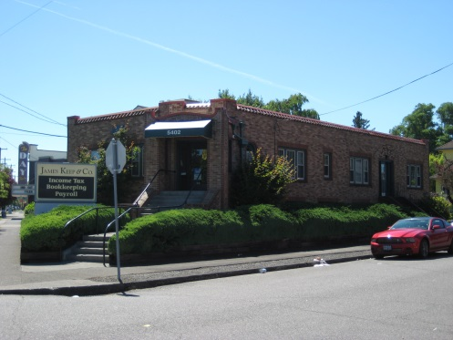
B | 5606 SE Foster Rd.  Portland, OR | 1S2E07DC 400 | 1926. Vernacular furniture and upholstery shop. Much altered fenestration and envelope | Lacks integrity.  Not eligible | 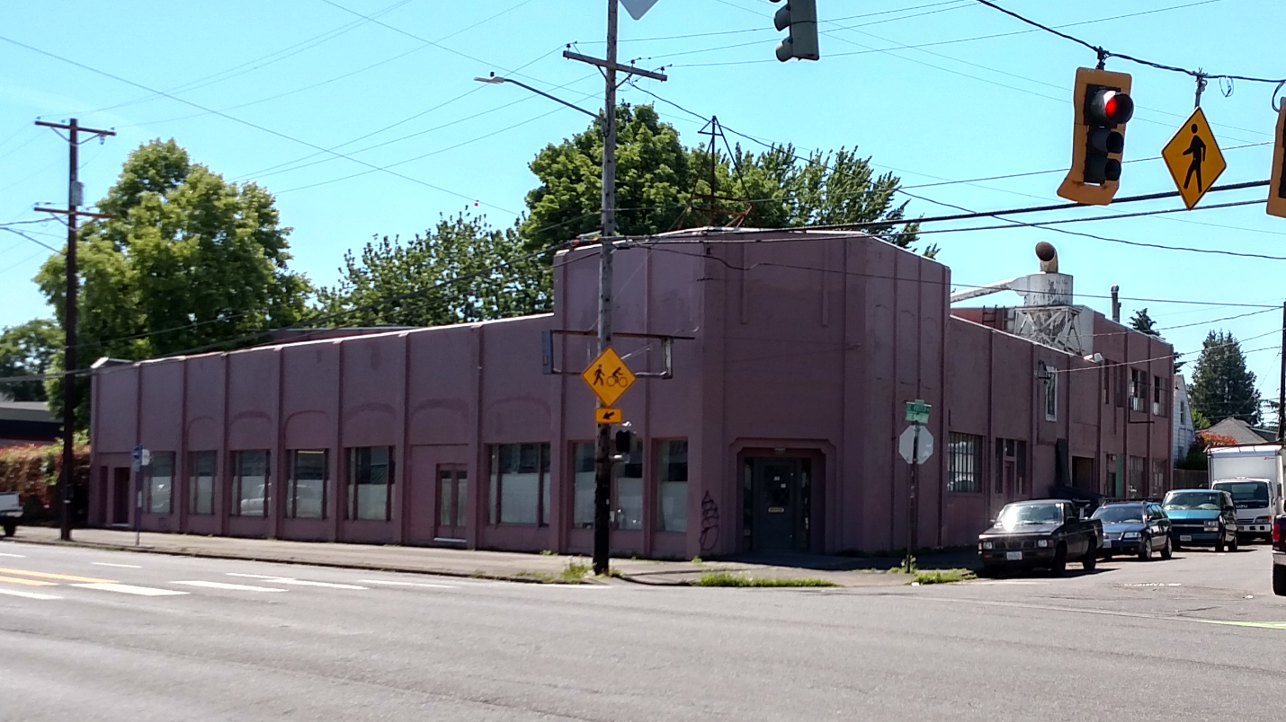
C | 10th Planet Jiu Jitsu Portland  5816 SE Foster Rd.  Portland, OR | 1S2E07DD 16600 | 1924/1968. Vernacular used car lot office and garage; later, lumber sales. Highly altered. | Lacks integrity.  Not eligible. | 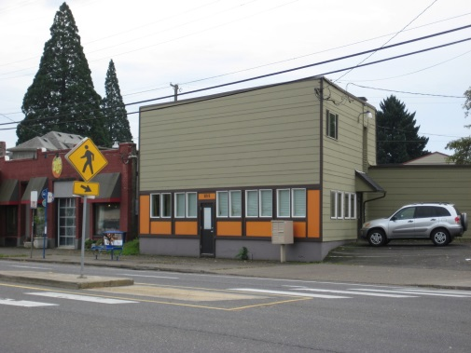
D | 5836-42 SE Foster Rd.  Portland, OR | 1S2E07DD 15100 | 1911. Vernacular storefront. Built around a simple gabled house at 5830 SE Foster Rd. | Lacks integrity.  Not eligible | 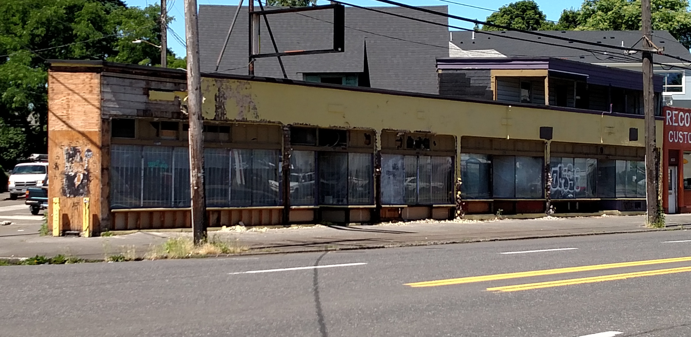
E | Southeast Child Development Center of the YMCA of Columbia-Willamette  6036 SE Foster Rd.  Portland, OR | 1S2E07DD 8100 | 1957. Originally the “John R. Leach Branch of the YMCA.” Mid-Century design, by Whittier & Frisch. | Possesses integrity. Possibly eligible under Criteria B and C. | 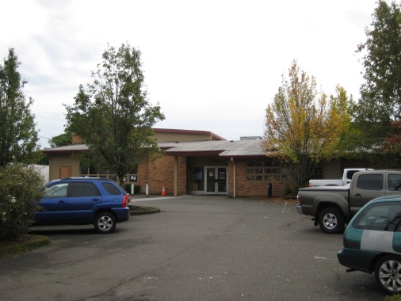
F | Roundtable Pizza  6250 SE Foster Rd.  Portland, OR | 1S2E17BB 6200 | 1958. Brick vernacular business block with extensive alterations to exterior walls and windows. | Lacks integrity.  Not eligible. | 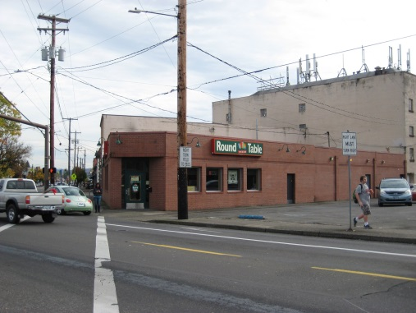
G | Vacant Retail  6256-58 SE Foster Rd.  Portland, OR | 1S2E17BB 6100 | 1928. Stucco two-story vernacular business block. | Possesses integrity. Possibly eligible under Criterion A as part of a district. | 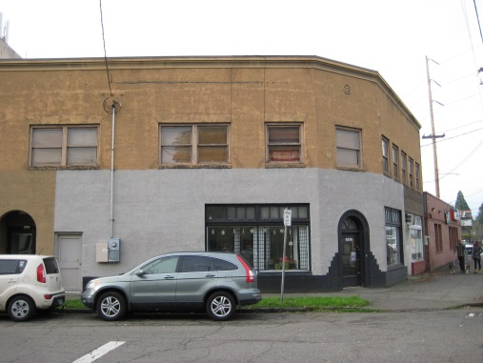
H | Foster Square Shopping Center  6730-6868 SE Foster Rd.  Portland, OR | 1S2E17BA 11800 | 1970. Mid-Century strip mall with significant alterations to primary elevation in 1993. | Lacks integrity.  Not eligible. | 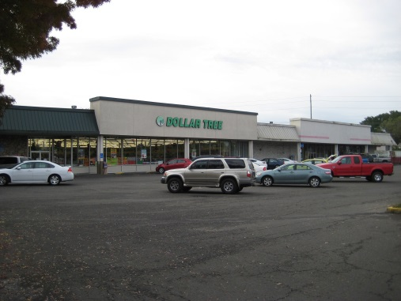
I | A-Boy Plumbing  7344 SE Foster Rd.  Portland, OR | 1S2E17AC 6000 | 1964. (Plumbing permits date building to 1925; A-Boy there since 1961.) Vernacular storefront. Some alterations to secondary elevations with metal siding. | Compromised integrity and fails under Criteria A, B, and C.  Not eligible. | 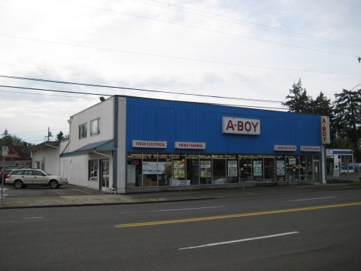
J | Automotive Outfitters  8324 SE Foster Rd.  Portland, OR | 1S2E16CB 6900 | 1927. Vernacular auto repair shop. Originally auto body; now tire shop. | Lacks integrity and fails under Criteria A, B, and C.  Not eligible. | 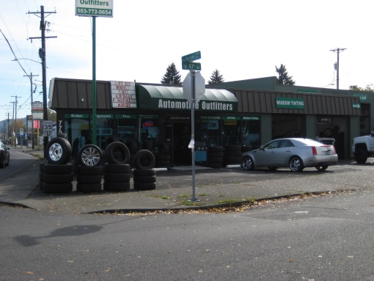
K | Hing Ming Market  8330 SE Foster Road  Portland, OR | 1S2E16CB 8700 | 1970. Former dry cleaning store now Asian convenience store. Neo-Mansard-style with half-timbered panels and ornamental cement block. Mostly intact. | Possesses integrity, but fails under Criteria A, B, and C.  Not eligible. | 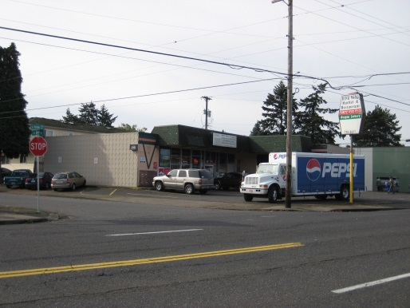
L | Space Age Fuel  8410 SE Foster Rd.  Portland, OR | 1S2E16CB 8800 | 1961. Richfield Service Station. Standardized service station with bays converted to convenience store. New bays added to rear. | Lacks integrity.  Not eligible. | 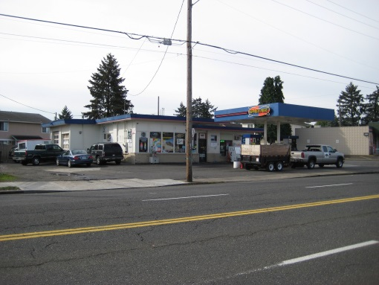
M | DeanzGreenz  5625 SE 85th Ave.  Portland, OR | 1S2E16CB 10200 | 1925. Craftsman house. Generally intact. However, recent incompatible commercial building added adjacent to it. | Compromised integrity. Also fails under Criteria A, B, and C.  Not eligible. | 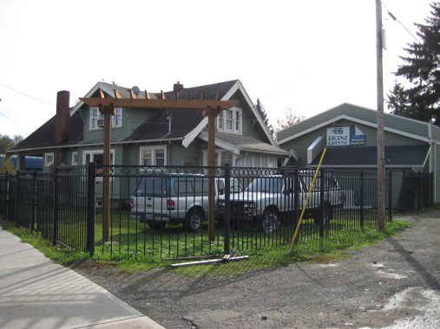
N | America Cleaning Solutions/Latino Tax Service  8506 SE Foster Rd.  Portland | 1S2E16CB 10300 | 1960. Vernacular Mid-Century auto parts store and other businesses. Intact. | Possesses integrity, but fails under Criteria A, B, and C.  Not eligible. | 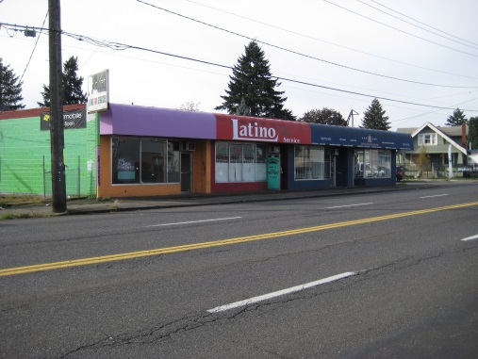
O | Premium Tire Service  8530 SE Foster Rd.  Portland, OR | 1S2E16CB 11200 | 1969. Mid-Century Piazza Pizza Factory. Some remodeling. | Lacks integrity.  Not eligible. | 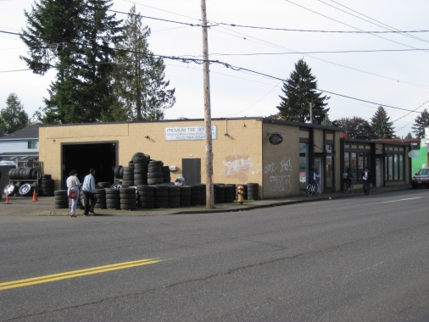
P | St. Peter RC Church Complex  5903 SE 87th Ave.  Portland, OR | 1S2E16CB 11800 | 1920s/1957. Campus of many buildings. 1920s Craftsman house (former Lents Methodist manse) has incompatible dormer; 1920s former Methodist church and gym (Methodius Hall) has incompatible additions and windows. 1920s Craftsman rectory has incompatible windows and enclosed porch. 1956 Ranch-style school has vinyl siding and windows. 1957 Mid-Century church possesses integrity | Not eligible as a district. However, church building has integrity and may be eligible individually under Criterion C. | 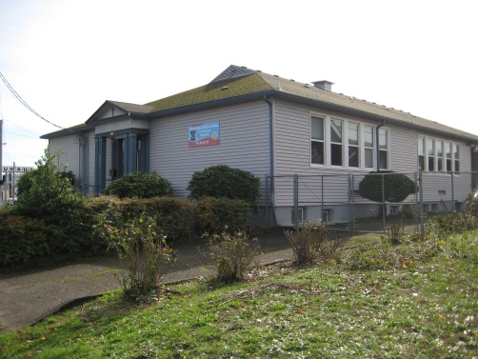  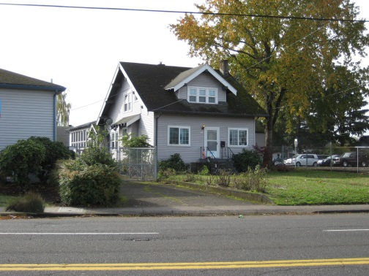  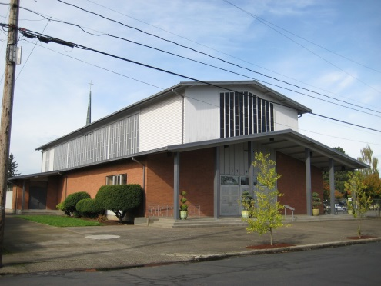
Q | House  8708 SE Foster Rd.  Portland, OR | 1S2E16CA 15300 | 1910. Intact Craftsman cottage. | Possesses integrity, but fails under Criteria A, B, and C.  Not eligible. | 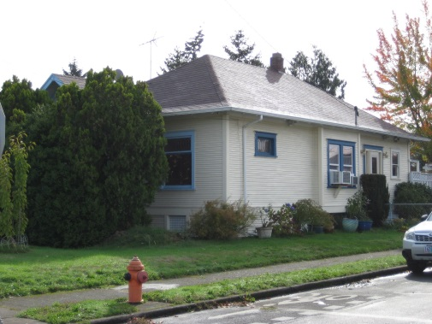
R | House  8718 SE Foster Rd.  Portland, OR | 1S2E16CA 15200 | 1909. Intact Craftsman cottage. | Possesses integrity, but fails under Criteria A, B, and C.  Not eligible. | 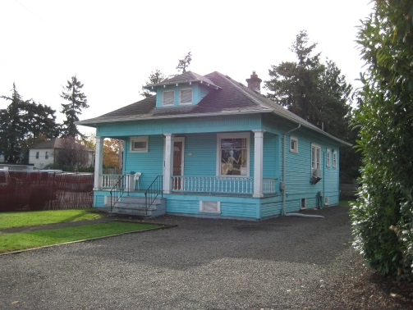
S | U-Haul of Oregon  8816 SE Foster Rd.  Portland, OR | 1S2E16CA 12800 | 1916 or 1940. Utilitarian concrete block warehouse. Some siding alterations and windows covered, but volumes are intact. | Possesses much integrity. Significant under Criterion A as the first U-Haul store in the US. Eligible Contributing.  Potentially eligible. | 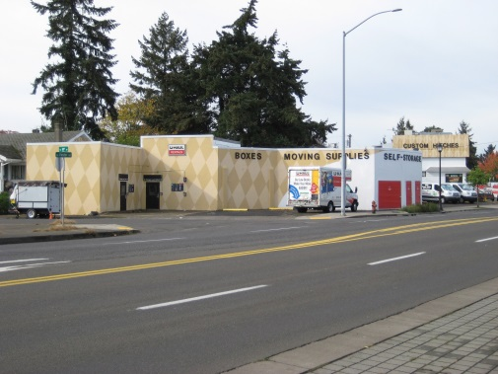
T | Auto Body Shop  5810 SE 89th Ave.  Portland, OR | 1S2E16CA 12700 | Age unknown. Tax rolls state 1988. Concrete block building. | Compromised integrity if older than 1988. Fails under Criteria A, B, and C.  Not eligible. | 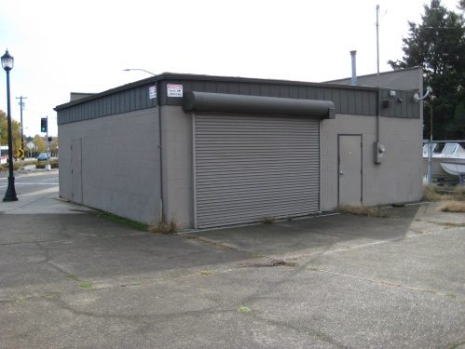
U | The Bridge  8747 SE Foster Rd.  Portland, OR | 1S2E16CA 4100 | 1958. The former Jacobson’s Funeral Home. Now a church. Intact Mid-Century Modern commercial building. Some modest alterations to primary elevation. | Possesses much integrity. Possibly eligible under Criterion C. | 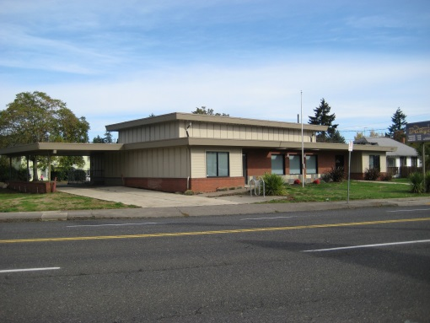
V | Rising Sun Koi  8721 SE Foster Rd.  Portland, OR | 1S2E16CA 4000 | 1930. House with a brick vernacular commercial addition, originally a barbershop. LP-111 siding and newer windows. | Lacks integrity.  Not eligible. | 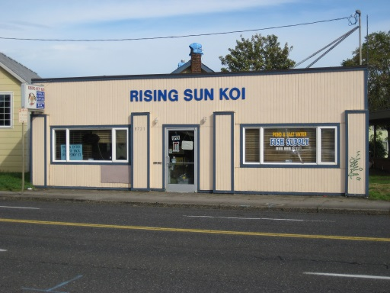
W | House  8717 SE Foster Rd.  Portland, OR | 1S2E16CA 3900 | 1914. Vernacular, possibly heavily remodeled Craftsman cottage. | Lacks integrity.  Not eligible. | 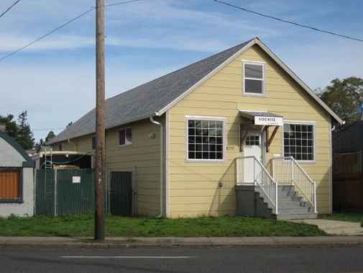
X | Retail  8705 SE Foster Rd. | 1S2E16CA 3800 | 1948. Postwar Quonset hut with cinderblock walls. Commercial use. Appliance store. | Not eligible. Marginal integrity. Fails under Criteria A, B, and C. | 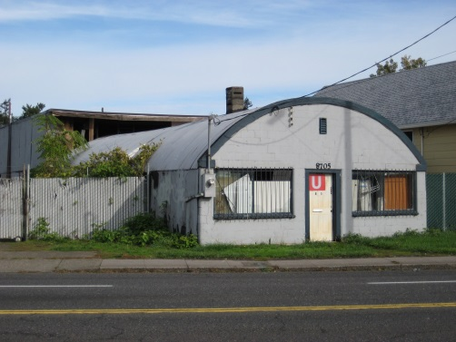
Y | House  8659 SE Foster Rd.  Portland, OR | 1S2E16CB 900 | 1922. Craftsman bungalow. Incompatible replacement windows. Siding is vinyl or cement board. | Eligible Contributing in SHPO database. However, it lacks integrity.  Not eligible. | 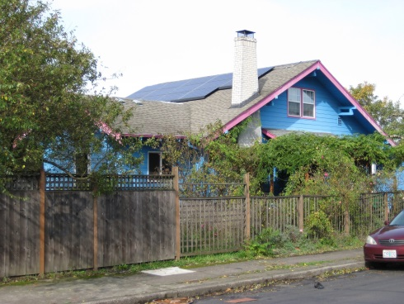
Z | Triplex  8637-41 SE Foster Rd.  Portland, OR | 1S2E16CB 1200 | 1909. Craftsman bungalow. Heavily remodeled. | Lacks integrity.  Not eligible. | 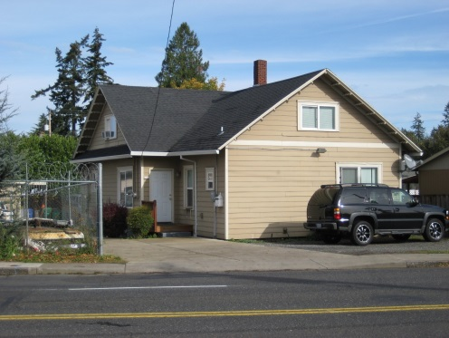
AA | Foster Autobody & Paint  8623-35 SE Foster Rd.  Portland, OR | 1S2E16CB 1400 | 1970-72. Utilitarian auto-related commercial structure. Newer siding and doors. | Lacks integrity.  Not eligible. | 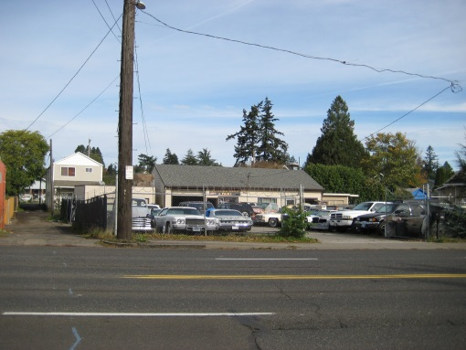
BB | Mini Mart  8619 SE Foster Rd.  Portland, OR | 1S2E16CB 1500 | 1953. Former minimalist Mid-Century Modern plumbing shop, now a mini mart. | Possesses some integrity, but fails under Criteria A, B, and C.  Not eligible. | 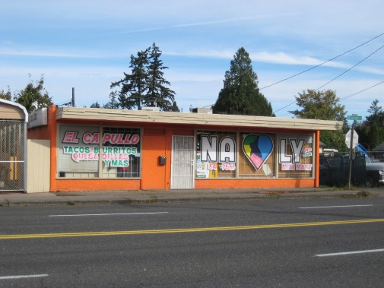
CC | House  8601 SE Foster Rd.  Portland, OR | 1S2E16CB 1500 | C.1920. Same tax lot as Y above. | Possesses integrity, but fails under Criteria A, B, and C.  Not eligible. | 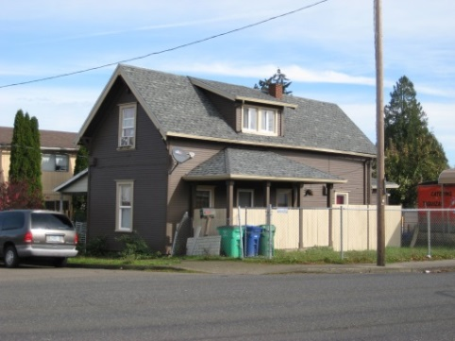
DD | ABC Landscape & Paint  8533 SE Foster Rd.  Portland, OR | 1S2E16CB 2800 | 1948 or 1961. Former woodworking shop of simple design. LP 111 siding. Low integrity. | Lacks integrity.  Not eligible. | 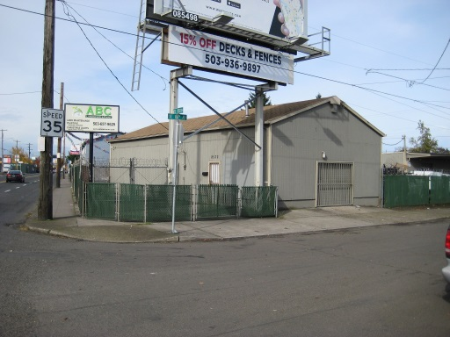
EE | Affordable Mechanics USA  8509 SE Foster Rd.  Portland, OR | 1S2E16CB 2900 | 1962. Intact example of an original Rose City Pre-Cut Buildings’ pre-cut aluminum garage. | Possesses integrity. May be eligible under Criterion C. | 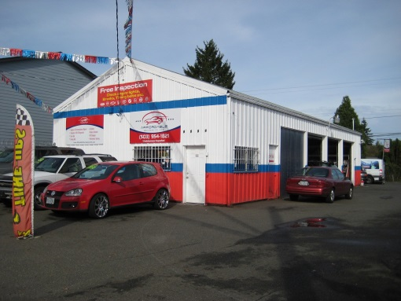
FF | JB Noodle Shop  8405 SE Foster Rd. (8413, 8415)  Portland, OR | 1S2E16CB 3300 | 1942. Former vernacular auto garage. Vinyl siding and newer windows. | Lacks integrity.  Not eligible. | 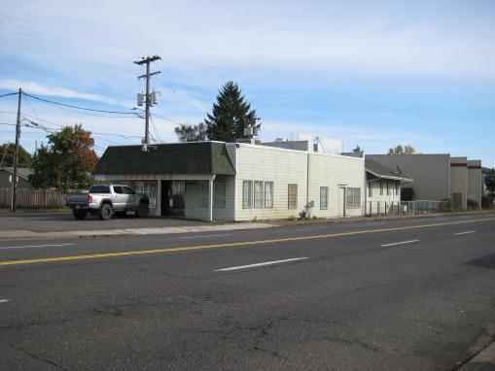
HH | Vacant businesses  7407-15 SE Foster Rd.  Portland, OR | 1S2E17AC 3900 | 1948. Small Mid-Century business block with incompatible rear addition. Some window replacement windows. Poor condition | Lacks integrity. Also fails under Criteria A, B, and C. Not eligible. | 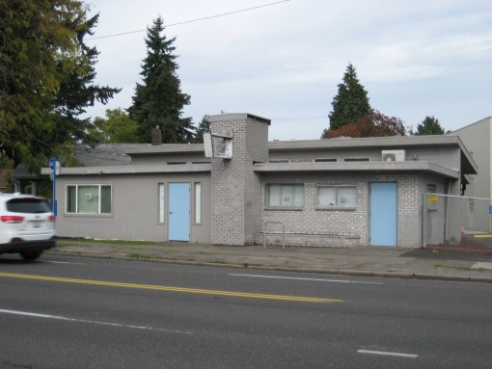
II | Custom Sheetmetal Fab  7227 SE Foster Rd.  Portland, OR | 1S2E17AC 5100 | 1971. Former site of Richfield Service Station. Current utilitarian metal building is intact. | Possesses integrity, but fails under Criteria A, B, and C.  Not eligible. | 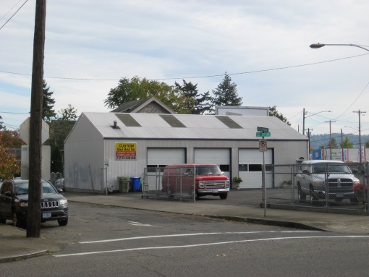
JJ | Maple Leaf Restaurant  7129 SE Foster Rd.  Portland, OR | 1S2E17BA 16100 | 1929/1953/1958. Mid-Century Modern restaurant. Began as Texaco service station, then soda fountain, then restaurant. Many alterations and additions over the years. | Lacks integrity. Fails under Criteria A, B, and C.  Not eligible. | 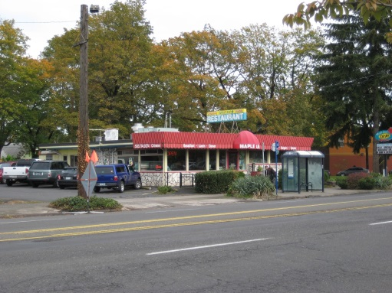
KK | Bill’s Quality Automotive  6835 SE Foster Rd.  Portland, OR | 1S2E17BA 11700 | 1946. Modest cinderblock auto service garage. Additional bays date from 1966. Intact, but common in form. | Possess integrity, but fails under Criteria A, B, and C.  Likely not eligible. | 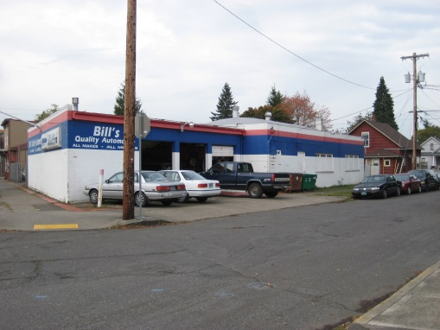
LL | Bar Carlo  6433-39 SE Foster Rd.  Portland, OR | 1S2E17BB 2600 | 1922. The Werth Building. Two-story vernacular brick retail/apartment building with bay windows on second story. Has housed several businesses on first floor. Mostly intact, all windows altered, heavily on 2nd story, but openings preserved; less alteration on 1st story fenestration. | Possesses integrity. Eligible Contributing. Potentially eligible under Criterion A. | 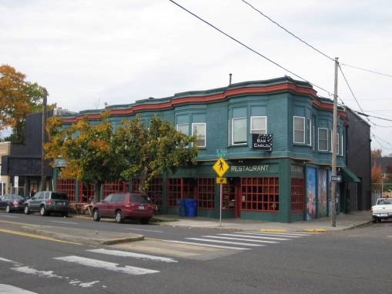
MM | Auto Sports  5815 SE Foster Rd.  Portland, OR | 1S2E07DD 17900 | 1955. Utilitarian cinderblock auto service garage. Intact, but not distinct. | Possesses integrity, but fails under Criteria A, B, and C.  Not eligible. | 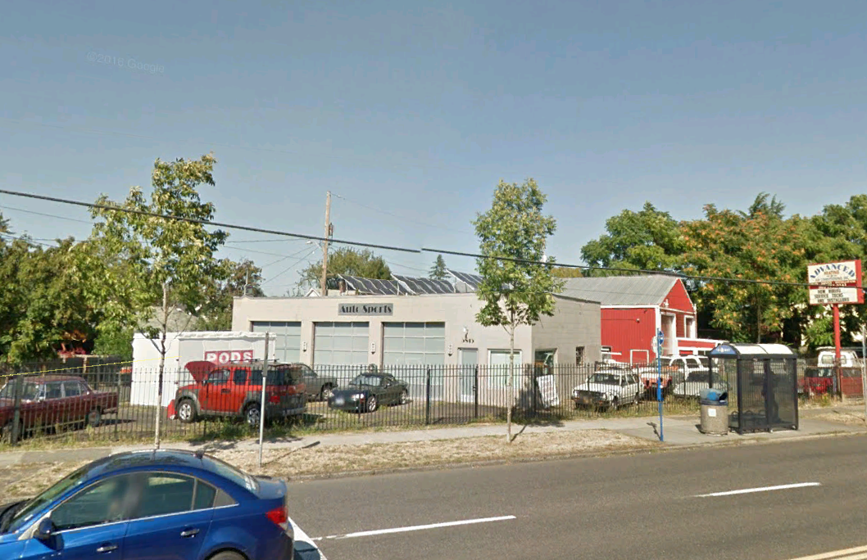
NN | 5427 SE Foster Rd.  Portland, OR | 1S2E07DB 6100 | 1912. Simple Flat Iron-shaped former restaurant building. Much altered. | Lacks integrity.  Not eligible. | 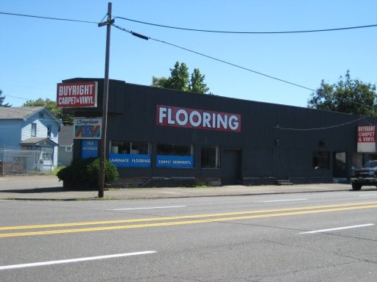
OO | Firland Parkway  (SE Firland Parkway)  SE 72nd Ave. between SE Holgate Blvd. and SE Foster Rd.  Portland, OR | 1S2E17AB 9300 | 1913. Greenway in the middle of SE 72nd Ave. from SE Holgate Blvd. to SE Foster Rd. Associated with development of Firland subdivision. Curbs date from 1917—20. South end of the parkway modified in the early 1980s with an extension to better delineate the SE 72nd Ave. at Foster Rd. intersection. The original plan called for 56 European linden trees. However, there are no lindens. Most trees are maples. Many are missing and pruning for powerlines has deformed others. Several mature non-native conifers are also in the parkway. | Compromised integrity. Not eligible as a standalone resource, but the parkway could be a contributing feature of a Firland subdivision historic district. However, the subdivision lacks enough integrity to be a historic district because of out-of-period construction, tear downs, and incompatible additions. | 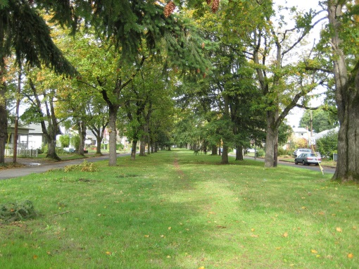  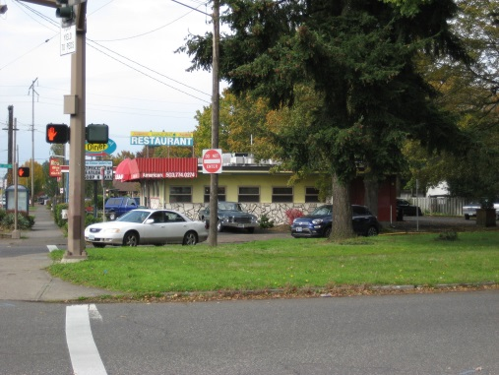
PP | SE Foster Road from SE 52th Ave to SE 72nd Ave.  Portland, OR | N/A | 1922. Roadway widened to include streetcar right-of-way. Plan of City Engineer Olaf Laurgaard. | Not eligible as a standalone resource. Also, loss of integrity for many buildings along Foster Rd. compromises potential for a historic district along the street. | 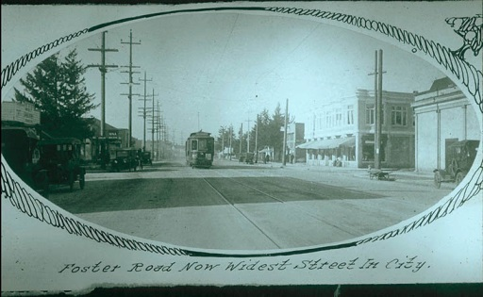

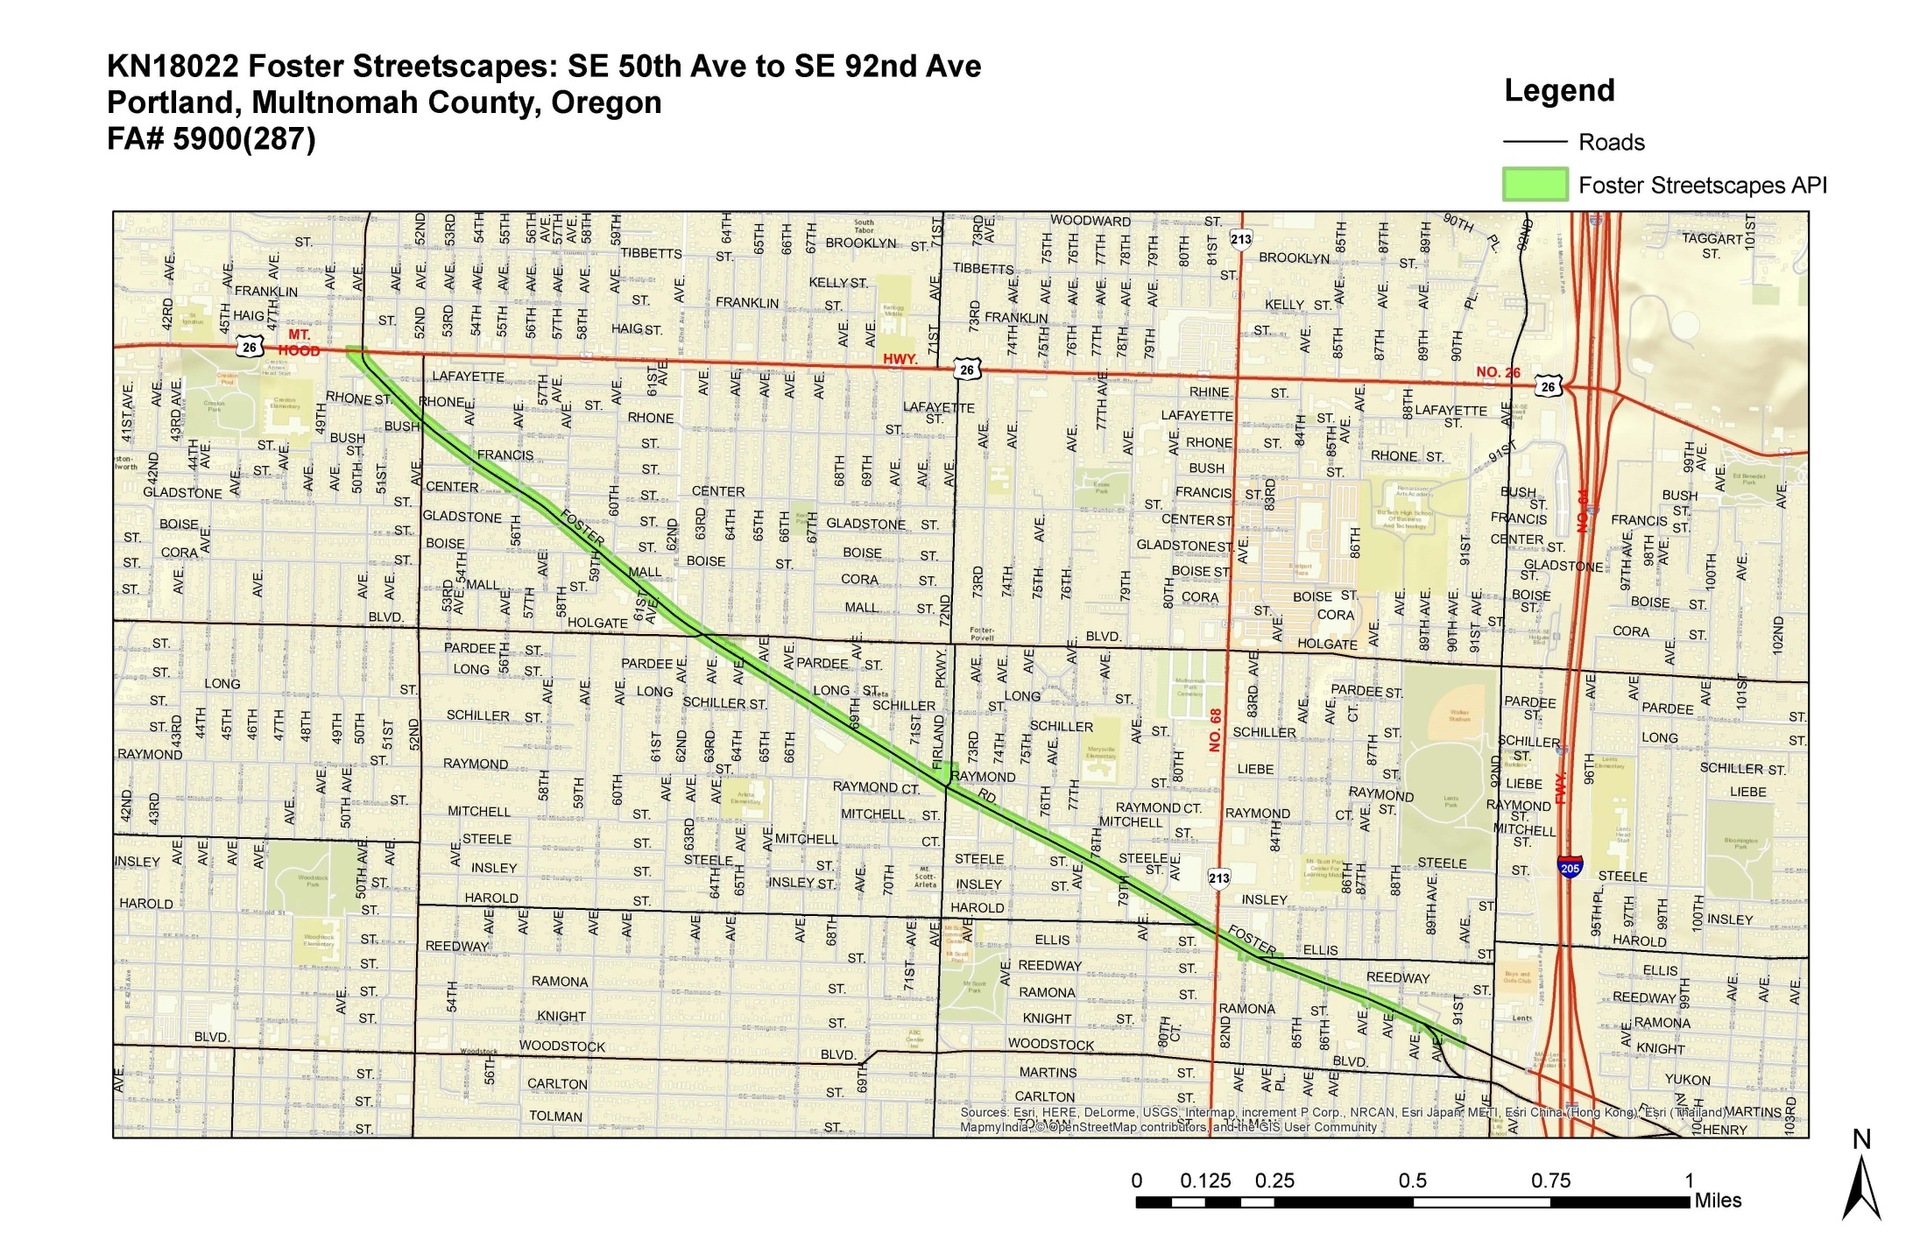
P

A
Potentially eligible historic built resources adjacent to project activities.
KK
EE
UE

S
G

E

Historic Resources Summary

There are seven potential historic built properties in the Foster Streetscapes project’s APE that are near locations where there are potential National Register-eligible properties. However, the project will not affect these resources. The project can be cleared with a Stipulation 4C memorandum.

Prepared by: __________________________ Date: June 19, 2017
Robert W. Hadlow, Ph.D.
ODOT Senior Historian

Reviewed by:__________________________ Date: June 19, 2017
Chris Bell
ODOT Historic Resources Program Coordinator

