Archaeological and Human Remains

Inadvertent Discovery Plan (IDP)
[Project Name]
Oregon Department of Transportation, Key # [Key#]

A COPY IS TO REMAIN ON SITE

This document outlines procedures and protocols to be followed if archaeological objects or features, or human remains are encountered in the course of work. These procedures are intended for circumstances where there is not an expectation or anticipation of encountering cultural resources or human remains. This is not a replacement for due diligence, robust project design, and consultation with appropriate Native American Tribes. Prior to undertaking project work, an assessment of the likelihood for disturbance to cultural resources and tribal heritage should be completed. All personnel will be briefed on all procedures and reporting structures before the start of any work.

Contents of this document
- Procedures for archaeological features and materials
- Procedures for human remains, burials, funerary objects, sacred objects, and objects of cultural patrimony
- Roles and responsibilities
- Contact information
- Confidentiality statement
- Procedure flow chart
- Visual reference guide for archaeology and tribal heritage items

Procedures for Inadvertent Discovery of Archaeological Features and Materials
(DOES NOT INCLUDE HUMAN REMAINS, BURIALS, FUNERARY OBJECTS, OBJECTS OF CULTURAL PATRIMONY, OR SPIRITUAL OBJECTS)
It is expected that ALL artifacts, features, structural elements, and other cultural items that are identified will be reported to required project, agency, and Tribal contacts, and accounted for as soon as possible. It is understood that there will be a single project point of contact to coordinate with the project archaeologist, SHPO, LCIS, and appropriate Native American Tribes.

Step 1. Stop work (immediately after discovery)
If any person believes that they have located an archaeological object or site, all work must stop immediately.

Step 2. Secure and protect the area (within first hour after discovery)
Establish a minimum 30 meter/100-foot area of protection, or more as necessary, around the find(s). Exclude all vehicle traffic and non-essential foot traffic. Non-ground-disturbing work may continue outside of the area of protection with caution until the situation is assessed by a qualified archaeologist.

Step 3. Notify (within first hour after discovery)
Notify the project manager, agency official (if applicable), and project archaeologist. If there is not an archaeologist on-site, or on retainer for the project, the project manager will contact an Oregon Qualified Archaeologist (which include agency and Tribal archaeologists) to assess the find.

Step 4. Identify and Follow Guidance (timeline variable, as soon as possible)
If the archaeologist determines the find is an archaeological feature or object, or other cultural item or feature, OR if no qualified archaeologist can be contacted within the first hour of discovery, the State Historic Preservation Office (SHPO) and appropriate Native American Tribes must be contacted, and their guidance must be followed. SHPO, Native American Tribes, and project and agency personnel will determine in consultation how or if work may continue at the site. If the discovery is determined to not be archaeological or a cultural item, you may continue work. This determination should be confirmed in writing to the project manager and agency official.

Procedures for Inadvertent Discovery of Human Remains
(INCLUDES HUMAN REMAINS, BURIALS, AND FUNERARY, CULTURAL PATRIMONY, SPIRITUAL OBJECTS)
It is expected that ALL potential human remains, burials, funerary objects, or objects of cultural patrimony that are identified will be reported and accounted for within 3 hours of discovery. It is understood that there will be a single project point of contact to coordinate with the project archaeologist, SHPO, LCIS, OSP and appropriate Native American Tribes.

Step 1: Stop work (immediately after discovery)
If any person believes that they have located human remains, ALL work will stop immediately. Any human remains, regardless of antiquity or ethnic origin, will always be treated with dignity and respect.

Step 2. Secure and protect the area (as soon as possible, within c. 10 min)
Secure and protect the area of inadvertent discovery with a minimum of 100 meter/300 foot buffer, or more as necessary. The location and other information about the find should be treated as confidential and shared on a need-to-know basis only. Prevent all vehicle traffic and unauthorized foot traffic from entry. Block remains from view and protect them from damage or exposure without touching or disturbing the remains and leave them in place.
Do not take photographs unless approved by the appropriate Native American Tribes and Oregon Legislative Commission on Indian Services (LCIS), and only for the purpose of identification. Do not speak to the media or public or post any information about the find on social media. Non-ground-disturbing work may continue outside of the buffer with caution.

Step 3. Notify (within first hour after discovery) – see contact list below (section D)
    - Project Manager/Inspector
    - ODOT REC/Archaeologist
    - Oregon State Police DO NOT CALL 911
    - State Historic Preservation Office (SHPO)
    - Legislation Commission on Indian Services (LCIS)
    - Appropriate Native American Tribes
Step 4. Follow guidance (timeline variable, may be up to several days or more)
If the site is determined not to be a crime scene by the Oregon State Police, do not move anything! The remains will continue to be secured in place along with any associated funerary objects, and protected from weather, water runoff, and shielded from view. Follow all guidance provided by OSP, LCIS, SHPO, and appropriate Native American Tribes.
Continue to maintain the work stoppage within the buffer until a plan is developed and carried out between the Oregon State Police, SHPO, LCIS, and appropriate Native American Tribes and you are directed in writing by the project manager that work may proceed.

Roles and Responsibilities

Person Responsible | Responsibility
ODOT Inspector will… | Notify the ODOT REC & ODOT Archaeologist
ODOT Archaeologist will… | Notify the State Agencies (OSP, LCIS, SHPO)
ODOT Archaeologist will… | Notify the Native American Tribes identified by LCIS
ODOT Inspector will… | Enforce the work stoppage and buffer

Contact Information

Agency | Position/Contact | Contact Information
ODOT REC | [Name] | [555-555-5555]
Contracted Archaeologist | Jessica Curteman, ODOT Archaeologist | 503-949-0842
Legislative Commission on Indian Services (LCIS) | Primary Contact: Dr. Elissa Bullion, State Physical Anthropologist | 971-707-1372
 | Secondary Contact: LCIS Office | 503-986-1067
Oregon State Police (OSP) | Primary Contact: Sgt. Ryan Tague | 541-576-4393
 | Secondary Contact: Dispatch, northern command | 800-442-0776
 | Secondary Contact: Dispatch, southern command | 800-442-2068
State Historic Preservation Office (SHPO) | Kurt Roedel, ODOT SHPO Liaison | 971-273-8073
 | Primary Contact: John Pouley, State Archaeologist | 503-480-9164
 | Secondary Contact: Jamie French, Asst. State Archaeologist | 503-979-7580

Confidentiality

The Project and employees shall make their best efforts, in accordance with federal and state law, to ensure that its personnel and contractors keep the discovery confidential. The media, or any third-party member or members of the public are not to be contacted or have information regarding the discovery, and any public or media inquiry is to be reported to ODOT. Photos shall not be taken except for when authorized by LCIS, SHPO, and Native American Tribes for identification purposes, and no photos will be circulated publicly or on social media. Prior to any release, the responsible agencies and Tribes shall concur on the amount of information, if any, to be released to the public.

To protect fragile, vulnerable, or threatened sites, the National Historic Preservation Act, as amended (Section 304 [16 U.S.C. 470s-3]), and Oregon State law (ORS 192.345(11)) establishes that the location of archaeological sites, both on land and underwater, shall be confidential.

Procedure Flow Chart
- Visual Reference Guide for Archaeology in Oregon

Lithics and stone tools

Figure 1. Stone flakes

Figure 2. Stone projectile points

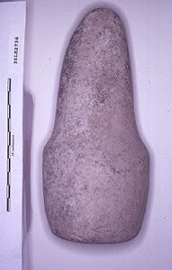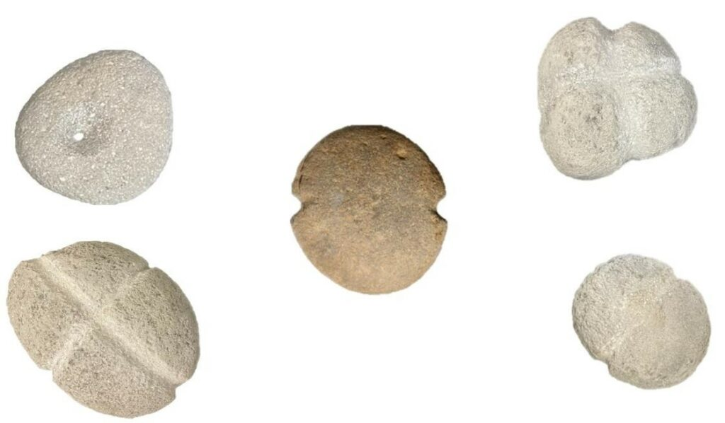
Figure 3. Ground stone tools: (left) pestle, (right) net weights,

Basketry/Cordage
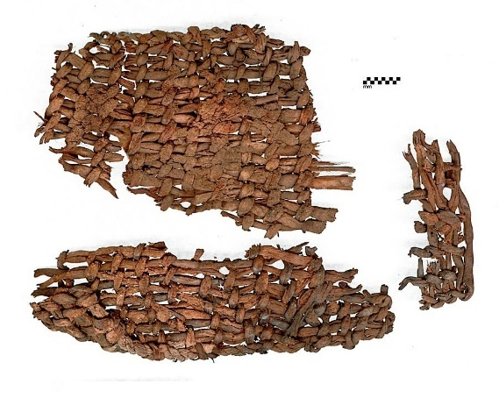
Figure 4. Open diagonal twine basket fragments from Fort Rock Cave (UOMNCH).
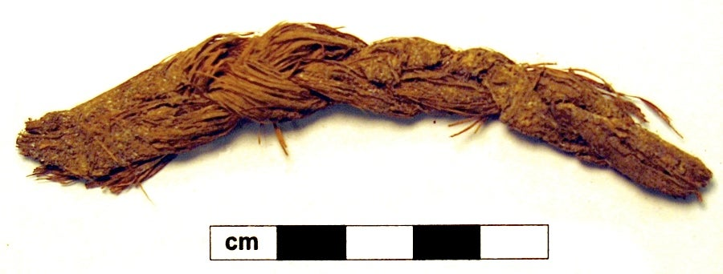
Figure 5. Three-strand braid, sagebrush bark from Paisley Caves (UOMNCH).

Shell Middens

Figure 6. Cross section of shell midden.

Beads

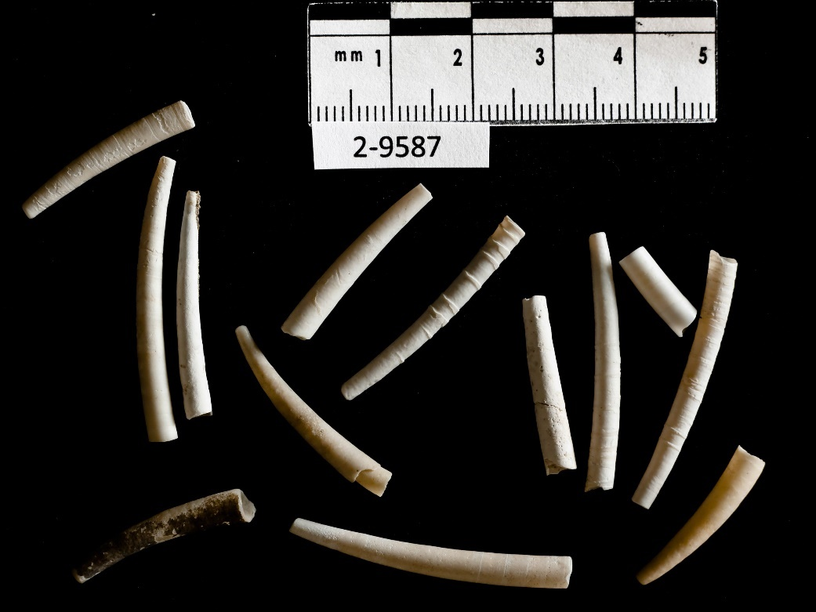
Figure 7. Dentalium shell beads (UOMNCH).

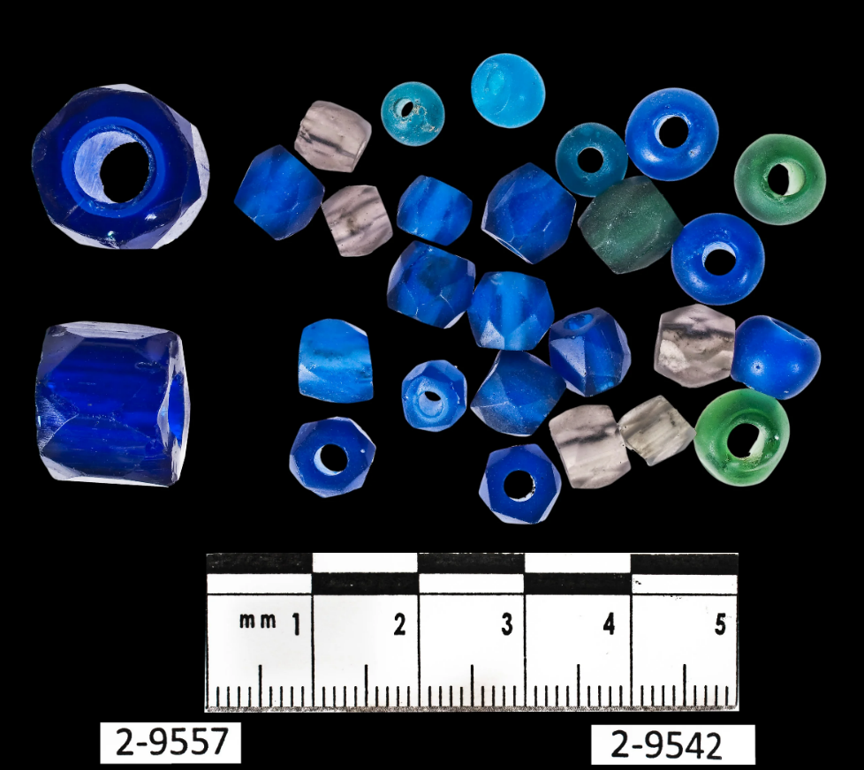
Figure 8. Glass trade beads, Upper Columbia River (UOMNCH).

Fish Weirs
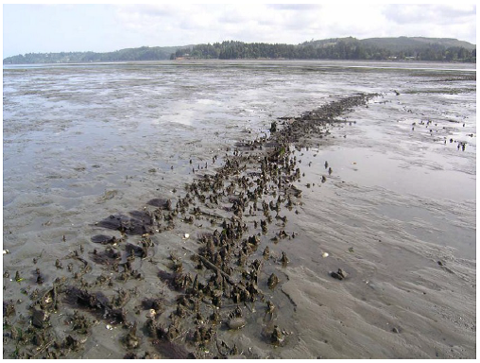
Figure 9. Wooden fish weir 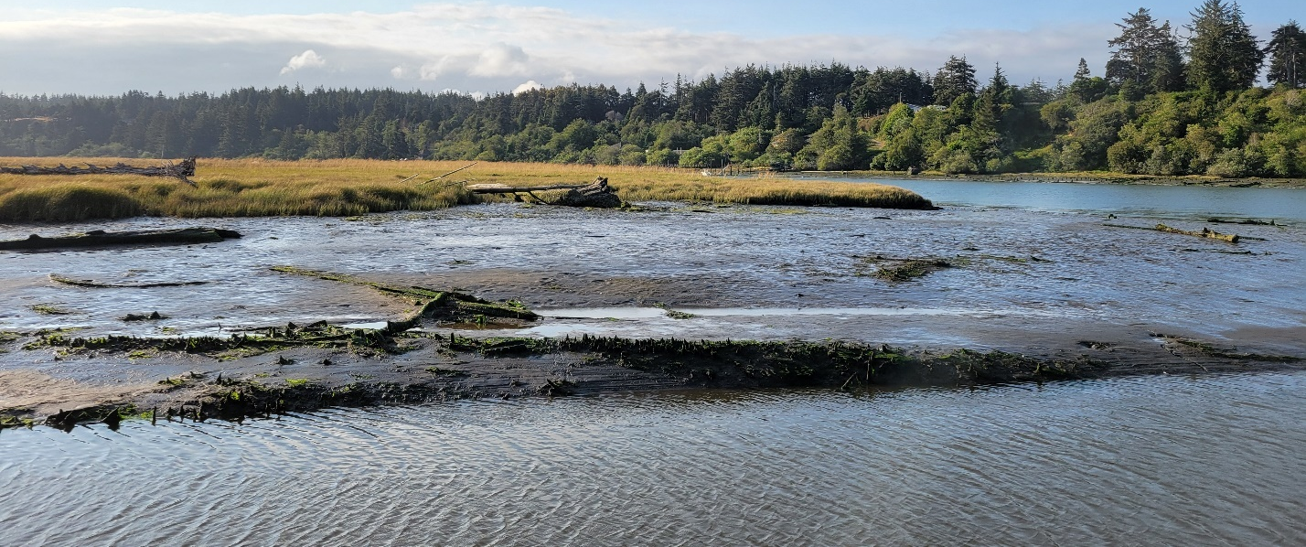
Figure 10. Fishing weir.
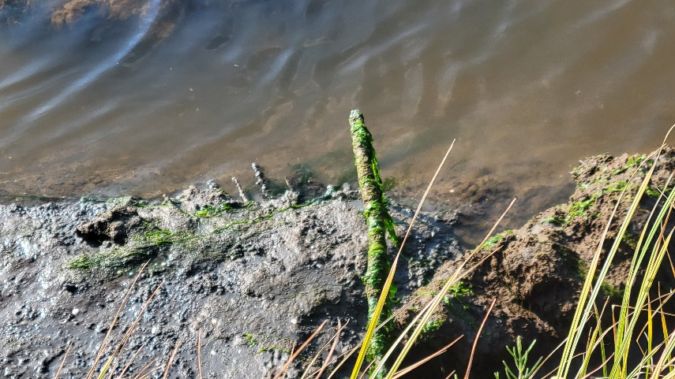
Figure 11. Close up of fishing weir.
Culturally Modified Trees

Figure 12. Example of peeled pine.

Figure 13. Arborglyph on aspen tree

Cultural Features

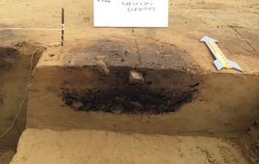
Figure 14. Hearth or cultural staining in soil

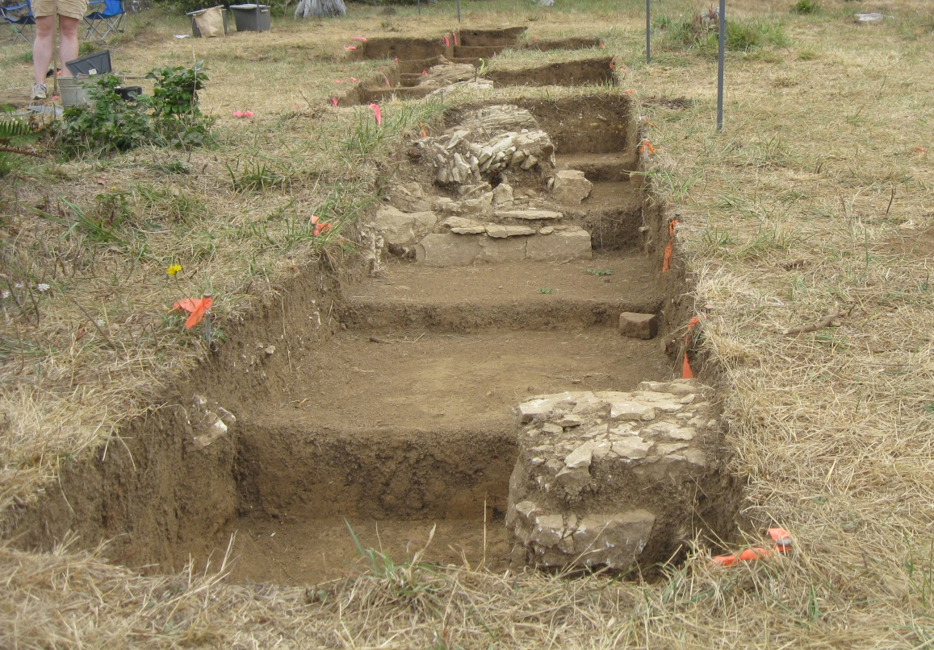
Figure 15. Historical building foundations

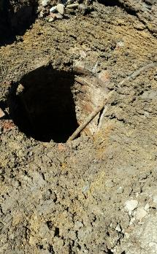

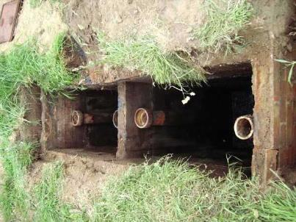

Figure 16. Historical wells and sceptic tanks

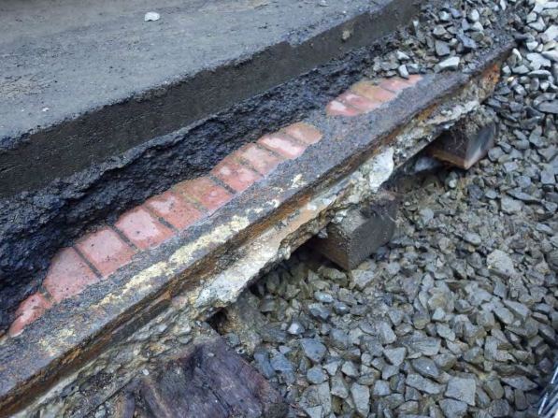
Figure 17. Historical trolly tracks

Historic/Post-Contact Artifacts

Figure 18. Historical glass

Figure 19. Historical metal artifacts Figure 20. Historical refuse scatter

Figure 21. Historical ceramics

Appropriate Native American Tribes will be identified by LCIS
“Archaeological object” means an object that is at least 75 years old (or 50 years if there is a federal nexus), is part of the physical record of an indigenous or other culture found in the state or waters of the state, and is material remains of past human life or activity that are of archaeological significance including, but not limited to, monuments, symbols, tools, facilities, technological by-products and dietary by-products (ORS 358.905).
“Archaeological site” means a geographic locality in Oregon that contains archaeological objects and the contextual associations of the archaeological objects with each other or biotic or geological remains or deposits (ORS 358.905).
Ground-disturbing work on different landforms distant from the find and outside of the buffer may continue.
Modifications to reporting timelines can be made in consultation with SHPO and Tribes.
Bone may be fragmented, weathered, or otherwise modified to make it difficult to identify, so when in doubt, stop work and call it in.
Ground-disturbing work on different landforms distant from the find and outside of the buffer may continue.
Contact information should be regularly updated for all individuals. Up to date contacts for LCIS, OSP, SHPO, and Native American Tribes can be found on the LCIS cultural resources page: Commission on Indian Services archaeology (oregonlegislature.gov)
Northern command: Benton, Clackamas, Clatsop, Columbia, Crook, Deschutes, Gilliam, Hood River, Jefferson, Klamath, Lane, Lincoln, Linn, Marion, Multnomah, Polk, Sherman, Tillamook, Wasco, Washington, Wheeler, Yamhill
Southern command: Baker, Coos, Curry, Douglas, Grant, Harney, Jackson, Josephine, parts of Klamath, Lake, Malheur, Morrow, Umatilla, Union, and Wallowa

